Low-cost igus stepper motor output stages for simple automation tasks
Fast commissioning - available from €70 directly from stock

Adjusting the width of a stop edge or the height of a monitor: programmable logic controllers (PLCs) are often oversized for thousands of such simple automation tasks. The alternatives from igus are the stepper motor output stages D7, D8 and D9 of the dryve series. Among other things, they are characterised by their simple operation and low-vibration running. At the same time, the output stages are particularly favourable and available directly from stock.

It does not always have to be a PLC to implement automation projects. Especially when it comes to simple adjustments. The right choice can save money and effort. "Demand is correspondingly high for simple stepper motor output stages that are reliable, cost-effective and easy to operate - but at the same time flexible enough so they can work together with a modern PLC to expand the range of possibilities", explains Rene Erdmann, Head of Business Unit drylin E Electric Drive Technology at igus. "We have therefore extended our dryve series motor control systems to include the three output stages D7, D8 and D9 as well as other variants. Output stages are already available from €70."

Quick manual adjustment without tools
To help users save installation time, igus has set great store by a fast commissioning of the control system. Users only need to connect the voltage source, control signals and the motor to the output stage. And off you go: in the so-called JOG operating mode, a signal triggered by a connected push-button initiates a counter-clockwise rotation, and a second signal ensures the clockwise rotation of the motor. The motor current and the speed of the output stage can be adjusted via eight microswitches on the housing, similar to a timer. Without software, without tools. Predefined motor speeds between 1 and 500rpm are possible, depending on the output stage variant.

Low-vibration operation protects nerves and adjacent components
Not only is it quick and intuitive to install and control the new output stages, they are also quiet in operation. "At all speeds, the output stages operate exceptionally quietly and with low vibration thanks to high-quality electronic components", says Erdmann. Not a matter of course. "Many inferior output stages cause stepper motors to vibrate. The vibrations create annoying noises and can result in screws and other components in the vicinity coming loose." Despite all the minimalism, there is still the possibility of expanding the applications of the output stages. To do so, users connect a higher-level control system via a standardised step/direction interface. In pulse operating mode, for example, it is then possible to implement highly precise positioning with simple step/direction signals. To make sure designers can integrate the output stage into larger systems as early as the planning phase without friction losses, igus also offers EPLAN macros for download for the output stages. Users of the EPLAN planning software can import the macro and plan circuit diagrams virtually. "Thus, they reduce the design effort by up to 50%." Quick installation in a switch cabinet is also guaranteed thanks to the TS35 DIN rail format. Furthermore, igus offers free sample programmes for higher-level machine control systems, such as those of Siemens or Arduino.

New variants of the output stages for more movement possibilities
The new output stages are available in three sizes and ready to ship within 24 hours. The D7 version is suitable for stepper motors with up to 2.2A continuous current (NEMA 11/17), D8 for motors with up to 4A continuous current (NEMA 23/24) and D9 for motors with up to 7A continuous current (NEMA 34). And for all designs there are sub-variants, which increase the flexibility of movement. D7-1, for example, is suitable for the JOG operating mode with slow speeds between 1 and 50rpm. And D7-2 replaces the JOG mode with a LOOP mode of operation, which, for example in a cleaning system, ensures that a nozzle moves continuously from left to right and right to left.

Caption:

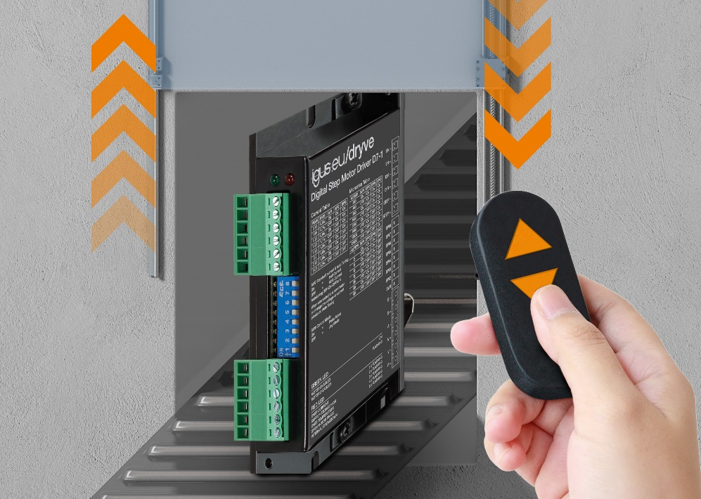
Picture PM1422-1
Open the doors for the stepper motor output stages from igus: used in simple automation systems, they are easy to operate and, with a price starting at €70, very cost-effective. (Source: igus GmbH)

PRESS CONTACT:

Alexa Heinzelmann
Head of International Marketing

igus® GmbH
Spicher Str. 1a
51147 Cologne
Tel. 0 22 03 / 96 49-7272
aheinzelmann@igus.net
www.igus.eu/press

ABOUT IGUS:

igus GmbH develops and produces motion plastics. These lubrication-free, high-performance polymers improve technology and reduce costs wherever things move. In energy supplies, highly flexible cables, plain and linear bearings as well as lead screw technology made of tribo-polymers, igus is the worldwide market leader. The family-run company based in Cologne, Germany, is represented in 35 countries and employs 4,900 people across the globe. In 2020, igus generated a turnover of €727 million. Research in the industry's largest test laboratories constantly yields innovations and more security for users. 234,000 articles are available from stock and the service life can be calculated online. In recent years, the company has expanded by creating internal startups, e.g. for ball bearings, robot drives, 3D printing, the RBTX platform for Lean Robotics and intelligent "smart plastics" for Industry 4.0. Among the most important environmental investments are the "chainge" programme – recycling of used e-chains - and the participation in an enterprise that produces oil from plastic waste.

The terms "igus", “Apiro”, "chainflex", "CFRIP", "conprotect", "CTD", “drygear”, "drylin", "dry-tech", "dryspin", "easy chain", "e-chain", "e-chain systems", "e-ketten", "e-kettensysteme", "e-skin", "e-spool”, "flizz", “ibow”, “igear”, "iglidur", "igubal", “kineKIT”, "manus", "motion plastics", "pikchain", "plastics for longer life", "readychain", "readycable", “ReBeL”, "speedigus", "tribofilament“, "triflex", "robolink", “xirodur”, and "xiros" are protected by trademark laws in the Federal Republic of Germany and internationally, where applicable.

