Co-operation for recycling expanded: igus partner Mura Technology collaborates with Dow
Global project for innovative plastics recycling continues to gain momentum

The "Hydrothermal Plastic Recycling Solution" of startup Mura Technology promises the conversion of plastic back to oil in just 25 minutes. In order for entry into a sustainable circular economy to succeed, globally active industrial companies such as igus are supporting the development of this technology. Dow Chemical, the world's second largest chemical company, is now another partner on board.

With the "Hydrothermal Plastic Recycling Solution" (HydroPRS), Mura Technology has developed a novel technology for chemical plastic recycling. The aim is to build a sustainable circular economy for plastics and prevent plastic waste from entering the environment. The method uses water, heat and pressure to convert plastic waste back into oil in just 25 minutes. The startup Mura Technology has already entered into collaborations with the engineering services company KBR and the motion plastics specialist igus. igus was the first investor from the industrial sector at the end of 2019 and had further increased its investment to 5 million euros in March. Now, Dow Chemical, a global developer and producer of plastics, is joining as another major partner. The collaboration will further drive the scaling of Mura's advanced recycling process.

Plastic waste becomes new packaging
The world's first facility to use HydroPRS on a large scale is currently being built in Teesside, UK. The first line with a capacity of 20,000 tonnes per year is expected to start operation in 2022. Once all four lines are completed, Mura will be able to recycle up to 80,000 tonnes of plastic waste per year and supply Dow with the raw materials obtained through the process. Dow will use this to develop new plastics for food packaging and other packaging products that will eventually be returned into global supply chains. Dow's commitment is also intended to demonstrate that Mura's solution can meet both the sustainability and performance requirements of the industry and that products made with HydroPRS can be used on a large scale to produce new plastics. igus CEO Frank Blase also welcomes the collaboration: "Strong partnerships are needed to help this technology achieve a breakthrough and thereby create a noticeable effect for the environment. We are delighted for Mura that Dow is on board."

Caption:

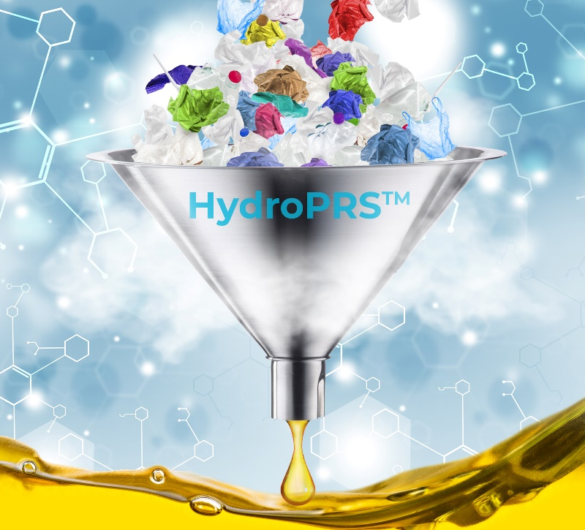
Picture PM2021-1
Dow Chemical invests in Mura's HydroPRS technology. It has the potential to recycle all kinds of plastic and recover oil from it. (Source: igus GmbH)

PRESS CONTACT:  Oliver Cyrus  Head of PR and Advertising  Anja Görtz-Olscher  PR and Advertising  igus® GmbH  Spicher Str. 1a  51147 Cologne  Tel. 0 22 03 / 96 49-459 or -7153  Fax 0 22 03 / 96 49-631  ocyrus@igus.net  agoertz@igus.net  www.igus.eu/press | ABOUT IGUS:  igus GmbH develops and produces motion plastics. These lubrication-free, high-performance polymers improve technology and reduce costs wherever things move. In energy supplies, highly flexible cables, plain and linear bearings as well as lead screw technology made of tribo-polymers, igus is the worldwide market leader. The family-run company based in Cologne, Germany, is represented in 35 countries and employs 3,800 people across the globe. In 2019, igus generated a turnover of €764 million. Research in the industry's largest test laboratories constantly yields innovations and more security for users. 234,000 articles are available from stock and the service life can be calculated online. In recent years, the company has expanded by creating internal startups, e.g. for ball bearings, robot drives, 3D printing, the RBTX platform for Lean Robotics and intelligent "smart plastics" for Industry 4.0. Among the most important environmental investments are the "chainge" programme – recycling of used e-chains - and the participation in an enterprise that produces oil from plastic waste. (Plastic2Oil).

The terms "igus", “Apiro”, "chainflex", "CFRIP", "conprotect", "CTD", “drygear”, "drylin", "dry-tech", "dryspin", "easy chain", "e-chain", "e-chain systems", "e-ketten", "e-kettensysteme", "e-skin", "e-spool”, "flizz", “ibow”, “igear”, "iglidur", "igubal", “kineKIT”, "manus", "motion plastics", "pikchain", "plastics for longer life", "readychain", "readycable", “ReBeL”, "speedigus", "tribofilament“, "triflex", "robolink", “xirodur”, and "xiros" are protected by trademark laws in the Federal Republic of Germany and internationally, where applicable.

