Complete chain! igus energy chain kits in the shopping cart with one click and delivered in three days
igus now offers DIY kits consisting of energy supply system, interior separation, trough and mounting brackets for long travels

For users who want to order their energy chain quickly and easily and assemble it themselves, igus now has the solution: complete kits. The kits consist of an E4.1 series energy chain, an aluminium trough, matching separators, strain relief elements and a screwdriver. This means that the customer does not need to worry about a time-consuming configuration of the energy supply system. All adjustments to the chain are made directly on the equipment or machine. The complete kits are available in three inner heights for travels from 8 to 24 metres in the igus online shop and are available from stock.

When purchasing an energy chain, the customer usually has to go through a few steps in the ordering process to correctly compile the shopping cart for his energy supply. Often the right type of chain can be found quickly, but additional products such as a trough and the appropriate mounting brackets are usually required. "Every chain configuration, like every application, is individual, so the customer has a wide choice. The e-chain expert helps to configure and order the energy supply system", explains Jörg Ottersbach, Head of the e-chain Business Unit at igus GmbH. "However, there are also customers, for example in the area of sewage treatment plants, in sawmills or in the chemical industry, who are looking for a quick and easy complete solution", he says. Therefore, igus now offers complete kits of energy chains for travels from 8 to 24 metres directly from stock. Longer travels can be ordered with the help of the e-chain expert. The kits consist of a proven and robust E4.1 series energy chain, the appropriate mounting brackets, strain relief elements, separators, an aluminium guide trough with glide bar and one without glide bar, matching installation sets and an igus screwdriver.

Just one click to the complete chain
The kits are available in a total of three inner heights from 32 to 56 millimetres. The ordering process is quick and easy: in the online shop, besides the inner height of the chain, the customer only has to decide on the desired total length, the inner width and the bend radius. With one click the kit is transferred to the shopping cart. The user receives the complete kit, including clear installation instructions, within three to five days. igus also promises a guarantee of 36 months on the complete energy supply system. The customer can easily generate the certificate online using the service life calculator. When the machine and system reaches the end of their service life and the energy chain is no longer in use, igus will take it back and guarantee pure recycling. In return, the user receives a credit note based on the net weight.

Caption:

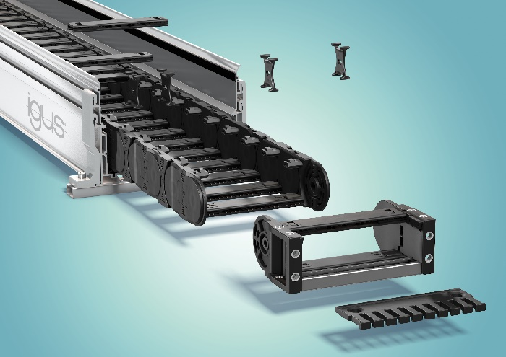
Picture PM6420-1
The new energy chain complete kits, which can be ordered quickly, consist of chain, trough, strain relief and separators and are easy to assemble. (Source: igus GmbH)

PRESS CONTACT:  Oliver Cyrus  Head of PR and Advertising  Anja Görtz-Olscher  PR and Advertising  igus® GmbH  Spicher Str. 1a  51147 Cologne  Tel. 0 22 03 / 96 49-459 or -7153  Fax 0 22 03 / 96 49-631  ocyrus@igus.net  agoertz@igus.net  www.igus.eu/press | ABOUT IGUS:  igus GmbH develops and produces motion plastics. These lubrication-free, high-performance polymers improve technology and reduce costs wherever things move. In energy supplies, highly flexible cables, plain and linear bearings as well as lead screw technology made of tribo-polymers, igus is the worldwide market leader. The family-run company based in Cologne, Germany, is represented in 35 countries and employs 3,800 people across the globe. In 2019, igus generated a turnover of €764 million. Research in the industry's largest test laboratories constantly yields innovations and more security for users. 234,000 articles are available from stock and the service life can be calculated online. In recent years, the company has expanded by creating internal startups, e.g. for ball bearings, robot drives, 3D printing, the RBTX platform for Lean Robotics and intelligent "smart plastics" for Industry 4.0. Among the most important environmental investments are the "chainge" programme – recycling of used e-chains - and the participation in an enterprise that produces oil from plastic waste. (Plastic2Oil).

The terms "igus", “Apiro”, "chainflex", "CFRIP", "conprotect", "CTD", “drygear”, "drylin", "dry-tech", "dryspin", "easy chain", "e-chain", "e-chain systems", "e-ketten", "e-kettensysteme", "e-skin", "e-spool”, "flizz", “ibow”, “igear”, "iglidur", "igubal", “kineKIT”, "manus", "motion plastics", "pikchain", "plastics for longer life", "readychain", "readycable", “ReBeL”, "speedigus", "tribofilament“, "triflex", "robolink", “xirodur”, and "xiros" are protected by trademark laws in the Federal Republic of Germany and internationally, where applicable.

