Ready-to-connect igus hybrid cables save installation space, weight and construction time
New readycable hybrid cables suitable for drive technology from Siemens and SEW-EURODRIVE
Save installation space and weight with just one cable for power and data: it's easy with harnessed igus readycable hybrid cables. New to the range are ready-to-connect cables suitable for SEW-EURODRIVE with MOVILINK DDI and Siemens SINAMICS S210 with OCC. In addition to PUR, the latter is also available with an outer jacket made of cost-effective PVC. Macros for the EPLAN Electric P8 software speed up cable planning by around 50%.
Reducing the complexity of automation solutions while saving money, time and installation space is a declared goal of engineers all over the world. This applies to cable planning as well. Here, so-called hybrid technology has become one of the major trends in recent years. While servo drive systems used to require several cables to transmit energy and data, hybrid cables simply combine the cores. "Hybrid technology is a pioneering development that we, as a cable specialist, are one hundred percent convinced is the way to go," says Markus Hüffel, Product Manager readychain and readycable at igus. "We are therefore continuously expanding our portfolio of ready-to-connect hybrid cables from the readycable series in order to offer our customers a fast, reliable, cost-effective solution for continuous use in energy chains."

Optimise project planning with just-in-time delivery, free cutting and macros for EPLAN Electric P8
The latest addition to the readycable series includes two models: a hybrid cable for motors from SEW-EURODRIVE, a German manufacturer, with the MOVILINK DDI interface, and a hybrid cable for Siemens servo drives suitable for SINAMICS S210. In addition to PUR, the outer jacket can be made of the lower-cost polyvinyl chloride (PVC). "Lean industrial processes in harnessing, very short throughput times and a high degree of warehousing enable designers to quickly have the new hybrid cables delivered directly from stock - at the desired length to the centimetre, without cutting charge, ready to connect and fit for immediate use," says Hüffel. To save even more project planning time, igus also provides direct links to the macros for the EPLAN Electric P8 planning software on their website. This allows the cables to be dragged and dropped into the digital cable plan as building blocks, reducing cable planning time by up to 50%.

Fail-safe continuous use in energy chains
Like all cables in the readycable series, the new hybrid cables have a strong outer jacket, a strain-relieved core, movement-optimised stranded wires, a stranded structure with a short pitch length and a gusset-filling extruded inner jacket. "This design and these high-quality materials make our new hybrid cables fail-safe in continuous use in energy chains, even in compact applications," says Hüffel. Materials with good electromagnetic compatibility prevent the energy and data transmission cores from having a negative influence on each other. All models have undergone several million test cycles in the 3,800 square meter igus test laboratory. igus therefore offers an above-average chainflex cable guarantee of 36 months. They also provide an online tool, with which customers can calculate the expected service life of their specific application.

Caption:
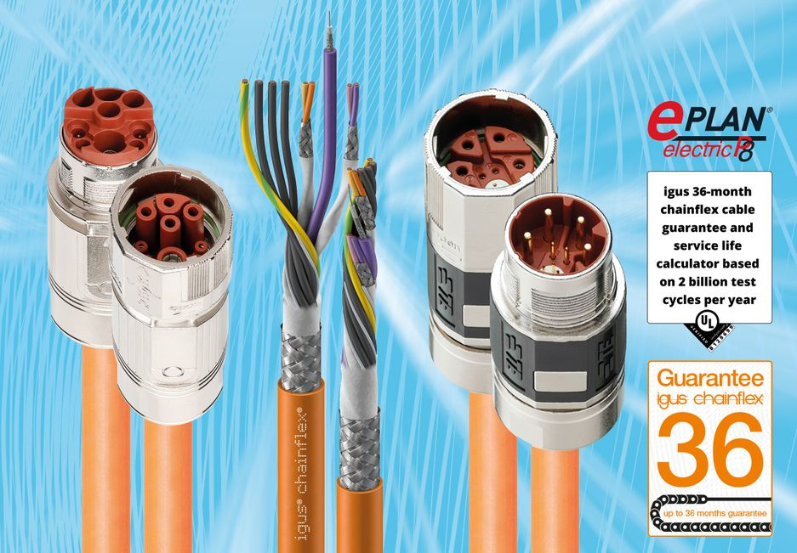
Picture PM4822-1
Reduce installation space and design time by 50%: igus is expanding its product portfolio of harnessed hybrid cables, adding ready-to-connect cables suitable for SEW-EURODRIVE with MOVILINK DDI and Siemens SINAMICS S210 with OCC. (Source: igus GmbH)

PRESS CONTACT:

Alexa Heinzelmann
Head of International Marketing

igus® GmbH
Spicher Str. 1a
51147 Cologne
Tel. 0 22 03 / 96 49-7272
aheinzelmann@igus.net
www.igus.eu/press

ABOUT IGUS:

igus GmbH develops and produces motion plastics. These lubrication-free, high-performance polymers improve technology and reduce costs wherever things move. In energy supplies, highly flexible cables, plain and linear bearings as well as lead screw technology made of tribo-polymers, igus is the worldwide market leader. The family-run company based in Cologne, Germany, is represented in 35 countries and employs 4,900 people across the globe. In 2021, igus generated a turnover of €961 million. Research in the industry's largest test laboratories constantly yields innovations and more security for users. 234,000 articles are available from stock and the service life can be calculated online. In recent years, the company has expanded by creating internal startups, e.g. for ball bearings, robot drives, 3D printing, the RBTX platform for Lean Robotics and intelligent "smart plastics" for Industry 4.0. Among the most important environmental investments are the "chainge" programme – recycling of used e-chains - and the participation in an enterprise that produces oil from plastic waste.

The terms "igus", “Apiro”, "chainflex", "CFRIP", "conprotect", "CTD", “drygear”, "drylin", "dry-tech", "dryspin", "easy chain", "e-chain", "e-chain systems", "e-ketten", "e-kettensysteme", "e-skin", "e-spool”, "flizz", “ibow”, “igear”, "iglidur", "igubal", “kineKIT”, "manus", "motion plastics", "pikchain", "plastics for longer life", "readychain", "readycable", “ReBeL”, "speedigus", "tribofilament“, "triflex", "robolink", “xirodur”, and "xiros" are protected by trademark laws in the Federal Republic of Germany and internationally, where applicable.

