Cost-effective labelling robot wins the 2022 igus ROIBOT Award
An amortisation period of 16 to 24 months and a zero margin of error convinces the panel of expert judges for the robotics competition

Simple, cost-effective automation solutions can be found both in an increasing number of Small and Medium Enterprises and among large industrial players. Every two years, igus presents the ROIBOT Award for the most creative applications. This year, the inventors of a labelling robot, the developers of a fully automatic container system for growing vegetables and herbs, and the designers of a wallpapering device received the coveted prize.

Robots are in use all over the world – in logistics, laboratories, and agriculture. Every two years, experts from industry and trade press work with igus GmbH to honour the most cost-effective, creative, clever solutions with the ROIBOT Award. The focus of the competition is on igus Low Cost Automation solutions such as delta robots, Cartesian robots, and articulated arm robots. The award's name says it all and reveals main decision criterion for the panel of judges: return on investment that quickly pays for the outlay. A total of 110 submissions from 20 countries show the diverse application options for cost-effective robotics. In the second iteration of the competition, MFG Technik & Service GmbH won over the judges with its "LabelMonkey" labelling robot, winning robotic components worth 5,000 euros. A robolink DP multi-axis articulated robot for 7,700 euros is the heart of this system. Its two printing modules ensure that logistics labels are reliably affixed to pallets. The LabelMonkey is a simple, cost-effective mechanism for the end user. The system pays for itself in just 16 to 24 months, making it very attractive for many logisticians to use.

Automatic harvest assistant takes second place
The increasing extremes in weather conditions due to climate change requires ever greater expenditure of resources and personnel in agriculture. Then there is crop storage and the long transport routes. Farmionic, an Austrian company, has therefore set itself a very special goal: The engineers are developing the vegetable garden of the future. It is a fully automatic, resource-conserving container system for growing vegetables and herbs with 24/7 availability, anywhere in the world. A robolink DP robot takes on all tasks, from planting to harvesting, on a seventh axis. The robotics system costs 11,200 euros. It pays for itself in 13 to 15 months. The pioneering invention took second place. tapo-fix GmbH & Co. KG, based in Wolfsburg, took third. Using a room linear robot, the manufacturer of wallpapering equipment for home and crafts has developed an extremely affordable automation solution for applying paste to metal. The acquisition value is 6,700 euros. To free up employees, the dosing robot is now assuming this task. It works extremely precisely and hand-in-hand with staff, saving the company up to 8,000 euros per year.

Find out more about the 2022 ROIBOT Award winners at: https://www.igus.eu/roibot-winners-2022

Caption:
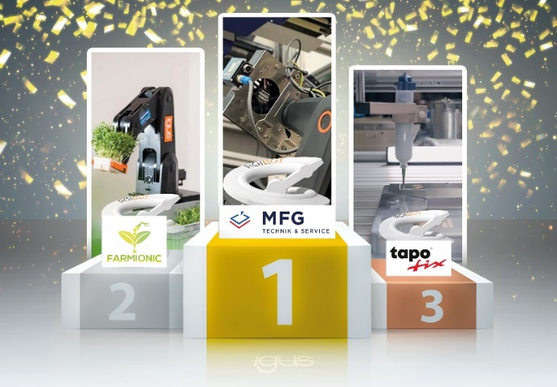
Picture PM6122-1
MFG Technik & Service GmbH took first place in the ROIBOT Awards for its labelling robot, followed by Farmionic with its automatic container system and the tapo-fix pasting robot. (Source: igus GmbH)

PRESS CONTACT:

Alexa Heinzelmann
Head of International Marketing

igus® GmbH
Spicher Str. 1a
51147 Cologne
Tel. 0 22 03 / 96 49-7272
aheinzelmann@igus.net
www.igus.eu/press

ABOUT IGUS:

igus GmbH develops and produces motion plastics. These lubrication-free, high-performance polymers improve technology and reduce costs wherever things move. In energy supplies, highly flexible cables, plain and linear bearings as well as lead screw technology made of tribo-polymers, igus is the worldwide market leader. The family-run company based in Cologne, Germany, is represented in 31 countries and employs 4,900 people across the globe. In 2021, igus generated a turnover of €961 million. Research in the industry's largest test laboratories constantly yields innovations and more security for users. 234,000 articles are available from stock and the service life can be calculated online. In recent years, the company has expanded by creating internal startups, e.g. for ball bearings, robot drives, 3D printing, the RBTX platform for Lean Robotics and intelligent "smart plastics" for Industry 4.0. Among the most important environmental investments are the "chainge" programme – recycling of used e-chains - and the participation in an enterprise that produces oil from plastic waste.

The terms "igus", “Apiro”, "chainflex", "CFRIP", "conprotect", "CTD", “drygear”, "drylin", "dry-tech", "dryspin", "easy chain", "e-chain", "e-chain systems", "e-ketten", "e-kettensysteme", "e-skin", "e-spool”, "flizz", “ibow”, “igear”, "iglidur", "igubal", “kineKIT”, "manus", "motion plastics", "pikchain", "plastics for longer life", "readychain", "readycable", “ReBeL”, "speedigus", "tribofilament“, "triflex", "robolink", “xirodur”, and "xiros" are protected by trademark laws in the Federal Republic of Germany and internationally, where applicable.

