When speed is a must: igus FastLine delivers injection-moulded special plain bearings in 7 days
New production line in the in-house igus toolmaking department enables fast production of customised plain bearings

When the market demand for a product is high, then the manufacturers and their suppliers are needed. Customised parts, such as plain bearings in special shapes, have to be delivered quickly and without complications. But it is not unusual for the production of special parts by injection moulding to take several weeks. The plastics specialist igus therefore now offers its customers the FastLine Service thanks to its expanded in-house toolmaking department. Lubrication-free, polymer plain bearings in special dimensions can be delivered within a few days at cost-effective unit prices.

When the production of a wear-resistant special plain bearing has to be fast, many users either think of 3D printing or milling the desired parts from bar stock. But for high volume production of 1,000 parts or more, both processes are too expensive in the long run. Therefore, igus now offers the production of cost-effective and highly wear-resistant plain bearings in special dimensions from injection moulding with its FastLine Service. This means that batches can be produced and sent to the user within just a few days. "By investing in our toolmaking department with its own production line for round parts with modern CNC technology, we are now able to respond even faster to our customers' needs", explains Stefan Loockmann-Rittich, Business Unit Manager of iglidur at igus GmbH. "In addition to our large catalogue range of polymer plain bearings, which are available from stock, we can produce customised parts cost-effectively in just a few days using the appropriate injection moulding tool."

Printed, milled or injection moulded?
But how does the customer find out when production in injection moulding is worthwhile, or whether another production process is more cost-effective? For this purpose, igus offers the iglidur Designer. In the online tool, the customer can simply enter the dimensions of the plain bearing, select the desired material, define the quantity and they will be shown an overview of the manufacturing processes with the appropriate costs.

Fast delivery of special plain bearings for ergometer series
ergoline GmbH also used the FastLine Service. The ergometer manufacturer was looking for a suitable maintenance-free plain bearing solution for the height adjustment of its new range. The plain bearings in standard dimensions were out of the question due to special inner and outer diameters. The initial tests were successfully made with turned bearings made of iglidur bar stock, but the start of batch production had to be quick due to the high demand in the market. "Six weeks for a regular mould was too late for us, and turning bearings from bar stock all the time was too time-consuming and too expensive", explains Dominik Huber, developer at ergoline GmbH. "That's why we were very happy about the igus FastLine Service. It took just four days from order to delivery. And the price is three times more cost-effective than expected." Since the mould has been stored, ergoline can continue to benefit from the cost-effective injection moulding of its parts in the future.

Caption:

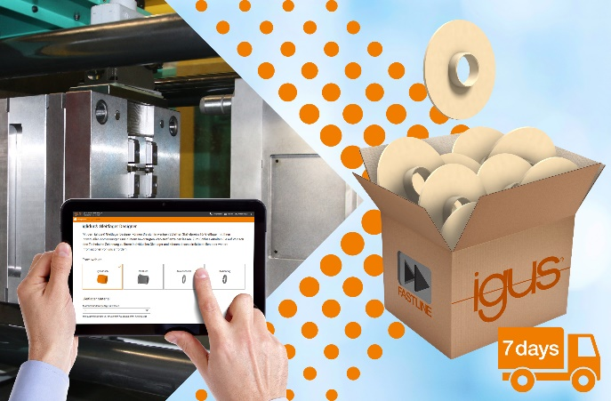
Picture PM0621-1
The customer can select the FastLine Service using the iglidur Designer. The special part is received in batches from the igus injection moulding department within 7 days. (Source: igus GmbH)

PRESS CONTACT:  Oliver Cyrus  Head of PR and Advertising  Anja Görtz-Olscher  PR and Advertising  igus® GmbH  Spicher Str. 1a  51147 Cologne  Tel. 0 22 03 / 96 49-459 or -7153  Fax 0 22 03 / 96 49-631  ocyrus@igus.net  agoertz@igus.net  www.igus.eu/press | ABOUT IGUS:  igus GmbH develops and produces motion plastics. These lubrication-free, high-performance polymers improve technology and reduce costs wherever things move. In energy supplies, highly flexible cables, plain and linear bearings as well as lead screw technology made of tribo-polymers, igus is the worldwide market leader. The family-run company based in Cologne, Germany, is represented in 35 countries and employs 3,800 people across the globe. In 2019, igus generated a turnover of €764 million. Research in the industry's largest test laboratories constantly yields innovations and more security for users. 234,000 articles are available from stock and the service life can be calculated online. In recent years, the company has expanded by creating internal startups, e.g. for ball bearings, robot drives, 3D printing, the RBTX platform for Lean Robotics and intelligent "smart plastics" for Industry 4.0. Among the most important environmental investments are the "chainge" programme – recycling of used e-chains - and the participation in an enterprise that produces oil from plastic waste. (Plastic2Oil).

The terms "igus", “Apiro”, "chainflex", "CFRIP", "conprotect", "CTD", “drygear”, "drylin", "dry-tech", "dryspin", "easy chain", "e-chain", "e-chain systems", "e-ketten", "e-kettensysteme", "e-skin", "e-spool”, "flizz", “ibow”, “igear”, "iglidur", "igubal", “kineKIT”, "manus", "motion plastics", "pikchain", "plastics for longer life", "readychain", "readycable", “ReBeL”, "speedigus", "tribofilament“, "triflex", "robolink", “xirodur”, and "xiros" are protected by trademark laws in the Federal Republic of Germany and internationally, where applicable.

