Lubrication-free adjustment of heavy loads with the new igus polymer lead screw nut
Wear-resistant dryspin lead screw nut for heavy-duty applications cost-effectively replaces ball screws

Plastic and heavy loads? This time igus proves that the combination works with a new lead screw nut design. The injection-moulded dryspin JGRM polymer nut offers a cost-effective alternative to ball screw nuts. The new lubrication-free and wear-resistant design can move heavy loads. For higher axial loads, the new lead screw nut is also available with a stainless steel plate as a "Heavy Duty version".

Whether in construction machinery, actuators or solar trackers, lead screws must be able to move high loads safely and durably in a wide variety of applications. igus has now developed a new lead screw nut precisely for this application. "The new JGRM series is a robust alternative to ball screw nuts", says Thorben Hendricks, Division Manager of Screw Technology at igus GmbH. "The new design of the nut, distributes the radial and axial loads in such a way, that we can absorb higher forces in contrast to conventional flanged lead screw nuts." The new type is based on the connection sizes and pitches of ball screws and therefore can be easily replaced. The nut offers a variety of installation methods: it can be screwed on or off or installed in a hole. The thread centring spigot, the anti-rotation feature by means of spanner flats, and the use of four M6 cap head screws helps in the installation. The nut is manufactured by igus using injection moulding in Cologne, so it is very light and cost-effective. Compared to ball screw systems, the polymer lead screw nuts cost only half as much. Due to the use of iglidur J high-performance polymers, the nut has a very low coefficient of friction. The rounded thread flanks and the absence of balls make the lead screw very smooth running. In addition, due to the use of dry lubricants, the lead screw nut does not require external lubrication that has to be released into the environment. "We are offering customers a maintenance-free solution that is insensitive to dust and dirt", says Hendricks.

Heavy duty version for more safety with higher axial loads
For higher axial loads, igus has also developed the JGRM lead screw nut as a heavy duty version with a stainless steel plate. The flange dimension remains identical. The stainless steel plate is mounted on the nut and thus increases the load-bearing surface for force dissipation. The screw heads no longer rest on the plastic. Tests in the company's in-house 3,800 square metre test laboratory showed that the Heavy Duty version can absorb up to 6 MPa and take 50 per cent more load than a comparable plastic flanged screw nut. The new lead screw nut is available for all thread types with a diameter of 14 to 20 millimetres. It achieves its highest efficiency on the patented asymmetrical dryspin lead screw from igus.

Learn more about dryspin lead screw technology in the video:
https://youtu.be/sM3WPNemN8Y

Caption:

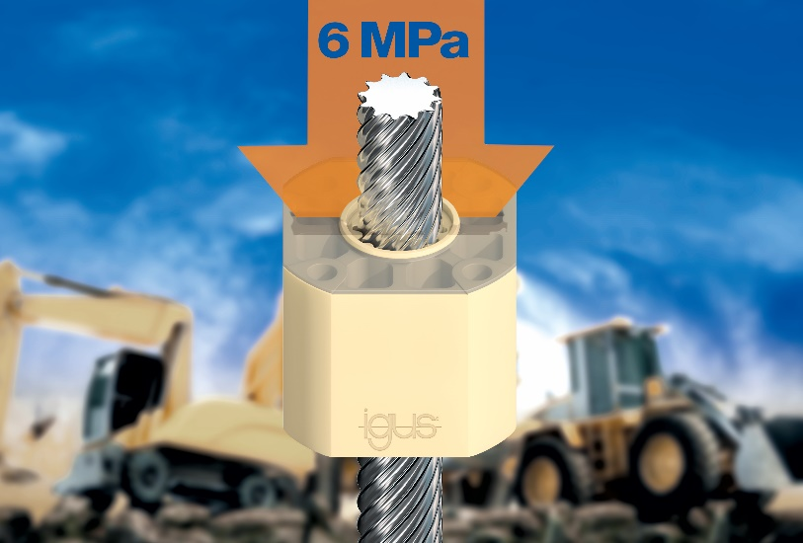
Picture PM4820-1
The new cost-effective and lubrication-free, injection-moulded dryspin heavy-duty nut in combination with a stainless steel plate can withstand loads of up to 6 MPa. (Source: igus GmbH)

PRESS CONTACT:  Oliver Cyrus  Head of PR and Advertising  Anja Görtz-Olscher  PR and Advertising  igus® GmbH  Spicher Str. 1a  51147 Cologne  Tel. 0 22 03 / 96 49-459 or -7153  Fax 0 22 03 / 96 49-631  ocyrus@igus.net  agoertz@igus.net  www.igus.eu/press | ABOUT IGUS:  igus GmbH is a global leading manufacturer of energy chain systems and polymer plain bearings. The Cologne-based family business has offices in 35 countries and employs 4,150 people around the world. In 2019, igus generated a turnover of 764 million euros from motion plastics, plastic components for moving applications. igus operates the largest test laboratories and factories in its sector to offer customers quick turnaround times on innovative products and solutions tailored to their needs.

The terms "igus", “Apiro”, "chainflex", "CFRIP", "conprotect", "CTD", “drygear”, "drylin", "dry-tech", "dryspin", "easy chain", "e-chain", "e-chain systems", "e-ketten", "e-kettensysteme", "e-skin", "e-spool”, "flizz", “ibow”, “igear”, "iglidur", "igubal", “kineKIT”, "manus", "motion plastics", "pikchain", "plastics for longer life", "readychain", "readycable", “ReBeL”, "speedigus", "triflex", "robolink", “xirodur”, and "xiros" are protected by trademark laws in the Federal Republic of Germany and internationally, where applicable.

