Greater efficiency in production with igus lightweight iglidur polymer linear bearings
New, cost-effective drylin linear bearing ensures fast, lubrication-free movements

igus, a motion plastics specialist, showcases what plastics can do with its first drylin W linear bearing made entirely of tribo-polymers. The linear bearing has been developed specifically for linear movements. At just ten grammes, it is quick to install, vibration-dampening, lubrication-free and ideal for transportable applications. The fact that it is injection moulded makes it very cost-effective. The injection moulding-optimised design also reduces its weight, lowering the necessary linear system drive energy.

Durable, lightweight and low-cost: the new drylin W linear bearing from igus. It is made entirely of iglidur polymer, so it can be manufactured quickly, simply and cost-effectively with injection moulding. The liner and linear housing are combined in a single component that simplifies handling, from storage to installation. The iglidur polymer bearing weighs up to 84% less than classic linear bearings with their metallic housings. There is thus less mass to move, so force, motor output and energy consumption falls. The slim bearing, just ten grammes at Installation Size 10, has several advantages for those new to linear technology who need a simple linear guide for applications, such as adjusting tabletop devices, cameras, sensors or monitors. The bearing is made of iglidur JB, a tribologically optimised high-performance polymer, so it needs no lubrication or maintenance and is durable and resistant to dust and dirt. The black material is remarkable for its very low coefficient of friction in dry running and very low stick-slip tendency. The polymer bearing can handle loads of up to 25 newtons with ease, as tests performed in our 3,800 square metre in-house laboratory in Cologne show. It is also impact-resistant and robust while remaining elastic and damping so that it can absorb and dissipate vibrations.
Cost-effective econ system with an elegant design
The new bearing can be installed very easily on any drylin W single rails or double rails. If the user is looking for a cost-effective linear guide, igus's clear anodised drylin W WS-CA aluminium rails are a good choice. Combining the two materials – silver aluminium and black bearing material – gives the user a complete solution with a simple, elegant design.

You can find information about the new iglidur polymer bearing here:
www.igus.eu/wjbmp

Caption:

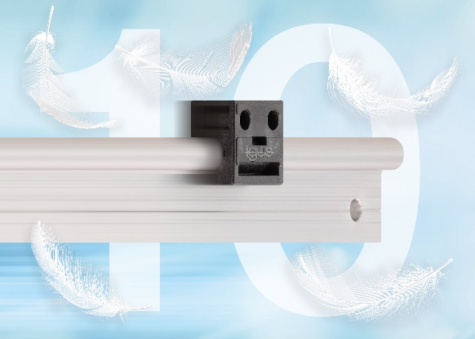
Picture PM3221-1
The lightweight drylin W polymer bearing (just ten grammes at Installation Size 10) reduces costs, weight and the necessary linear system drive energy. (Source: igus GmbH)

PRESS CONTACT:  Oliver Cyrus  Head of PR and Advertising  Anja Görtz-Olscher  PR and Advertising  igus® GmbH  Spicher Str. 1a  51147 Cologne  Tel. 0 22 03 / 96 49-459 or -7153  Fax 0 22 03 / 96 49-631  ocyrus@igus.net  agoertz@igus.net  www.igus.eu/press | ABOUT IGUS:  igus GmbH develops and produces motion plastics. These lubrication-free, high-performance polymers improve technology and reduce costs wherever things move. In energy supplies, highly flexible cables, plain and linear bearings as well as lead screw technology made of tribo-polymers, igus is the worldwide market leader. The family-run company based in Cologne, Germany, is represented in 35 countries and employs 3,800 people across the globe. In 2019, igus generated a turnover of €764 million. Research in the industry's largest test laboratories constantly yields innovations and more security for users. 234,000 articles are available from stock and the service life can be calculated online. In recent years, the company has expanded by creating internal startups, e.g. for ball bearings, robot drives, 3D printing, the RBTX platform for Lean Robotics and intelligent "smart plastics" for Industry 4.0. Among the most important environmental investments are the "chainge" programme – recycling of used e-chains - and the participation in an enterprise that produces oil from plastic waste. (Plastic2Oil).

The terms "igus", “Apiro”, "chainflex", "CFRIP", "conprotect", "CTD", “drygear”, "drylin", "dry-tech", "dryspin", "easy chain", "e-chain", "e-chain systems", "e-ketten", "e-kettensysteme", "e-skin", "e-spool”, "flizz", “ibow”, “igear”, "iglidur", "igubal", “kineKIT”, "manus", "motion plastics", "pikchain", "plastics for longer life", "readychain", "readycable", “ReBeL”, "speedigus", "tribofilament“, "triflex", "robolink", “xirodur”, and "xiros" are protected by trademark laws in the Federal Republic of Germany and internationally, where applicable.

