From XXL trucks to virtual/real trade show stands: igus trade shows start with 175 motion plastics innovations
Improve what moves: igus shows how this can be achieved with tribo-plastics at its roadshows, at trade shows and on the internet

With a selection of 175 motion plastics innovations, the igus in-house exhibition is back on tour this year. Whether as a pop-up trailer or as an XXL road show truck: with the mobile trade show stand, customers have the opportunity to see and experience the motion plastics of interest to them directly on site. If you prefer digital information, you can also get to know the latest lubrication-free and maintenance-free tribo-components online at the award-winning virtual/real igus trade show stand.

igus presented 175 plastic innovations and product range extensions from all motion plastics areas at the Hannover Messe this year: these include a plain bearing range made of regranulated plastics, the world's first tribo 3D printing resin for very small components or a particularly cost-effective, smart monitoring unit for sliding e-chain systems for €248. With many of these new products to present, the igus in-house exhibition is now back on tour and can be easily booked for an individual visit. As an alternative to the classic trade show, a modular pop-up stand on 50 quare metres offers an exhibition area with the latest from the world of lubrication-free and maintenance-free motion plastics. For colder days, the new roadshow truck is an alternative: conversations can be conducted comfortably and in a pleasant fully air-conditioned atmosphere, even at lower temperatures. When it comes to product solutions for cost-effective automation in particular, igus sends the Low Cost Automation Van onto the road. It visits users along with robolink articulated arm, delta and linear robots, such as the smart ReBeL for €4,970. The focus is in particular on the direct implementation of an application on the customer's premises, which brings a quick return on investment.

Prefer real or virtual? igus makes both possible
Whether trailer, truck or van: the focus of all variants is personal contact in a relaxed and familiar environment. igus employees discuss the possible uses of the products together with customers, present innovations and help with the design. Visitors will also be introduced to the latest state of the art of tribo-technology. An offer especially for employees who do not travel to trade shows and therefore cannot experience igus products live. "Taking things into your hands, trying them out and then engaging in a personal exchange is still important for many users," notes Tobias Vogel, CEO of Plain Bearings and Linear Technology at igus. "We can see this at the roadshow as well as at the currently reoccurring events, such as the Hannover Messe or automatica, where we are presenting our products." If desired, igus also offers interested companies this opportunity with a special info corner. The regional sales representative provides them with individual samples and further information. Around 5,000 display stands have already been set up worldwide, 2,200 of them in Germany alone. Another convenient way to find out about the new products is the igus motion plastics show (IMPS). The real-life stand, which is around 400 square metres in size, can be accessed online and, in the latest version 3.0, provides multimedia and mobile information on the subject, "improve what moves". The IMPS, which won the iF Design Award, is part of the digital support offered to customers; furthermore, personal tours, as well as individual and group meetings at the stand can also be arranged.

Caption:

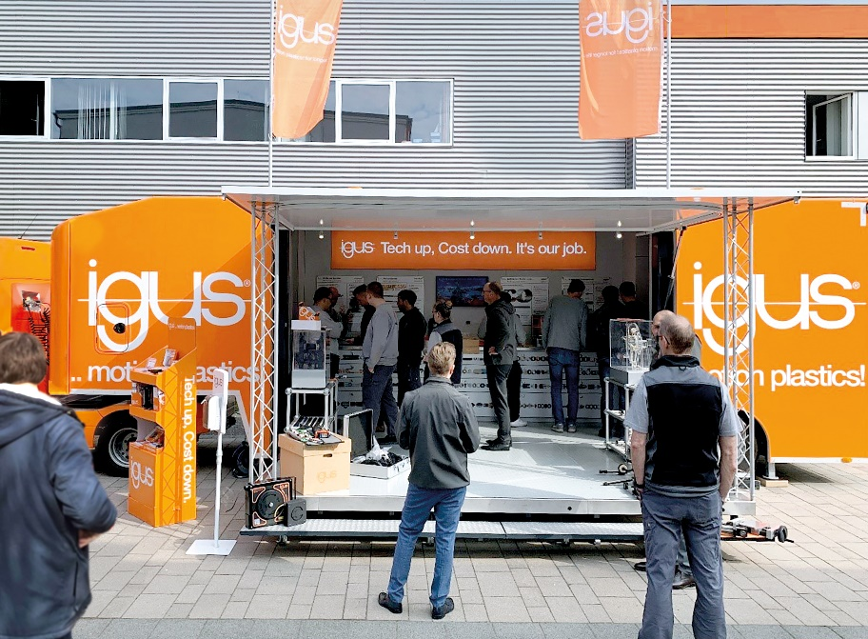
Picture PM3422-1
The new XXL roadshow truck from igus visits customers and showcases an individual selection of 175 motion plastics innovations directly on site. (Source: igus GmbH)

PRESS CONTACT:

Alexa Heinzelmann
Head of International Marketing

igus® GmbH
Spicher Str. 1a
51147 Cologne
Tel. 0 22 03 / 96 49-7272
aheinzelmann@igus.net
www.igus.eu/press

ABOUT IGUS:

igus GmbH develops and produces motion plastics. These lubrication-free, high-performance polymers improve technology and reduce costs wherever things move. In energy supplies, highly flexible cables, plain and linear bearings as well as lead screw technology made of tribo-polymers, igus is the worldwide market leader. The family-run company based in Cologne, Germany, is represented in 35 countries and employs 4,900 people across the globe. In 2021, igus generated a turnover of €961 million. Research in the industry's largest test laboratories constantly yields innovations and more security for users. 234,000 articles are available from stock and the service life can be calculated online. In recent years, the company has expanded by creating internal startups, e.g. for ball bearings, robot drives, 3D printing, the RBTX platform for Lean Robotics and intelligent "smart plastics" for Industry 4.0. Among the most important environmental investments are the "chainge" programme – recycling of used e-chains - and the participation in an enterprise that produces oil from plastic waste.

The terms "igus", “Apiro”, "chainflex", "CFRIP", "conprotect", "CTD", “drygear”, "drylin", "dry-tech", "dryspin", "easy chain", "e-chain", "e-chain systems", "e-ketten", "e-kettensysteme", "e-skin", "e-spool”, "flizz", “ibow”, “igear”, "iglidur", "igubal", “kineKIT”, "manus", "motion plastics", "pikchain", "plastics for longer life", "readychain", "readycable", “ReBeL”, "speedigus", "tribofilament“, "triflex", "robolink", “xirodur”, and "xiros" are protected by trademark laws in the Federal Republic of Germany and internationally, where applicable.

