From recycling to bicycling: igus develops bicycle components for the mobility of tomorrow
At Eurobike 2023, igus is showing recyclable and partly recycled components for bicycle manufacturers, including handlebars that are about to go into series production. The first customer for these items is Advanced, a bicycle manufacturer.

After presenting the entirely plastic igus:bike last year, igus is now presenting an additional product line made of high-performance plastics for bicycle manufacturers. Other lines include frames made from a single mould or several components, impellers, and cranksets. The handlebars are about to go into series production and will be used on the Advanced Reco bike. The handlebars are produced with compounded polymers igus developed in house and have vigirously tested in the vast igus bicycle laboratory. The products are recyclable and made partly from recycled material. Production will start in Cologne and be expanded to Asia and North America, so as to offer bike OEMs local supply chains.

Resource conservation is also becoming increasingly important in bicycle design and production. Transport, energy-intensive production, and component disposal make up the largest part of a bicycle's CO2 footprint. “We see plastic technology as a new option for the industry, with prospects for all components in bicycles. Our customers are increasingly demanding CO2 reduction, recyclability, durability, and local supply chains. At Eurobike in Frankfurt, we will present new solutions," says Jan Philipp Hollmann, Head of Business Unit bicycle components at igus. igus will present new catalogue products for bicycle manufacturers: ball bearings, cranksets, steering head bearings, and a freewheel made of high-performance plastics developed specifically for movement. Frames, impellers, and handlebars will be coming soon. Also in the pipeline are seat posts and saddle rails. The intrigue with this concept is that igus offers OEM customers everything from a single source: research and product development, tests in the in-house laboratory on what will soon be 25 test rigs dedicated to bicycle components, tool manufacture, and production with specially developed and compounded plastics. igus has been supplying plain bearings and other moving components to many well-known bicycle manufacturers and high-quality components for over 30 years. In the future, bike OEMs will be locally supplied from 12 factories on four continents.

Advanced is the first customer: recyclable handlebars for the Reco bike
igus has now implemented the first customer project with Advanced, a bicycle manufacturer and pioneer that has successfully launched a next-generation e-bike. The highlight here is the Reco frame is made of plastic and is entirely recyclable. In order to consistently pursue this approach, newly developed igus handlebars will now be used in the Reco bike. These are made from high-performance polymers in a special manufacturing process and are therefore just as stable as its aluminium counterpart. But production requires significantly less energy and is performed locally at the igus headquarter in Cologne. The handlebars are also entirely recyclable. Production uses the injection moulding process, so the handlebars are cast in one piece without any weld seams. "We have completely redeveloped this manufacturing process for this kind of curved part with high stability and cavities. This allows us to freely choose the plastics, implement various colours and even create internal feed-throughs for wiring and shifter cables," says Hollmann.

Bicycle made from recycled plastic serves as a "test laboratory" for the industry
The development of the all-plastic bicycle, the igus:bike, which was presented at the 2022 Hannover Messe, is also working sucessfully with co-developer mtrl, based in the Netherlands. The result will be a solid plastic bike with frames and wheels made of post-consumer waste, such as shampoo bottles and ocean fishing nets. All the bike's wear parts are made of durable igus tribo-polymers. The goal is a bicycle that does not rust, requires no maintenance or lubrication, and can be entirely recycled. igus calls the project a "live test laboratory for the bicycle industry". At the beginning of September 2023, the first Cologne bikes should reach the market. "Everything that we learn and successfully implement here, we are making available to the bike OEMs as catalogue or custom-made products," says Hollmann. Another part of the project is the igus:bike platform, which allows further partnerships, ideas, and offers a way to share knowledge. igus' goal is to promote plastics expertise in the bicycle industry and to work with many other manufacturers to refine the concept and advance the global plastics circular economy.
Caption:

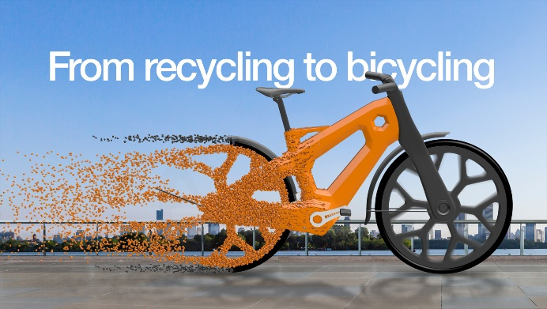
Picture PM3323-1
"From recycling to bicycling": igus is advancing the development of plastic bicycle components. (Source: igus GmbH)

PRESS CONTACT:

Alexa Heinzelmann
Head of International Marketing

igus® GmbH
Spicher Str. 1a
51147 Cologne
Tel. 0 22 03 / 96 49-7272
aheinzelmann@igus.net
www.igus.eu/press

ABOUT IGUS:

igus GmbH develops and produces motion plastics. These lubrication-free, high-performance polymers improve technology and reduce costs wherever things move. In energy supplies, highly flexible cables, plain and linear bearings as well as lead screw technology made of tribo-polymers, igus is the worldwide market leader. The family-run company based in Cologne, Germany, is represented in 31 countries and employs 4,600 people across the globe. In 2022, igus generated a turnover of €1,15 billion. Research in the industry's largest test laboratories constantly yields innovations and more security for users. 234,000 articles are available from stock and the service life can be calculated online. In recent years, the company has expanded by creating internal startups, e.g. for ball bearings, robot drives, 3D printing, the RBTX platform for Lean Robotics and intelligent "smart plastics" for Industry 4.0. Among the most important environmental investments are the "chainge" programme – recycling of used e-chains - and the participation in an enterprise that produces oil from plastic waste.

The terms "igus", “Apiro”, "chainflex", "CFRIP", "conprotect", "CTD", “drygear”, "drylin", "dry-tech", "dryspin", "easy chain", "e-chain", "e-chain systems", "e-ketten", "e-kettensysteme", "e-skin", "e-spool”, "flizz", “ibow”, “igear”, "iglidur", "igubal", “kineKIT”, "manus", "motion plastics", "pikchain", "plastics for longer life", "readychain", "readycable", “ReBeL”, "speedigus", "tribofilament“, "triflex", "robolink", “xirodur”, and "xiros" are protected by trademark laws in the Federal Republic of Germany and internationally, where applicable.

