Artificial intelligence and automation: SMEs must not miss the boat
Low Cost Automation from Germany promises obstacle-free entry into the robot era

Accountants, journalists and even computer scientists are all amazed at how rapidly automation is developing, including with artificial intelligence. Industry representatives are, too. They are drawing new ideas for smart factories. Many traditional SMEs, however, are in danger of falling behind. Low Cost Automation can provide immediate assistance and help them avoid missing the boat.

According to the International Federation of Robotics (IFR), more and more robots are carrying out work in factories. In 2022, the global stock reached a new record of 3.5 million robots, worth an estimated €15.7 billion. Still, the world is a long way from rapid growth, according to a study that McKinsey, a management consultancy firm, recently conducted on the occasion of automatica 2023, a major trade show. In today's manufacturing landscape, the authors see a small number of factories that set automation standards - from artificial intelligence to digital twins to self-learning robots. Artificial intelligence in particular proved to be one of the topics that dominated automatica. The rapid pace of development here heralds a new era of automation. The study indicates that the majority of factories are still a long way from the levels of digitisation and automation that are actually possible today. They risk falling behind in a time of rapid change.

Low Cost Automation is becoming a market segment with great growth potential
How can not only big players with serious budgets, but also SMEs that have so far had little contact with these issues, participate in the future of AI automation? The key here is Low Cost Automation, automation solutions that are inexpensive and undemanding. The market segment has great growth potential. Low Cost Automation providers have increasingly entered the market in recent years, offering robots at a fraction of the price of classic industrial robots. They use web shops to allow solution configuration in a few clicks - without expensive integrators. And, thanks to so-called no-code technology, robots can even be controlled as easily as a computer game. IFR figures indicate that these important factors can easily be adjusted. They show that programming and integrating a robot application currently accounts for up to 70% of the total costs.

RBTX.com: inexpensive robot components from different manufacturers from a single source with price and compatibility guarantees
igus GmbH is one of the providers of Low Cost Automation. To enable SMEs to enter the automation age, the Cologne-based plastics company builds robots at competitive prices. The ReBeL, for example, costs only €4,970 in Germany. The "made in Cologne" cobot is made almost entirely of high-performance plastic and suitable for such applications as loading and unloading machines in industry and serving beer in service. To help interested parties find exactly the right automation solution for their application and budget, igus has created RBTX.com. The online marketplace brings together manufacturers and users of low-cost robotics. Over 100 partners now offer their products here. An online tools allows the combination of robots, machine frames, grippers, conveyor belts etc. and even the testing of movement - very simply with drag and drop in a 3D model on the computer. In future, these functions will also be available in virtual reality. igus has already created its own metaverse for this - the iguverse. No programming knowledge is required.

95% of solutions involve an investment of less than €12,000
"Several thousand SMEs from all over the world have already implemented automation solutions on RBTX.com – from an earthworm farm to a baker who packs doughnuts," says Alexander Mühlens, Head of the Low Cost Automation Business Unit at igus. "95% of the more than 400 solutions involve an investment of less than €12,000. Since the launch of RBTX, we have seen increasing interest. The platform offers more low-cost solutions than any other we know of. We have now provided consultation on over 2,500 projects and sent several thousand robots to the global market. Of course, you have to remember that not every task can be automated with low-cost robotics - especially when very heavy loads need moving or extreme precision is required. However, a wide range of work steps can be automated cost-effectively today. In addition to medium-sized companies, large corporations also use the platform. Every euro saved or quickly amortised counts. The advantage of RBTX is that users get low-cost robotic components from different manufacturers from a single source - and always with a price and compatibility guarantee. Providers have the opportunity to open up new target groups and sales channels for their products. It's a win-win situation for everyone involved."

Caption:

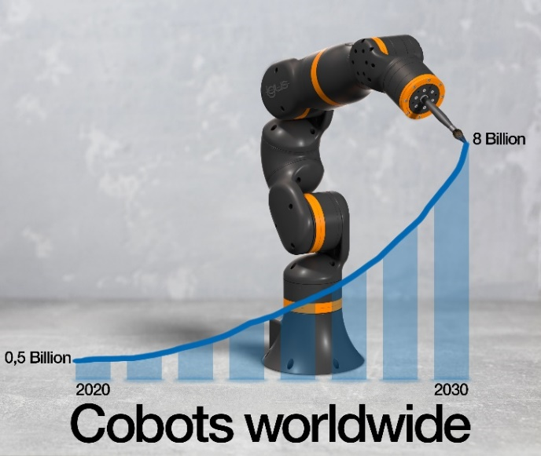
Picture PM3723-1
The global stock of robots is growing continuously. The market volume for collaborative robots alone could be worth eight billion US dollars by 2030. The low-cost igus ReBeL Cobot allows even SMEs easy entry into the automation age. (Source: igus GmbH)

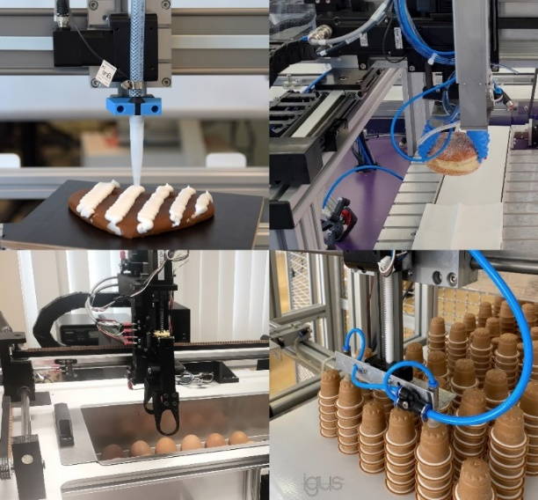
Picture PM3723-2
From operating machines in a factory to picking doughnuts to dosing precisely, the RBTX online marketplace features over 400 cost-effective, immediately usable robotic solutions that are revolutionising our working environment. (Source: igus GmbH)

PRESS CONTACT:

Alexa Heinzelmann
Head of International Marketing

igus® GmbH
Spicher Str. 1a
51147 Cologne
Tel. 0 22 03 / 96 49-7272
aheinzelmann@igus.net
www.igus.eu/press

ABOUT IGUS:

igus GmbH develops and produces motion plastics. These lubrication-free, high-performance polymers improve technology and reduce costs wherever things move. In energy supplies, highly flexible cables, plain and linear bearings as well as lead screw technology made of tribo-polymers, igus is the worldwide market leader. The family-run company based in Cologne, Germany, is represented in 31 countries and employs 4,600 people across the globe. In 2022, igus generated a turnover of €1,15 billion. Research in the industry's largest test laboratories constantly yields innovations and more security for users. 234,000 articles are available from stock and the service life can be calculated online. In recent years, the company has expanded by creating internal startups, e.g. for ball bearings, robot drives, 3D printing, the RBTX platform for Lean Robotics and intelligent "smart plastics" for Industry 4.0. Among the most important environmental investments are the "chainge" programme – recycling of used e-chains - and the participation in an enterprise that produces oil from plastic waste.

The terms "igus", “Apiro”, "chainflex", "CFRIP", "conprotect", "CTD", “drygear”, "drylin", "dry-tech", "dryspin", "easy chain", "e-chain", "e-chain systems", "e-ketten", "e-kettensysteme", "e-skin", "e-spool”, "flizz", “ibow”, “igear”, "iglidur", "igubal", “kineKIT”, "manus", "motion plastics", "pikchain", "plastics for longer life", "readychain", "readycable", “ReBeL”, "speedigus", "tribofilament“, "triflex", "robolink", “xirodur”, and "xiros" are protected by trademark laws in the Federal Republic of Germany and internationally, where applicable.

