Seven in one go: new chainflex series saves 35 per cent cable costs in Top Drives
Tested and safe cable package with motor, data & hybrid cables for offshore e-loop from igus

igus has developed the e-loop especially for hanging installations in extremely challenging applications, such as deep drilling rigs. The extremely robust energy chain system safely guides cables vertically and is already replacing more and more service loops worldwide. With the new CFSPECIAL.5 series, there is now also the matching igus cable range for the e-loop. A combination of seven chainflex cables makes cost savings of 35 per cent possible.

To guide cables safely in hanging applications and harsh environments, igus has developed the e-loop as an alternative to the frequently used service loop. This is because in a service loop the cables have no guide and no defined bend radius, they cannot move and break. When servicing or repairing, the complete system must be replaced. As an extremely resilient three-dimensional energy supply system, the e-loop combines the advantages of a polymer energy chain with a high-strength pull rope. The rope absorbs the tensile forces inside the chain and transmits them to the mounting brackets. The modular e-chain has a defined bend radius and withstands vibrations and shocks thanks to PU protectors - ideal for use in drilling rigs or bucket wheel excavators. To match the e-loop, igus now presents the CFSPECIAL.5 cable series.

Chain, cable, guarantee, assembly: everything from one source
The cable package for the e-loop will be available in the first quarter of 2021 and consists of seven different types of cable: three single-core cables of different cross sections, a protective conductor, two data cables and a hybrid cable. The selection is based on the current Top Drive systems on the market and is continuously adapted. All chainflex cables are available without minimum order quantity. Due to the availability as a catalogue part, the usual lengthy and expensive individual production is no longer necessary. With the igus complete package consisting of chain, cable, harnessing and installation, the customer finally benefits from the delivery of all components from a single source and the guarantee that all components are ideally matched. Due to the tests in the 3,800 square metre test laboratory, igus is able to certify this. At the same time, the harnessed readychain system reduces procurement time by almost 90 per cent and assembly time by 68 per cent.
e-loop series available in different versions
The e-loop series is available in different sizes and variants, such as the version with crossbars every 2nd link. The new design is used statically, e.g. in oil drilling rigs for energy supply from the mast to the power container. The e-loop is also available with rollers and handle modules so that it can be easily moved from A to B over the floor at quay facilities. igus offers a "drop safe" version with additional screw locking as well as a stainless steel bracket option.

More information and videos about the CFSPECIAL series for Top Drives can be found at https://www.igus.eu/info/n20-cf-topdrive-cable.

Caption:

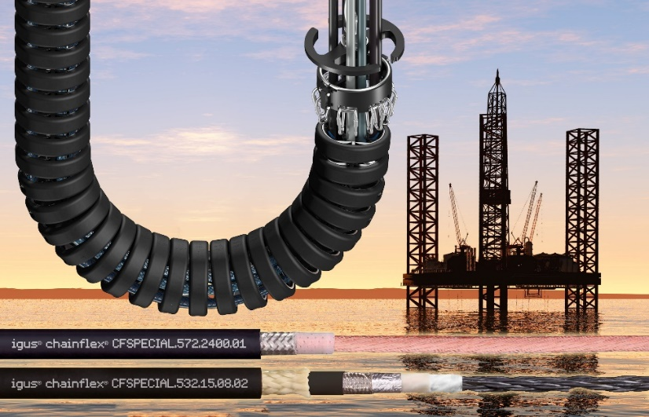
Picture PM6620-1
Tested, safe and fast delivery: the cable package consisting of seven chainflex cables is adapted for use in the e-loop from igus. (Source: igus GmbH)

PRESS CONTACT:  Oliver Cyrus  Head of PR and Advertising  Anja Görtz-Olscher  PR and Advertising  igus® GmbH  Spicher Str. 1a  51147 Cologne  Tel. 0 22 03 / 96 49-459 or -7153  Fax 0 22 03 / 96 49-631  ocyrus@igus.net  agoertz@igus.net  www.igus.eu/press | ABOUT IGUS:  igus GmbH develops and produces motion plastics. These lubrication-free, high-performance polymers improve technology and reduce costs wherever things move. In energy supplies, highly flexible cables, plain and linear bearings as well as lead screw technology made of tribo-polymers, igus is the worldwide market leader. The family-run company based in Cologne, Germany, is represented in 35 countries and employs 3,800 people across the globe. In 2019, igus generated a turnover of €764 million. Research in the industry's largest test laboratories constantly yields innovations and more security for users. 234,000 articles are available from stock and the service life can be calculated online. In recent years, the company has expanded by creating internal startups, e.g. for ball bearings, robot drives, 3D printing, the RBTX platform for Lean Robotics and intelligent "smart plastics" for Industry 4.0. Among the most important environmental investments are the "chainge" programme – recycling of used e-chains - and the participation in an enterprise that produces oil from plastic waste. (Plastic2Oil).

The terms "igus", “Apiro”, "chainflex", "CFRIP", "conprotect", "CTD", “drygear”, "drylin", "dry-tech", "dryspin", "easy chain", "e-chain", "e-chain systems", "e-ketten", "e-kettensysteme", "e-skin", "e-spool”, "flizz", “ibow”, “igear”, "iglidur", "igubal", “kineKIT”, "manus", "motion plastics", "pikchain", "plastics for longer life", "readychain", "readycable", “ReBeL”, "speedigus", "tribofilament“, "triflex", "robolink", “xirodur”, and "xiros" are protected by trademark laws in the Federal Republic of Germany and internationally, where applicable.

