Configure and order individual CNC parts online in just three minutes
igus is adding new functions to its online CNC Service 2.0, including live feasibility analysis and service life prediction

Time is sometimes of the essence. An example is when a machine is due for maintenance, but the required component is not in stock. The igus online CNC Service 2.0 allows orders for machined parts made of tribologically optimised high-performance plastics (optimised for friction and wear) to be processed in just a few minutes.

Sending design drawings by e-mail, waiting for a feasibility assessment, clarifying issues by telephone: All these steps take time and are tiring. "To make it as easy as possible for our customers and to reduce coordination effort, especially in time-critical cases, we launched our online CNC service in October 2020," says Patrick Schwitalla, iglidur bar stock lean engineer at igus. "The positive customer feedback motivated us to stay on the ball and develop new functions and an improved user interface for the tool. Now order processing is even faster and more convenient – with just a few clicks". The service is already available in Germany and Austria and will be rolled out in other countries later this year.

Automated feasibility and tolerance checks in seconds
Users can just upload a 3D model of their component as a STEP file and immediately receive an automated feasibility analysis with transparent price information. They also receive visual feedback on production-critical issues directly in the tool. This feature is constantly being expanded. The tool also indicates when it cannot calculate something due to complexity or for manufacturing reasons. Transparency is crucial here. igus also offers the option of uploading technical drawings as PDF or image files for automatic checking within seconds. The user receives immediate feedback on tolerances and other information on the drawing. The tool highlights infeasible dimensional, geometrical, and positional tolerances directly on the drawing and suggests corrections.

Transparent, reliable service life prediction
This is the basis for providing reliable pricing information. Depending on the material, quantity, delivery time, and tolerance selection, the price adjusts as the parameters change, ensuring optimum transparency and decision support at all times. Another feature that will soon be available in the tool is the integrated service life prediction for sliding applications. igus collects data from numerous tests in its in-house laboratory so that the product service life can be calculated quickly and easily. If everything is all right, the components can be added to the igus shopping cart to request a quotation or for direct online ordering. Then, the application can quickly go into production. If the customer opts for express processing, the machined components can be ready to ship in as little as three days. "The advantage is that customers get everything from one source," says Schwitalla. "Online tool, diverse material selection, production, individual consultation – it all comes straight from igus. Our all-round service gets customers their special CNC part in a very short time – as conveniently as possible. And the large material variety of self-lubricating, highly wear-resistant plastics means that the right solution can be found for almost any application."

Production line back in operation on time thanks to online CNC service
It's a service that has already proven its worth in practice – for example at Dr. Quendt GmbH, the largest food manufacturer of Christmas treats such as Dresden Christmas cakes. "We wanted to make efficient use of a short maintenance interval to replace existing PA bearings with iglidur bearings," says Tom Oldach, project engineer at Dr. Quendt GmbH. "The fast quotation calculation and express shipping from the igus online CNC Service enabled us to procure the parts in just a few days and get the production line up and running again on time."

More information on the igus online CNC Service can be found here: https://www.igus.eu/info/cnc-machining-online

Caption:

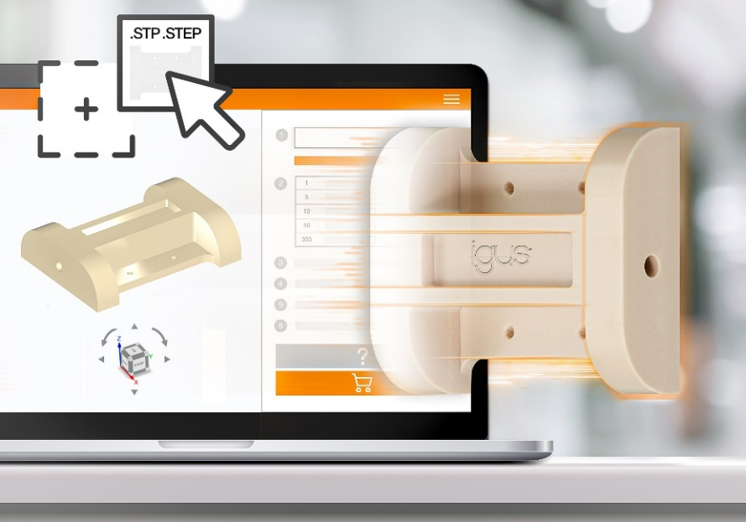
Picture PM5123-1
A machined part made of durable high-performance plastic in just a few clicks: the online CNC Service 2.0 offers transparent instant calculation, live feasibility analysis, service life calculation, and faster, greatly simplified order processing. (Source: igus GmbH)

PRESS CONTACT:

Alexa Heinzelmann
Head of International Marketing

igus® GmbH
Spicher Str. 1a
51147 Cologne
Tel. 0 22 03 / 96 49-7272
aheinzelmann@igus.net
www.igus.eu/press

ABOUT IGUS:

igus GmbH develops and produces motion plastics. These lubrication-free, high-performance polymers improve technology and reduce costs wherever things move. In energy supplies, highly flexible cables, plain and linear bearings as well as lead screw technology made of tribo-polymers, igus is the worldwide market leader. The family-run company based in Cologne, Germany, is represented in 31 countries and employs 4,600 people across the globe. In 2022, igus generated a turnover of €1,15 billion. Research in the industry's largest test laboratories constantly yields innovations and more security for users. 234,000 articles are available from stock and the service life can be calculated online. In recent years, the company has expanded by creating internal startups, e.g. for ball bearings, robot drives, 3D printing, the RBTX platform for Lean Robotics and intelligent "smart plastics" for Industry 4.0. Among the most important environmental investments are the "chainge" programme – recycling of used e-chains - and the participation in an enterprise that produces oil from plastic waste.

The terms "igus", “Apiro”, "chainflex", "CFRIP", "conprotect", "CTD", “drygear”, "drylin", "dry-tech", "dryspin", "easy chain", "e-chain", "e-chain systems", "e-ketten", "e-kettensysteme", "e-skin", "e-spool”, "flizz", “ibow”, “igear”, "iglidur", "igubal", “kineKIT”, "manus", "motion plastics", "pikchain", "plastics for longer life", "readychain", "readycable", “ReBeL”, "speedigus", "tribofilament“, "triflex", "robolink", “xirodur”, and "xiros" are protected by trademark laws in the Federal Republic of Germany and internationally, where applicable.

