New lubrication-free, maintenance-free igus plain bearings for the automotive industry of the future
Alternative to metal: iglidur H5 series bearings are particularly robust, chemical-resistant and lightweight

Robust, corrosion-free, chemical-resistant and lightweight - the automotive industry places high demands on plain bearings, for everything from engine compartments to windscreen wipers. Since many bearing materials reach their limits here, igus, the Cologne-based plastics specialist, is launching an alternative: plain bearings made from iglidur H5, the new high-performance plastic.

Plain bearings in the chassis or gearbox, convertible top systems or pedals should be robust, durable and corrosion-free. When used in windscreen wipers, for instance, they should also be resistant to a wide range of chemicals. Lightweight is also important to increase range and reduce power consumption. "This is comparable to a flyweight boxer who has to survive in the super heavyweight division," says Stefan Loockmann-Rittich, Head of Business Unit iglidur Plain Bearings at igus. But throwing in the towel is not an option. "In order to meet the increasing demands of the automotive industry, we have developed iglidur H5, a new high-performance plastic for plain bearings."

A high bar: iglidur H5 is 30% more wear-resistant than its predecessor
iglidur H5 is the fifth member of the iglidur H series. All previous materials in the product range are often more durable and fail-safe in automotive engineering than most plain bearings made from metal composites and conventional plastics. "With iglidur H5, we have now raised the bar even higher," says Loockmann-Rittich. "Long-term tests in our in-house test laboratory have shown that iglidur H5 is up to 30% more wear-resistant than its predecessor, H4." This improvement was achieved by further optimising the formulation. The significantly improved impact resistance and flexibility of the new iglidur H5 material complement the materials in the H series, which are also fibre-reinforced, primarily for higher loads, while remaining relatively hard and therefore brittle. iglidur H5 is also resistant to high loads and force application, but much tougher than iglidur H3 and H4, for example.
iglidur H5: robust with as little as one-fifth the weight of alternative materials and resistant to temperatures of up to 200°C
Automotive engineering has many possible applications for the new plain bearings. iglidur H5 can be used in windscreen wipers, for instance, which must work reliably under heavy loads - such as layers of snow. "We have therefore added fibres and filling materials to the base polymer. They enable the plain bearings to withstand high forces, edge loads, impacts and shocks, even under continuous load," says Loockmann-Rittich. The new material is also resistant to road salt, chemicals, fuels, oils and high temperatures (up to 200°C). It is therefore also suitable for components in the engine compartment, such as water and coolant pumps. "iglidur H5 is a refined material that ideally prepares us for current and future requirements in the automotive industry." But the new polymer plain bearings can also be used in pumps in chemical plants and other industrial applications.

Caption:

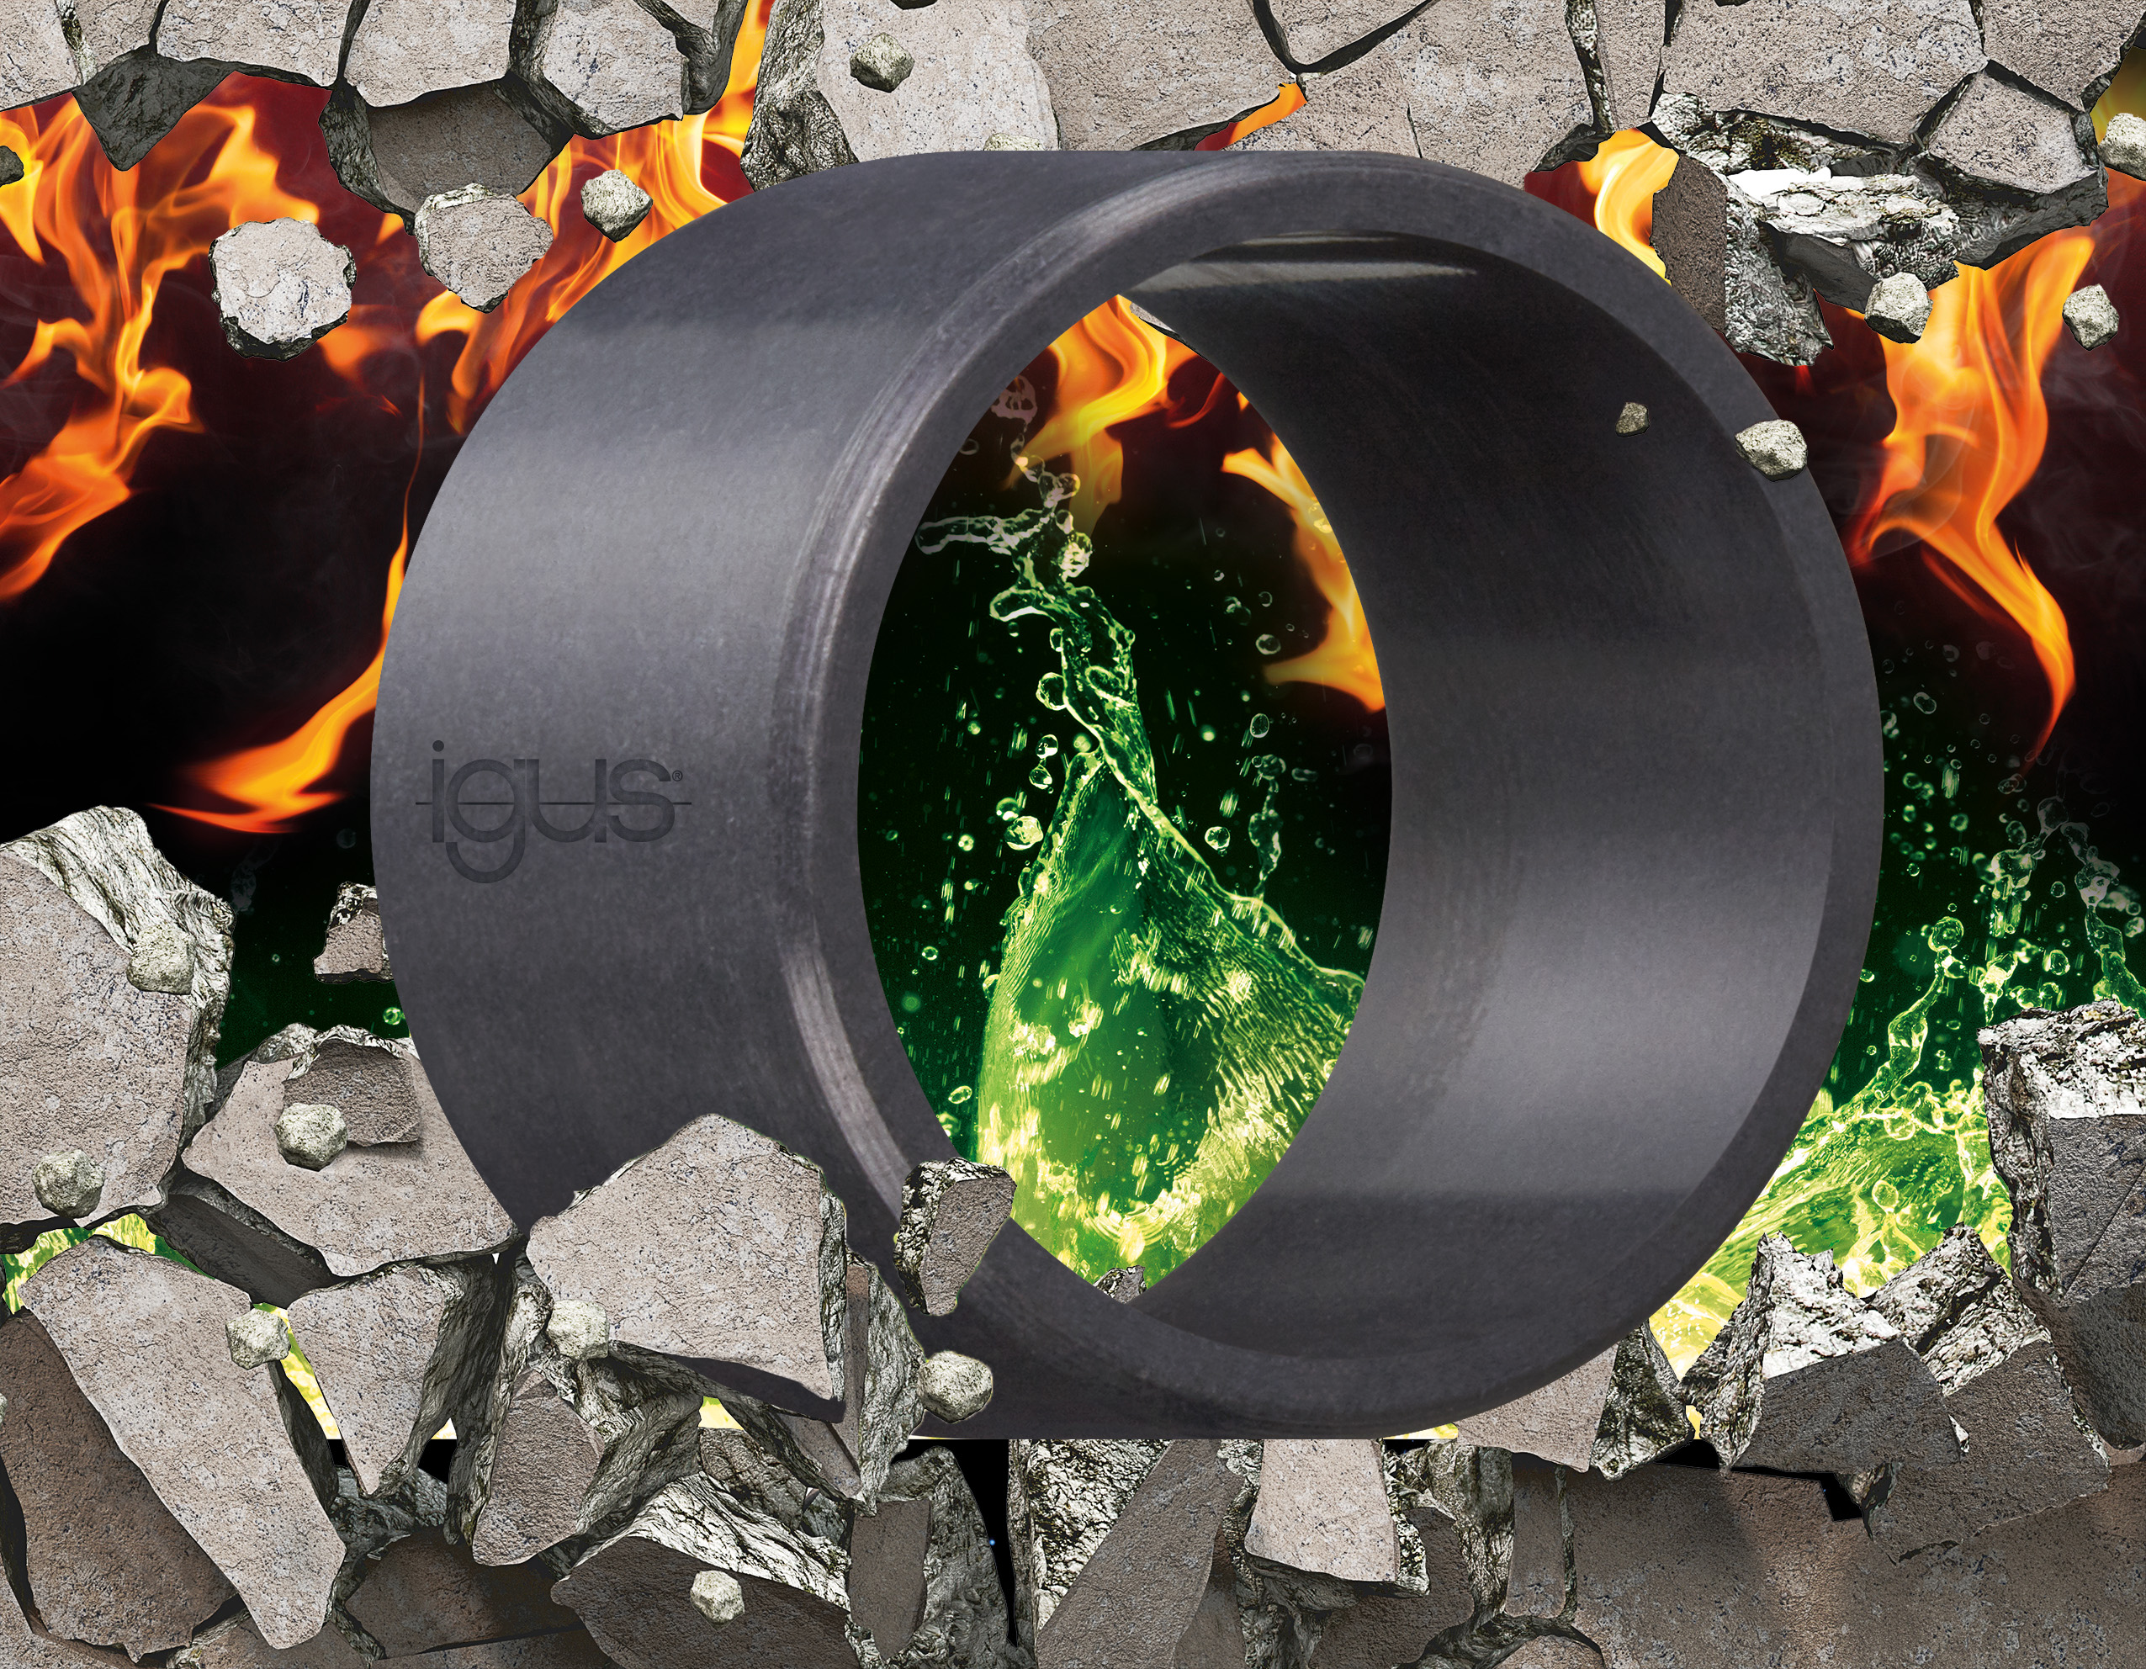
Picture PM5222-1
igus developed the chemical-resistant iglidur H5 tribo-plain bearing material especially for corrosive environments where high temperatures, edge pressures and impact loads occur. (Source: igus GmbH)

PRESS CONTACT:

Alexa Heinzelmann
Head of International Marketing

igus® GmbH
Spicher Str. 1a
51147 Cologne
Tel. 0 22 03 / 96 49-7272
aheinzelmann@igus.net
www.igus.eu/press

ABOUT IGUS:

igus GmbH develops and produces motion plastics. These lubrication-free, high-performance polymers improve technology and reduce costs wherever things move. In energy supplies, highly flexible cables, plain and linear bearings as well as lead screw technology made of tribo-polymers, igus is the worldwide market leader. The family-run company based in Cologne, Germany, is represented in 35 countries and employs 4,900 people across the globe. In 2021, igus generated a turnover of €961 million. Research in the industry's largest test laboratories constantly yields innovations and more security for users. 234,000 articles are available from stock and the service life can be calculated online. In recent years, the company has expanded by creating internal startups, e.g. for ball bearings, robot drives, 3D printing, the RBTX platform for Lean Robotics and intelligent "smart plastics" for Industry 4.0. Among the most important environmental investments are the "chainge" programme – recycling of used e-chains - and the participation in an enterprise that produces oil from plastic waste.

The terms "igus", “Apiro”, "chainflex", "CFRIP", "conprotect", "CTD", “drygear”, "drylin", "dry-tech", "dryspin", "easy chain", "e-chain", "e-chain systems", "e-ketten", "e-kettensysteme", "e-skin", "e-spool”, "flizz", “ibow”, “igear”, "iglidur", "igubal", “kineKIT”, "manus", "motion plastics", "pikchain", "plastics for longer life", "readychain", "readycable", “ReBeL”, "speedigus", "tribofilament“, "triflex", "robolink", “xirodur”, and "xiros" are protected by trademark laws in the Federal Republic of Germany and internationally, where applicable.

