Sustainability at the touch of a button with the e-chain in Drop Water beverage vending machines
The new miniature filling system from California uses igus motion plastics to reduce transport and the use of plastic bottles

The Drop Station is a new sustainable beverage vending machine that fills compostable containers with customised beverages at the touch of a button. The water for the vending machine does not need to be transported, since the kiosk can be connected to a water source on site. A linear robot with drylin linear guides mixes the beverages and dispenses them. Harnessed e-chains ensure protection for the chainflex energy and data cables.

You can find them in airports, supermarkets and train stations: beverage vending machines from Drop Water, based in California. Customers can use a touch display to select a beverage from the Drop Station. They then receive an individually filled, compostable container filled with tap water filtered at the point of sale and, according to the customer's wishes, may contain caffeine or be flavoured or heated or cooled to a certain temperature. The new vending machine allows Drop Water to decentralise the process of bottle filling by having the self-service kiosk function as a miniature filling system. The company's approach is much more environmentally friendly than that of conventional providers of bottled water. It eliminates the need for transporting filled bottles. "The Drop Container is a large part of what makes our kiosks unique. Each Drop Station has a supply of empty, compostable containers that can be refilled as necessary. The customer can also use their own bottles", says Scott Edwards, CEO of Drop Water. The heart of the vending machine is a linear robot that manufactures and dispenses beverages. It is also supplied with energy and data. Although an energy chain was used, there were cable failures in the prototypes. It was found that the cables rotated slowly during each cycle, so they were twisted after 1,000 cycles. A second problem was harnessing. In order to avoid having to continually buy, cut, modify and assemble every single component, the company needed a functioning, ready-to-connect solution.

Looking for a better system
Thanks to the right interior separation and a fully harnessed readychain igus e-chain system, the vending machine now functions perfectly. This saves the company a great deal of installation time and costs. Drop Water also turned to igus for the linear robot and the output unit. The mechanical system consists of maintenance-free drylin W and drylin N rails and carriages. "We are proud to work with a forward-looking, socially responsible company like Drop Water, and we wish them many years of success as we contribute to all the movements that will keep our planet clean and free from pollution for the generations to come", says Rick Abbate, Vice President of igus Inc.﻿ USA. The project convinced the judges for the seventh vector awards. The prize is awarded once every two years and distinguishes creative energy chain applications from all over the world. Drop Water received the green vector award, which was awarded to two sustainable projects for the first time.
Find out more about Drop Water:
https://youtu.be/kR6rBpCXZyQ

Caption:
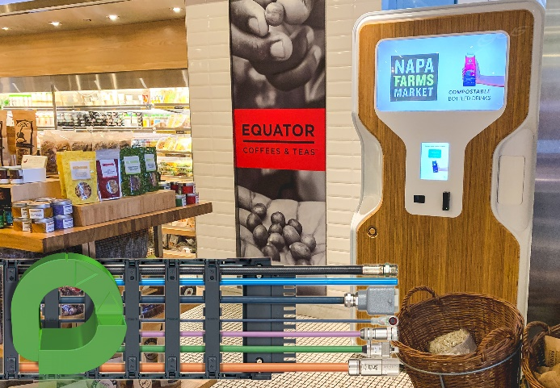
Picture PM3821-1
A harnessed readychain safely guides the cables in the Drop Station. The project was awarded the green vector for its sustainability. (Source: igus GmbH)

ABOUT IGUS:

igus GmbH develops and produces motion plastics. These lubrication-free, high-performance polymers improve technology and reduce costs wherever things move. In energy supplies, highly flexible cables, plain and linear bearings as well as lead screw technology made of tribo-polymers, igus is the worldwide market leader. The family-run company based in Cologne, Germany, is represented in 35 countries and employs 4,150 people across the globe. In 2020, igus generated a turnover of €727 million. Research in the industry's largest test laboratories constantly yields innovations and more security for users. 234,000 articles are available from stock and the service life can be calculated online. In recent years, the company has expanded by creating internal startups, e.g. for ball bearings, robot drives, 3D printing, the RBTX platform for Lean Robotics and intelligent "smart plastics" for Industry 4.0. Among the most important environmental investments are the "chainge" programme – recycling of used e-chains - and the participation in an enterprise that produces oil from plastic waste (Plastic2Oil).

PRESS CONTACT:

Oliver Cyrus Anja Görtz-Olscher
Head of PR and Advertising Manager PR and Advertising

igus® GmbH igus® GmbH
Spicher Str. 1a Spicher Str. 1a
51147 Cologne 51147 Cologne
Tel. 0 22 03 / 96 49-459 Tel. 0 22 03 / 96 49-7153
ocyrus@igus.net agoertz@igus.net
www.igus.de/presse www.igus.de/presse

The terms "igus", “Apiro”, "chainflex", "CFRIP", "conprotect", "CTD", “drygear”, "drylin", "dry-tech", "dryspin", "easy chain", "e-chain", "e-chain systems", "e-ketten", "e-kettensysteme", "e-skin", "e-spool”, "flizz", “ibow”, “igear”, "iglidur", "igubal", “kineKIT”, "manus", "motion plastics", "pikchain", "plastics for longer life", "readychain", "readycable", “ReBeL”, "speedigus", "tribofilament“, "triflex", "robolink", “xirodur”, and "xiros" are protected by trademark laws in the Federal Republic of Germany and internationally, where applicable.

