igus energy supply, the only one of its kind in the world, makes jib cranes safer
Space-saving, durable and cost-effective: guidelok swing is to establish itself as an alternative to classic festoons

Energy and data cables hanging from jib cranes often pose a great risk. Careless movement of loads, forklifts or other slewing crane systems in the immediate vicinity can cause them to become entangled and torn off. igus has therefore developed the guidelok swing, the only energy supply system of its kind in the world. It can be installed directly in the T-beam contour, and a special rocker system allows it to be used for long beam lengths cost-effectively with little wear. This significantly increases operational safety.

Jib cranes are an indispensable part of industry. They transport workpieces of all kinds - to loading ramps, processing machines and assembly stations. However, failures can always occur - for example, when hanging cable loops are damaged by a forklift during workpiece unloading. The result is downtime, unplanned repair costs and even production delays. "To increase system safety and productivity, we have developed a new energy supply system called the guidelok swing," says Theo Diehl, Head of Industry Management Cranes at igus. "Energy and data cables no longer hang in the air, but move directly in the jib crane's girder contour thanks to the energy supply system's particularly slim, space-saving design. They stay out of the reach of lifted loads, industrial vehicles or other jib cranes."

A technical design trick ensures fail-safe operation
And this is how the system works: the energy and data cables are fitted in an energy chain made of high-performance plastic. The lower run rests on the T-beam flange and is connected to the trolley. Unlike traditional chain applications, the guidelok swing moves the lower run. The upper run is held above the trolley by the guidelok swing's rocker elements. A classic energy chain movement would normally involve the upper run gliding on the lower run. igus, however, has introduced a design trick: every 800 millimetres, rockers are screwed to the T-beam crossbar. When the upper run passes, the chain radius pushes the rocker flaps up and engages. In the opposite movement, the flaps open like a trapdoor and release the upper run again. The advantage is that the upper and lower runs never touch. Wear is therefore low, extending the energy supply system's service life. "Another advantage is that the guidelok swing eliminates the need for a guide trough, since the e-chain is held in position by the rockers and cannot break out sideways," says Diehl. "The energy supply system is therefore also cost-effective, since it costs about as much as classic festoons." Existing systems can also be converted more quickly because there is no guide trough.

The world's first users have been won over
SEW-Eurodrive is the first to use the new guide system. The German drive technology manufacturer has equipped an indoor crane with the guidelok swing at its plant in Gauteng, South Africa. The crane moves components for chemical cleaning with a high-pressure cleaner. "Initially, the engineers considered working with classic festoon systems," Diehl recalls. "But Sales Manager Marius Ferreira from our partner Stahl Cranes and Hoists quickly convinced them that the new guidelok swing guide system reduced the risk of accidents and increased crane reliability." The energy supply system not only prevents collisions with forklifts, but is also chemical-resistant and corrosion-free and requires no maintenance or external lubricants. SEW-Eurodrive is enthusiastic about the solution, as is an industrial company in South Africa, Barloworld, which has announced that it will work with Stahl Cranes and Hoists to gradually convert more jib cranes in its workshops.

Caption:

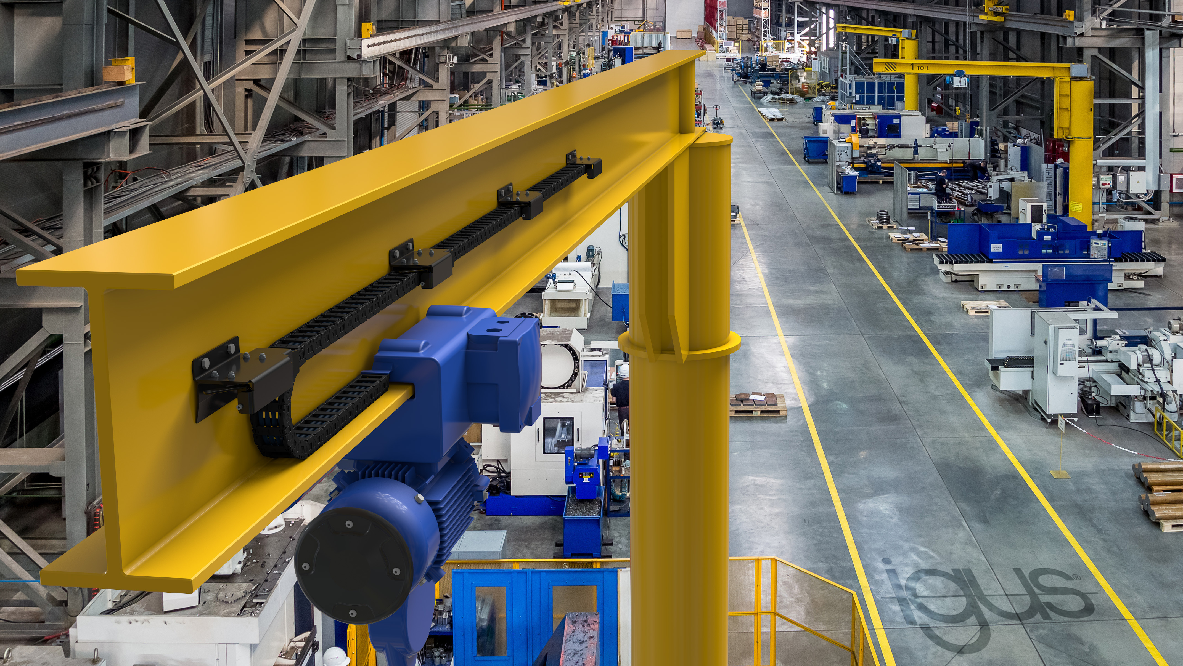
Picture PM1923-1
The igus guidelok swing energy supply system, the only one of its kind anywhere in the world, increases crane system reliability and productivity. (Source: igus GmbH)

PRESS CONTACT:

Alexa Heinzelmann
Head of International Marketing

igus® GmbH
Spicher Str. 1a
51147 Cologne
Tel. 0 22 03 / 96 49-7272
aheinzelmann@igus.net
www.igus.eu/press

ABOUT IGUS:

igus GmbH develops and produces motion plastics. These lubrication-free, high-performance polymers improve technology and reduce costs wherever things move. In energy supplies, highly flexible cables, plain and linear bearings as well as lead screw technology made of tribo-polymers, igus is the worldwide market leader. The family-run company based in Cologne, Germany, is represented in 31 countries and employs 4,900 people across the globe. In 2021, igus generated a turnover of €961 million. Research in the industry's largest test laboratories constantly yields innovations and more security for users. 234,000 articles are available from stock and the service life can be calculated online. In recent years, the company has expanded by creating internal startups, e.g. for ball bearings, robot drives, 3D printing, the RBTX platform for Lean Robotics and intelligent "smart plastics" for Industry 4.0. Among the most important environmental investments are the "chainge" programme – recycling of used e-chains - and the participation in an enterprise that produces oil from plastic waste.

The terms "igus", “Apiro”, "chainflex", "CFRIP", "conprotect", "CTD", “drygear”, "drylin", "dry-tech", "dryspin", "easy chain", "e-chain", "e-chain systems", "e-ketten", "e-kettensysteme", "e-skin", "e-spool”, "flizz", “ibow”, “igear”, "iglidur", "igubal", “kineKIT”, "manus", "motion plastics", "pikchain", "plastics for longer life", "readychain", "readycable", “ReBeL”, "speedigus", "tribofilament“, "triflex", "robolink", “xirodur”, and "xiros" are protected by trademark laws in the Federal Republic of Germany and internationally, where applicable.

