Still more choice: two new hybrid cables from igus suitable for Bosch Rexroth and Siemens
Guaranteed reliability with new cables for MS2N motors of Bosch Rexroth and Siemens SINAMICS S210 drives

Energy and data transmission bundled in one cable: hybrid technology is gaining acceptance among more and more drive manufacturers. In view of this ongoing trend, igus is expanding its chainflex cable portfolio with two new hybrid cables: one is the CF280.UL.H401 with PUR jacket suitable for the modular drive system ctrlX DRIVE from Bosch Rexroth for synchronous servo motors of the MS2N series. The other is the proven hybrid cable for Siemens SINAMICS S210 drives, now with PVC outer jacket.

Hybrid technology has been one of the biggest trends in the cable industry in recent years, which igus has also embraced. With over 30 different types, igus has the largest portfolio of highly flexible hybrid cables, which consists of two series: CF280.UL with PUR outer jacket and CF220.UL with PVC outer jacket. igus relies on two different jacket materials so that the right one can be selected individually for different applications and external conditions. For example, the jacket made of oil-resistant PVC is the ideal partner for use in the energy chain due to its high abrasion resistance when it comes to high cycle numbers in dry areas - for example in woodworking machines. PVC is designed for ambient temperatures of +5°C to +70°C. PUR, on the other hand, has an exceptionally high notch and oil resistance. This makes the halogen-free PUR cables suitable for use in the energy chain, especially with very high oil loads, e.g. in a machine tool. In addition, it works reliably in an extended temperature range from -25°C to +80°C. The chainflex cables are available from stock, sold by the metre and as harnessed products, and are designed to match the well-known manufacturer standards. "To be able to offer our customers more and more solutions for the drive systems of a wide range of manufacturers, we are continuously expanding our cable range. That is why we are now offering two new hybrid cables suitable for Bosch Rexroth and Siemens," explains Rainer Rössel, Head of Business Unit chainflex Cables at igus.

More solutions for different areas of application
With the PUR hybrid cable CF280.UL.H401 for synchronous servo motors of the MS2N series, igus is adding a product for the modular drive system ctrlX DRIVE from Bosch Rexroth to its portfolio. The new cable is suitable for applications with a bend factor of up to 15 x d and can therefore be used in a wide range of industries - from machine tools and material handling to the automotive industry. In addition, igus is now offering its hybrid cable as CF220.UL.H304 with PVC outer jacket to match Siemens SINAMICS S210 drives. "Our customers can now also use the proven hybrid cable with a 15.3% more cost-effective PVC jacket for applications in dry environments. This additionally reduces costs in the hybrid cable segment, giving customers the choice between two technically identical cables with different jacket qualities, depending on the area of application," says Rainer Rössel. "This allows us to implement even more diversity and offer our customers additional individual solutions for their applications." By using chainflex cables, users also save around 40% installation space in the energy chain and 43% material weight compared to opting for separate servo and measuring system cables. The fact that the system needs to drive less weight also means that a lower amount of energy is needed.

Tested with millions of cycles for guaranteed fail-safe performance
The highly flexible cables are specifically designed for use in moving applications, and guarantee a long service life even with high dynamics. Each cable is specially adapted to the respective motor type. Like all igus chainflex cables, the new hybrid cables have also been tested under real conditions with millions of cycles. Based on the test results collected in the 3,800-square-metre in-house laboratory, the cable specialist can make a service life statement for its cables. This data also flows into an online tool, with the help of which customers can calculate the service life of their cable very easily and in the shortest possible time. As the only manufacturer on the market, igus therefore also offers a guarantee of up to 36 months on its entire cable range. This gives customers additional security for planning their application.

Caption:

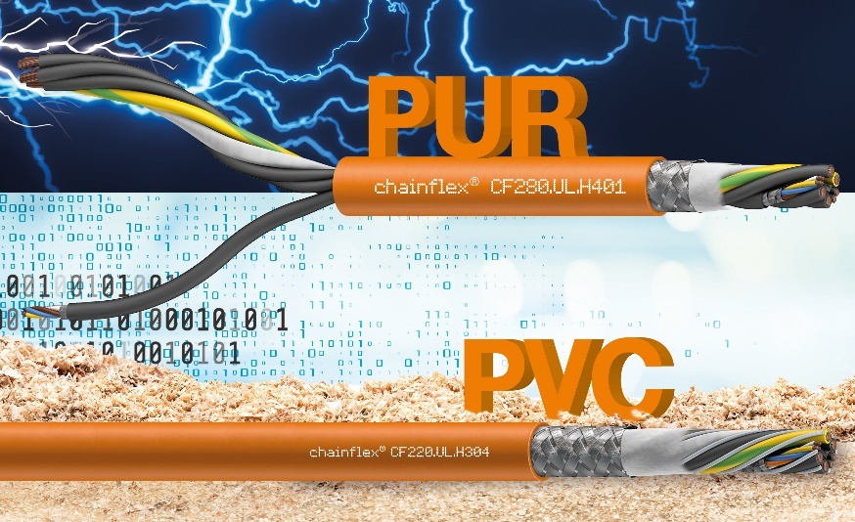
Picture PM0123-1
Whether PUR or PVC: igus offers the right hybrid cable for every application - e.g. for MS2N motors from Bosch Rexroth and Siemens SINAMICS S210 drives. (Source: igus GmbH)

PRESS CONTACT:

Alexa Heinzelmann
Head of International Marketing

igus® GmbH
Spicher Str. 1a
51147 Cologne
Tel. 0 22 03 / 96 49-7272
aheinzelmann@igus.net
www.igus.eu/press

ABOUT IGUS:

igus GmbH develops and produces motion plastics. These lubrication-free, high-performance polymers improve technology and reduce costs wherever things move. In energy supplies, highly flexible cables, plain and linear bearings as well as lead screw technology made of tribo-polymers, igus is the worldwide market leader. The family-run company based in Cologne, Germany, is represented in 31 countries and employs 4,900 people across the globe. In 2021, igus generated a turnover of €961 million. Research in the industry's largest test laboratories constantly yields innovations and more security for users. 234,000 articles are available from stock and the service life can be calculated online. In recent years, the company has expanded by creating internal startups, e.g. for ball bearings, robot drives, 3D printing, the RBTX platform for Lean Robotics and intelligent "smart plastics" for Industry 4.0. Among the most important environmental investments are the "chainge" programme – recycling of used e-chains - and the participation in an enterprise that produces oil from plastic waste.

The terms "igus", “Apiro”, "chainflex", "CFRIP", "conprotect", "CTD", “drygear”, "drylin", "dry-tech", "dryspin", "easy chain", "e-chain", "e-chain systems", "e-ketten", "e-kettensysteme", "e-skin", "e-spool”, "flizz", “ibow”, “igear”, "iglidur", "igubal", “kineKIT”, "manus", "motion plastics", "pikchain", "plastics for longer life", "readychain", "readycable", “ReBeL”, "speedigus", "tribofilament“, "triflex", "robolink", “xirodur”, and "xiros" are protected by trademark laws in the Federal Republic of Germany and internationally, where applicable.

