E-car wallboxes: no more tangled cables
igus presents design study for automatic and compact cable retraction system
One quick tug and the power cable rolls up: with the e-tract 2.0 automatic retraction system, igus wants to make charging on wallboxes a bit more convenient for e-car owners. The special feature: thanks to the ingenious interplay of two guide rollers, long extension lengths are possible with limited installation space.

Many e-car owners will be familiar with the dilemma: after charging the vehicle on the in-house wallbox, they would have to wind up the power cable by hand. But lethargy triumphs. The cable stays on the ground. Unprotected from wind and weather, it presents a tripping hazard and is unsecured. "We are therefore working on a compact retraction system that automatically retracts the cable - just as easy as with a vacuum cleaner," says Jörg Ottersbach, Head of Business Unit e-chains at igus. Although the system is currently still a design study, implementation is planned. Laboratory tests have already been carried out. "To offer a solution that is as simple and space-saving as possible, igus plans to integrate the wallbox electronics into the e-tract 2.0 system."

Long extension lengths with limited installation space
The system is particularly compact thanks to the ingenious interplay of two guide rollers. The rollers sit at the ends of the rectangular housing. The cables are wound up in multiple tracks like with a pulley. If the user pulls the power cable, the lower guide roller moves towards the upper roller on a linear rail while unwinding. "This dynamic multiple deflection allows us to achieve long extension lengths with limited installation space," explains Ottersbach. The cable can be extended up to a length of five metres. The user can then conveniently attach the connector to the vehicle. To give the system full freedom of movement, the housing is mounted on a swivel base. After charging, a short tug is enough and the system automatically rewinds the cable. This means that the cables do not pose any risk to the users.

Usable for many years without maintenance
The retraction system is designed to last. Weatherproof and UV-resistant plastics are used in the housing, some of which are recyclates. The rollers are made of high-performance plastic that is gentle on cables. The cable itself also has a defined bend radius. Another special feature of the design: the power connection, which is connected to the wallbox, does not rotate during unwinding. A slip ring, which is indispensable for classic cable drums, is therefore superfluous. "This design principle makes our retraction system more fail-safe," emphasises Ottersbach. "Wallbox owners will also be able to use the automatic retraction system outdoors for many years without maintenance." The same applies to many other areas of application, from control panels to wired tools on assembly lines and work tables.

Caption:
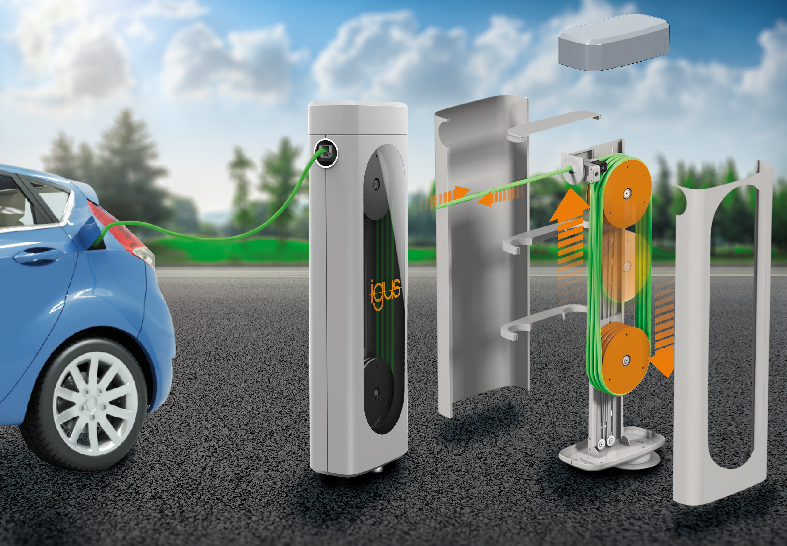
Picture PM5822-1
A tidy wallbox: the e-tract 2.0 system from igus protects the cables and makes it easy to roll up and unroll the cables. (Source: igus GmbH)

PRESS CONTACT:

Alexa Heinzelmann
Head of International Marketing

igus® GmbH
Spicher Str. 1a
51147 Cologne
Tel. 0 22 03 / 96 49-7272
aheinzelmann@igus.net
www.igus.eu/press

ABOUT IGUS:

igus GmbH develops and produces motion plastics. These lubrication-free, high-performance polymers improve technology and reduce costs wherever things move. In energy supplies, highly flexible cables, plain and linear bearings as well as lead screw technology made of tribo-polymers, igus is the worldwide market leader. The family-run company based in Cologne, Germany, is represented in 31 countries and employs 4,900 people across the globe. In 2021, igus generated a turnover of €961 million. Research in the industry's largest test laboratories constantly yields innovations and more security for users. 234,000 articles are available from stock and the service life can be calculated online. In recent years, the company has expanded by creating internal startups, e.g. for ball bearings, robot drives, 3D printing, the RBTX platform for Lean Robotics and intelligent "smart plastics" for Industry 4.0. Among the most important environmental investments are the "chainge" programme – recycling of used e-chains - and the participation in an enterprise that produces oil from plastic waste.

The terms "igus", “Apiro”, "chainflex", "CFRIP", "conprotect", "CTD", “drygear”, "drylin", "dry-tech", "dryspin", "easy chain", "e-chain", "e-chain systems", "e-ketten", "e-kettensysteme", "e-skin", "e-spool”, "flizz", “ibow”, “igear”, "iglidur", "igubal", “kineKIT”, "manus", "motion plastics", "pikchain", "plastics for longer life", "readychain", "readycable", “ReBeL”, "speedigus", "tribofilament“, "triflex", "robolink", “xirodur”, and "xiros" are protected by trademark laws in the Federal Republic of Germany and internationally, where applicable.

