e-skin flat ESD: for the highest level of safety and cleanliness in cleanrooms
igus is adding an electrostatically dissipative variant to its almost particle-free e-skin flat energy chain series

igus has added an ESD variant specifically for highly sensitive cleanrooms to its e-skin flat series. The modular ribbon cable's new material prevents the chain from becoming electrostatically charged while ensuring that it generates no particles, even during very fast movements. The modular design with individual pods also allows quick energy supply system filling.

In addition to particle-free cleanrooms, electronics and semiconductor industry production also requires machine components that are electrostatically dissipative. Even the smallest current surge from electrostatic charge can easily destroy the product. So, igus has added an ESD variant to its e-skin flat series. The new black e-skin flat is made of an electrostatically dissipative material. "The new material combines ESD approval, which is frequently required, with the proven e-skin flat's low particle emissions. The chain produces almost no particles and dissipates electronic charges directly," says Kira Weller, e-chain Product Manager at igus. "The new e-skin flat ESD gives us just the product our customers need to produce sensitive electronic components." The new cable is used by such companies as Weiss, an automation specialist, in its high-speed HP70 pick & place unit, which comes into play in such applications as material handling in the medical and pharmaceutical industries. Weiss is enthusiastic about the advantages of the e-skin flat ESD. The igus ribbon cable is much stronger and quieter and less susceptible to wear in quick movement than are classic corrugated hoses. The e-skin flat also features a modular design, unlike laminated ribbon cables made of polytetrafluoroethylene (PTFE). In the igus in-house cleanroom laboratory, which was developed with the Fraunhofer Institute, the new e-skin flat has already proven itself in the highest cleanroom class.

Easy cable replacement
"Single pod" profiles ensure quick, easy e-skin flat installation, so the energy supply system can be easily expanded. A zip-lock system allows easy cable replacement. "This is a big advantage over the widely-used PTFE ribbon cables, in which the stranded cores are welded in a continuous ribbon and cannot be separated. If a single wire breaks, users have to replace the entire system. That takes time and money," says Weller. "For our e-skin flat, we offer the CFCLEAN cable cores for transmitting energy, motor control, bus and Ethernet signals. This way, the user gets a ready-to-connect energy supply system directly from a single source." If longer travel distances (up to five metres) are needed, a support chain can be simply integrated into the pods. Spacers, connection elements from the e-skin flat series and the smart i.Cee EC.S ultrasonic condition monitoring sensor are also compatible with the new ESD chain.

Caption:
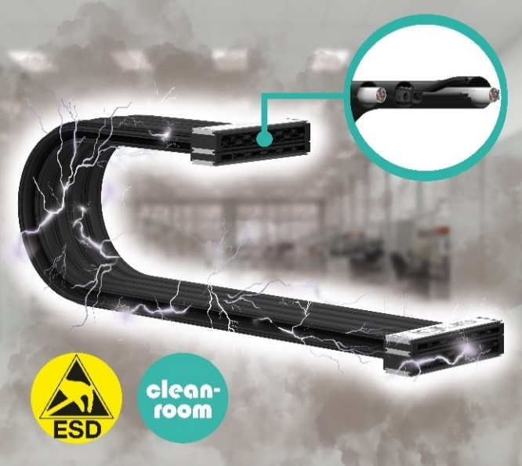
Picture PM4923-1
For safe, particle-free ESD-sensitive part production, igus has developed an electrostatically dissipative version of the e-skin flat - and it, too, has replaceable cables. (Source: igus GmbH)

PRESS CONTACT:

Alexa Heinzelmann
Head of International Marketing

igus® GmbH
Spicher Str. 1a
51147 Cologne
Tel. 0 22 03 / 96 49-7272
aheinzelmann@igus.net
www.igus.eu/press

ABOUT IGUS:

igus GmbH develops and produces motion plastics. These lubrication-free, high-performance polymers improve technology and reduce costs wherever things move. In energy supplies, highly flexible cables, plain and linear bearings as well as lead screw technology made of tribo-polymers, igus is the worldwide market leader. The family-run company based in Cologne, Germany, is represented in 31 countries and employs 4,600 people across the globe. In 2022, igus generated a turnover of €1,15 billion. Research in the industry's largest test laboratories constantly yields innovations and more security for users. 234,000 articles are available from stock and the service life can be calculated online. In recent years, the company has expanded by creating internal startups, e.g. for ball bearings, robot drives, 3D printing, the RBTX platform for Lean Robotics and intelligent "smart plastics" for Industry 4.0. Among the most important environmental investments are the "chainge" programme – recycling of used e-chains - and the participation in an enterprise that produces oil from plastic waste.

The terms "igus", “Apiro”, "chainflex", "CFRIP", "conprotect", "CTD", “drygear”, "drylin", "dry-tech", "dryspin", "easy chain", "e-chain", "e-chain systems", "e-ketten", "e-kettensysteme", "e-skin", "e-spool”, "flizz", “ibow”, “igear”, "iglidur", "igubal", “kineKIT”, "manus", "motion plastics", "pikchain", "plastics for longer life", "readychain", "readycable", “ReBeL”, "speedigus", "tribofilament“, "triflex", "robolink", “xirodur”, and "xiros" are protected by trademark laws in the Federal Republic of Germany and internationally, where applicable.

