manus award 2023: igus is once again looking for innovative plastic bearing applications
igus is awarding the manus award for the eleventh time for the most creative, economical and sustainable applications of polymer plain bearings
With immediate effect, igus is accepting submissions for the manus award 2023, which the plastics specialist has been conducting every two years for the last 20 years. The prize honours the most creative, economical and sustainable uses of plastic plain bearings in industrial applications. There was a record number of participants in 2021 with 582 submissions from 41 countries. The winners of the gold, silver, bronze and green manus awards will receive prize money of up to €5,000.

Regardless of whether it is a garbage truck, a packaging machine or an aircraft seat: engineers are increasingly using plain bearings made of high-performance plastics. The advantages are obvious: polymer bearings are lighter than metal bearings, improve energy efficiency, do not require any additional lubricants thanks to incorporated solid lubricants and therefore also protect the environment. "We are always surprised at the applications in which our polymer bearings are now used across industries," says Tobias Vogel, CEO of Plain Bearings & Linear Technology at igus. "To promote this positive development and reward innovative engineers, we are honouring the most innovative uses of polymer plain bearings in industrial applications with the manus award 2023." Users can now apply for the manus award 2023. igus will accept submissions until 10th February, 2023. Everything is possible, from series application up to custom pieces. The only requirement: there must be at least one finished prototype. A jury of experts from science, industry and specialist media will then award four prizes worth up to €5,000: the gold, silver and bronze manus award and the green manus award for the most sustainable application. The winners will receive their awards at Hannover Messe 2023.

manus award is becoming increasingly popular
igus has been hosting the manus award for 20 years and this year is the eleventh time. Over 3,000 applicants from all over the world have taken part in the competition in recent years. The 10th award anniversary took place in 2021 and attracted the record number of 582 submissions from 41 countries. The golden manus was awarded to Kässbohrer Geländefahrzeug AG. In the four oscillating axles of the PowerBully track vehicle, the vehicle manufacturer said goodbye to dirt-prone and maintenance-intensive metal plain bearings and instead opted for polymer iglidur TX1-type plain bearing bushings. For this application, igus had manufactured and tested the polymer bushings in previously unheard-of dimensions. Finbin won the green manus. The Finnish company developed a dustbin that uses solar energy to compact waste. Dirt-resistant and lubrication-free plain bearings made from tribologically optimised plastic iglidur G are used in the hatch, pedal and transmission linkage of the bin.

Terms and conditions of participation, participant applications and an overview of previous winners can be found at https://www.igus.eu/info/manus-award

Caption:

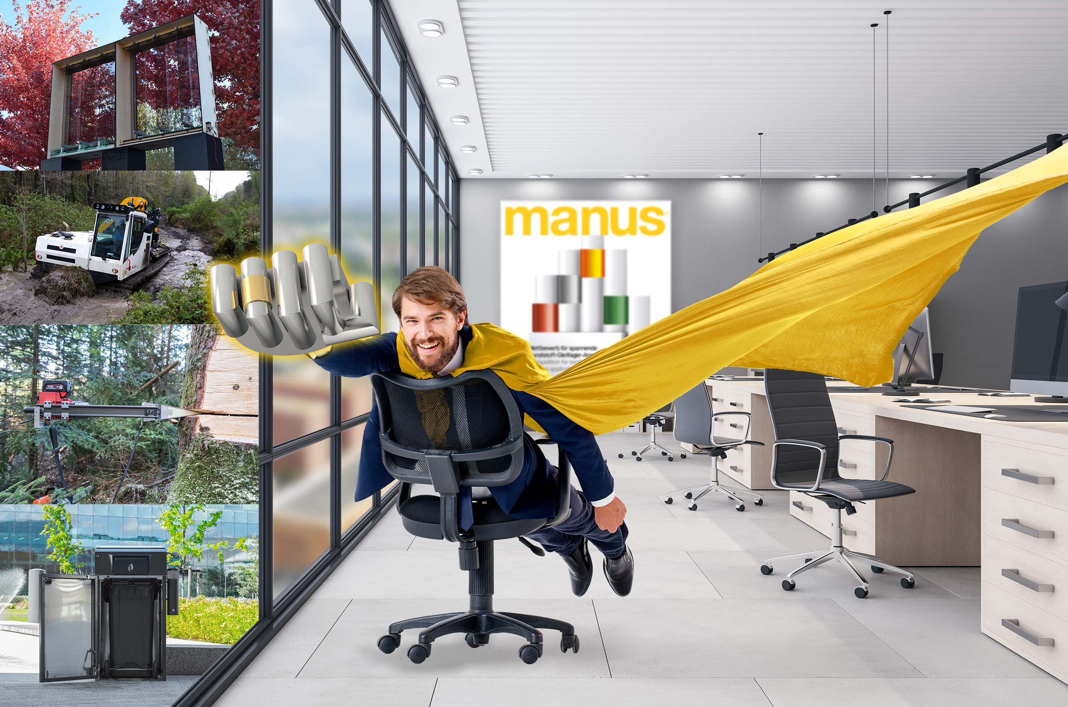
Picture PM5722-1
The manus award is entering the next round: whether garbage truck, packaging machine or aircraft seat - igus is once again looking for the most innovative applications for lubrication-free and maintenance-free igus polymer plain bearings. (Source: igus GmbH)

PRESS CONTACT:

Alexa Heinzelmann
Head of International Marketing

igus® GmbH
Spicher Str. 1a
51147 Cologne
Tel. 0 22 03 / 96 49-7272
aheinzelmann@igus.net
www.igus.eu/press

ABOUT IGUS:

igus GmbH develops and produces motion plastics. These lubrication-free, high-performance polymers improve technology and reduce costs wherever things move. In energy supplies, highly flexible cables, plain and linear bearings as well as lead screw technology made of tribo-polymers, igus is the worldwide market leader. The family-run company based in Cologne, Germany, is represented in 31 countries and employs 4,900 people across the globe. In 2021, igus generated a turnover of €961 million. Research in the industry's largest test laboratories constantly yields innovations and more security for users. 234,000 articles are available from stock and the service life can be calculated online. In recent years, the company has expanded by creating internal startups, e.g. for ball bearings, robot drives, 3D printing, the RBTX platform for Lean Robotics and intelligent "smart plastics" for Industry 4.0. Among the most important environmental investments are the "chainge" programme – recycling of used e-chains - and the participation in an enterprise that produces oil from plastic waste.

The terms "igus", “Apiro”, "chainflex", "CFRIP", "conprotect", "CTD", “drygear”, "drylin", "dry-tech", "dryspin", "easy chain", "e-chain", "e-chain systems", "e-ketten", "e-kettensysteme", "e-skin", "e-spool”, "flizz", “ibow”, “igear”, "iglidur", "igubal", “kineKIT”, "manus", "motion plastics", "pikchain", "plastics for longer life", "readychain", "readycable", “ReBeL”, "speedigus", "tribofilament“, "triflex", "robolink", “xirodur”, and "xiros" are protected by trademark laws in the Federal Republic of Germany and internationally, where applicable.

