Drynamic mobility: igus presents motion plastics relevant to mobility trends
igus experts will use live shows to demonstrate how plastics can permanently reduce costs and improve technical performance

Mobility is changing rapidly: e-scooters, e-bikes, and e-vehicles with alternative drives have long been commonplace. The concept of car sharing is establishing itself in major cities all over the world. Complementing IAA Mobility 2021 in Munich, igus is presenting its motion plastics products and innovations on six trending topics. Industry and plastics specialists will provide insights into the ways lubrication-free polymer solutions can contribute to sustainability. For instance, plain bearings, linear guides and energy chains made of polymers reduce lubricant, fuel consumption and weight. In a presentation on the topic of alternative drives, igus will show how polymer plain bearings can greatly reduce costs. A livestream on aerodynamics will deal with corrosion at bearing points in hinges. Whilst the experts in the slot on Value Engineering present the short-term services of igus for rapid development and product optimisation. Autonomous driving also requires design creativity from developers. igus shows how to reliably guide complicated moving cables. But cars are not the only mobility option in which polymer solutions are advantageous; in the increasingly popular bicycle, with or without battery power, polymer bearings have a long service life despite contact with dirt and water. igus bicycle experts will demonstrate a few true examples of weight and lubrication reduction.
The six presentations will be held live from the trade show stand in Cologne. All participants will have the opportunity to ask the experts questions immediately after the broadcasts. More information about free access to the shows can be found at www.igus.eu/drynamic-mobility-show-lp

Take a look at the show trailer: www.igus.eu/drynamic-mobility-trailer

Caption:
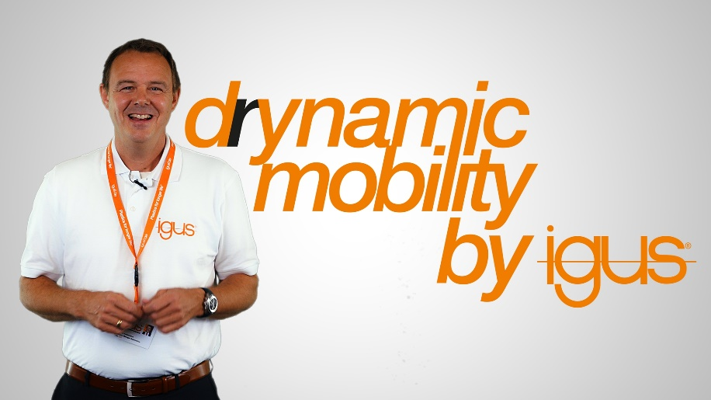
Picture PM4121-1
In six shows, igus plastics and industry experts will present motion plastics products relevant to trending issues. (Source: igus GmbH)

ABOUT IGUS:

igus GmbH develops and produces motion plastics. These lubrication-free, high-performance polymers improve technology and reduce costs wherever things move. In energy supplies, highly flexible cables, plain and linear bearings as well as lead screw technology made of tribo-polymers, igus is the worldwide market leader. The family-run company based in Cologne, Germany, is represented in 35 countries and employs 4,150 people across the globe. In 2020, igus generated a turnover of €727 million. Research in the industry's largest test laboratories constantly yields innovations and more security for users. 234,000 articles are available from stock and the service life can be calculated online. In recent years, the company has expanded by creating internal startups, e.g. for ball bearings, robot drives, 3D printing, the RBTX platform for Lean Robotics and intelligent "smart plastics" for Industry 4.0. Among the most important environmental investments are the "chainge" programme – recycling of used e-chains - and the participation in an enterprise that produces oil from plastic waste (Plastic2Oil).

PRESS CONTACT:

Oliver Cyrus Anja Görtz-Olscher
Head of PR and Advertising Manager PR and Advertising

igus® GmbH igus® GmbH
Spicher Str. 1a Spicher Str. 1a
51147 Cologne 51147 Cologne
Tel. 0 22 03 / 96 49-459 Tel. 0 22 03 / 96 49-7153
ocyrus@igus.net agoertz@igus.net
www.igus.de/presse www.igus.de/presse

The terms "igus", “Apiro”, "chainflex", "CFRIP", "conprotect", "CTD", “drygear”, "drylin", "dry-tech", "dryspin", "easy chain", "e-chain", "e-chain systems", "e-ketten", "e-kettensysteme", "e-skin", "e-spool”, "flizz", “ibow”, “igear”, "iglidur", "igubal", “kineKIT”, "manus", "motion plastics", "pikchain", "plastics for longer life", "readychain", "readycable", “ReBeL”, "speedigus", "tribofilament“, "triflex", "robolink", “xirodur”, and "xiros" are protected by trademark laws in the Federal Republic of Germany and internationally, where applicable.

