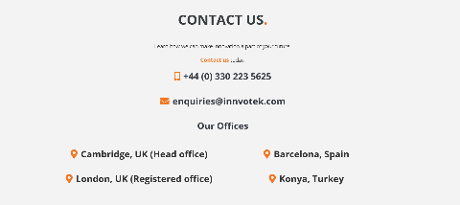
Batt2TheFuture
This project will develop an automated process for selecting spent electric vehicle batteries for second-life use. Our process, Batt2TheFuture aims to speed up and streamline the second life repurposing of end-of-life EV batteries cells. The automation of battery cell testing will dramatically reduce the assessment time of battery cells state of health (SoH) and state of charge (SoC). These performance parameters are key in determining whether the battery's cell can be reused for a second-life application or if it is defunct and needs to be recycled.

Batt2TheFuture goes beyond the current state-of-the-art and automatise:
- State of Health (SoH) and State of Charge (SoC) testing inspection, our solution has been designed to carry out battery cell level inspection compared to state-of-the-art module level inspection
- Inspection speed, Batt2TheFuture assesses the battery cell in 1 second compared to the typical 6-hours
- Agnostic to battery system, our solution can inspect any system layout
- Scalability, the process can easily be scaled to accommodate larger volumes of cells without any significant further capital investments.
- Increased product reliability, any cell that has been inspected and graded using Batt2TheFuture has the state of health ascribed to it, thereby offering increased cell reliability.
- Barcoding will provide traceability and will provide consistent and performance guaranty of second-life battery packs.
- Capacity – Throughput of circa 1000-2000 cells in an 8-hour shift (i.e 15s per cell)

