Smart Green Island Makeathon: igus promotes innovative ideas for the sustainable technologies of tomorrow
igus promotes an innovation festival on Gran Canaria and supports creative minds there with expertise and low-cost robotics

Designing, constructing and programming: that's what the Smart Green Island Makeathon on Gran Canaria was all about. It was recently held for the sixth time, organised by ITQ GmbH. The prototyping event brings students, universities and companies from all over the world together to develop the innovative, sustainable technologies of tomorrow. The focus is on such topics as robotics and automation, smart and green energy and smart mobility. One of the event's top sponsors is igus GmbH from Cologne, which supported the young talented people on site with expertise and low-cost robotics.

Innovation thanks to Education 4.0: that is the goal ITQ is pursuing with its Makeathon, in which interdisciplinary project teams spend four days working on prototypes for sustainable, innovative technologies. The event is aimed at international students and teachers from technical degree programmes - from programmers to engineers to IT specialists. The innovation festival gives them the opportunity to exchange ideas with companies and experts from industry, tackle real-world challenges and develop innovative solutions. The challenges can be set either by the companies or within the teams. The participants organise themselves into interdisciplinary groups in which everyone can contribute their individual skills. Many creative technical projects have already been developed in this way. This year, 364 people from 29 countries participated in the Makeathon, including 227 young people from 48 colleges and universities. They were supported by 25 companies.

Solutions for the digital future
The Smart Green Island Makeathon is focussed on the digital future. It addresses various topics, e.g. smart home, IoT, automation, robotics, smart farming, smart production, smart health, smart and green energy, smart mobility and connected systems. Students work on projects such as smart traffic monitoring and regulation or develop automated urban cultivation systems to produce fresh, sustainable food close to the city. They can also puzzle over innovative robotics applications, for instance for waste handling.

How robots can support sustainability
As a manufacturer of technical products, igus places special importance on sustainable materials. It develops and produces plain bearings from regranulated production waste and renewable raw materials, for instance, and makes energy chains from 100% recycled material. Therefore, the Industry Challenge igus set for the students was to build a robot that quickly harvests seaweed (a renewable raw material), cleans it and prepares it for use as insulating material in the construction industry. The plastics specialist supported the participants with its expertise and provided a wide selection of equipment from its Low Cost Automation range: the ReBeL cobot, delta and linear robots, individual axes, motors, control systems and partner products from the RBTX online marketplace, e.g. grippers and cameras. "The Smart Green Island Makeathon lets us start a direct dialogue with students. It's exciting to see how our cost-effective automation products can be used in sustainable solutions," says Alexander Mühlens, Head of Business Unit Low Cost Automation at igus. "At the same time, we want to share our knowledge to encourage young tech enthusiasts. Having fun is always a priority. New concepts and formats, such as the ITQ Makeathon, offer completely new opportunities for knowledge exchange, networking and the joint development of innovative technologies of tomorrow."

Caption:

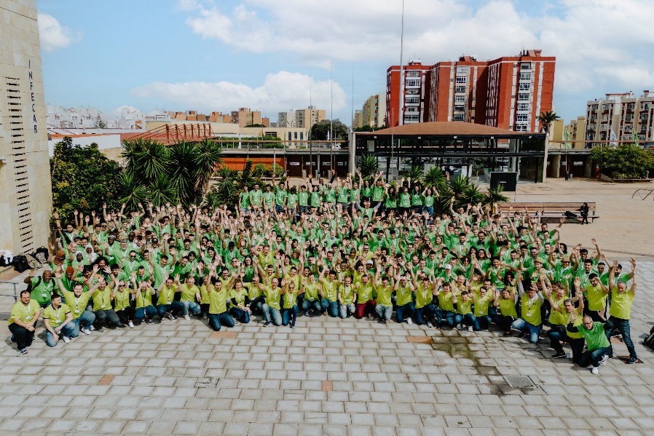
Picture PM1723-1
At the sixth Smart Green Island Makeathon, international students worked in interdisciplinary project teams on prototypes for sustainable, innovative technologies. igus supported the young talented people with its expertise and low-cost robotics. (Source: ITQ GmbH)

PRESS CONTACT:

Alexa Heinzelmann
Head of International Marketing

igus® GmbH
Spicher Str. 1a
51147 Cologne
Tel. 0 22 03 / 96 49-7272
aheinzelmann@igus.net
www.igus.eu/press

ABOUT IGUS:

igus GmbH develops and produces motion plastics. These lubrication-free, high-performance polymers improve technology and reduce costs wherever things move. In energy supplies, highly flexible cables, plain and linear bearings as well as lead screw technology made of tribo-polymers, igus is the worldwide market leader. The family-run company based in Cologne, Germany, is represented in 31 countries and employs 4,900 people across the globe. In 2021, igus generated a turnover of €961 million. Research in the industry's largest test laboratories constantly yields innovations and more security for users. 234,000 articles are available from stock and the service life can be calculated online. In recent years, the company has expanded by creating internal startups, e.g. for ball bearings, robot drives, 3D printing, the RBTX platform for Lean Robotics and intelligent "smart plastics" for Industry 4.0. Among the most important environmental investments are the "chainge" programme – recycling of used e-chains - and the participation in an enterprise that produces oil from plastic waste.

The terms "igus", “Apiro”, "chainflex", "CFRIP", "conprotect", "CTD", “drygear”, "drylin", "dry-tech", "dryspin", "easy chain", "e-chain", "e-chain systems", "e-ketten", "e-kettensysteme", "e-skin", "e-spool”, "flizz", “ibow”, “igear”, "iglidur", "igubal", “kineKIT”, "manus", "motion plastics", "pikchain", "plastics for longer life", "readychain", "readycable", “ReBeL”, "speedigus", "tribofilament“, "triflex", "robolink", “xirodur”, and "xiros" are protected by trademark laws in the Federal Republic of Germany and internationally, where applicable.

