"Can I use my machine without lubrication?" - igusGO® App now provides the answer
New igus® app uses AI to show the optimisation potential of motion plastics for over 450 applications in just a few seconds

What is an easy way for me to improve my machine? The answer is: try the new igusGO app. Plastics specialist igus® has now used AI to develop a unique product search app. Just take a photo of the application and its environment, and the igusGO intelligence will show you which products to use for, say, lubrication-free design. The app also shows where there is even more potential to improve machine technology while saving costs.

Finding the right products can be very time-consuming and a real time sink during the design process - especially when there is a wide range of products on the market. To help customers find the right components for their application in a playful way, igus has developed the igusGO app. Customers can use the app to discover the potential of igus products in their application and thus improve their design. The lubrication- and maintenance-free machine elements made of lightweight high-performance plastics not only extend service life but also reduce costs. Working with the app is as easy as winking. Users take a photo of their application. igusGO uses AI to determine the object and shows possible application options of igus products in the machine or plant. To do this, the AI uses data from igus projects the customer has already implemented on comparable machines and components. With one click, the app user receives more information about the plain bearings, linear technology or energy chain, and can then order the product immediately in the igus shop or else have the expected product service life in the machine displayed beforehand. "Many of our customers are not aware of just how many application options there are for all our products. Therefore, we developed the igusGO app. It's an addition to our service offer and available 24/7," explains Frank Blase, CEO at igus.

igusGO's intelligence continues to grow every day
Over 450 different applications are already in the app's brain - and more are added every day. From coffee machines to bottling plants to aeroplanes to bucket wheel excavators. "The igusGO app is intended to be a source of inspiration. At the same time, we want to open the app to a community where everyone can participate and share their projects with others," says Blase. "If the app does not recognise an application, the user can report it to us immediately. We'll respond within 24 hours and point out any opportunities for improvement." In the last few months, the first beta testers have already convinced themselves of igusGO and suggested improvements. The app is available in German and English for both Android and IOS and as a web version at https://app.igusgo.cloud/. In the next configuration level, igus also plans to integrate an AI chatbot that can answer users' questions.

igus also uses AI for product recognition
igus is now also using AI for the spare-parts business of its energy chains. "With our product recognition, we want to help all employees in companies order spare parts really quickly," says Peter Wirth, Head of Digital Sales & Marketing. Here, too, the principle is simple: just take a photo of the chain using the product recognition app. The AI trained by igus recognises the corresponding model from almost 50 e-chain series. One click takes users to the online shop, where they can order their new chain in the desired length, without having to carry out a time-consuming search for the last purchase order.

Caption:

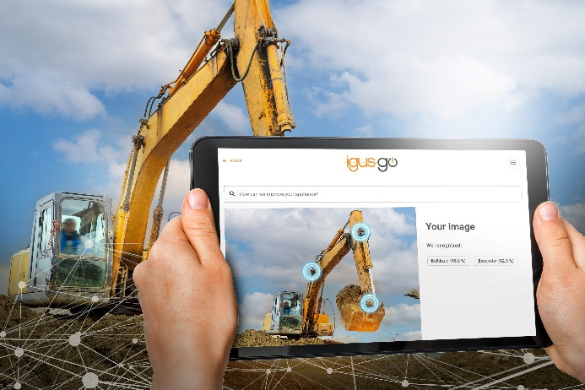
Image PM5923-1
With the igusGO® app, optimization potential in more than 450 applications can be discovered in just a few seconds - e.g. by eliminating lubrication. (Source: igus GmbH)
PRESS CONTACT:

Alexa Heinzelmann
Head of International Marketing

igus® GmbH
Spicher Str. 1a
51147 Cologne
Tel. 0 22 03 / 96 49-7272
aheinzelmann@igus.net
www.igus.eu/press

ABOUT IGUS:

igus GmbH develops and produces motion plastics. These lubrication-free, high-performance polymers improve technology and reduce costs wherever things move. In energy supplies, highly flexible cables, plain and linear bearings as well as lead screw technology made of tribo-polymers, igus is the worldwide market leader. The family-run company based in Cologne, Germany, is represented in 31 countries and employs 4,600 people across the globe. In 2022, igus generated a turnover of €1,15 billion. Research in the industry's largest test laboratories constantly yields innovations and more security for users. 234,000 articles are available from stock and the service life can be calculated online. In recent years, the company has expanded by creating internal startups, e.g. for ball bearings, robot drives, 3D printing, the RBTX platform for Lean Robotics and intelligent "smart plastics" for Industry 4.0. Among the most important environmental investments are the "chainge" programme – recycling of used e-chains - and the participation in an enterprise that produces oil from plastic waste.

The terms "igus", “Apiro”, "chainflex", "CFRIP", "conprotect", "CTD", “drygear”, "drylin", "dry-tech", "dryspin", "easy chain", "e-chain", "e-chain systems", "e-ketten", "e-kettensysteme", "e-skin", "e-spool”, "flizz", “ibow”, “igear”, "iglidur", "igubal", “kineKIT”, "manus", "motion plastics", "pikchain", "plastics for longer life", "readychain", "readycable", “ReBeL”, "speedigus", "tribofilament“, "triflex", "robolink", “xirodur”, and "xiros" are protected by trademark laws in the Federal Republic of Germany and internationally, where applicable.

