Hannover Trade Show 2021: New modular gearbox kit from igus for innovative cobot ideas
Cost-effective, lightweight plug & play combination consisting of gearbox, encoder, controller, force control system and motor for service robotics

The potential for service robotics is enormous: in kitchens and bars, in the area of nursing, or in agriculture and logistics, lightweight robots facilitate the automation of monotonous or non-ergonomic tasks. To make the implementation of such new concepts easy and, above all, cost-effective, igus is presenting a new modular gearbox kit for cobots at the Hannover Trade Show. The fully integrated tribo strain wave gear with motor, absolute-value encoder, force control system and controller is the main component of this kit.

"With our Low Cost Automation solutions, we enable design engineers to cost-effectively take part in the future of service robotics", says Stefan Niermann, who is responsible for the area of Low Cost Automation in the extended igus management structure. "This opens up space for new ideas in the area of automation: robots that can dispense coffee in retail shops or clear out the dishwasher at home. Cobots, that can be used in the area of nursing as well as in industry – and everything made in Germany." The gearboxes play an especially important role in this context as they are the heart of any modern robot. For this reason, motion plastics specialist igus introduced a new generation of tribo strain wave gearboxes for movement on the 5th robot axis last year. Friction and wear are optimised by means of lubrication-free tribo-polymers. The use of plastics enables an extremely compact design and cost-effective production. The drygear strain wave gear can be used along the last axis of an articulated arm, linear robot or delta robot, for example, in front of different gripper systems. The new modular gearbox kit for cobots that igus is showing at the Hannover Trade Show 2021, supplements the wide range of igus products in the area of Low Cost Automation. This plug & play solution facilitates the speedy implementation of exciting cobot ideas, without any thought being given to the power electronics.

Fully integrated strain wave gear for low cost cobot applications
The modular gearbox kit in sizes 80 and 105 consists of tribo strain wave gear with integrated motor controller, force control electronics, absolute-value encoder and motor. In the gearbox, a tribo wave generator and a tribo flex ring with external teeth, as well as a brushless DC motor with external rotor are used. On the basis of the gearbox, an individual robot can also be designed as a cobot with the help of joining links, thanks to the additional electronic components. "For our lightweight strain wave gears, we see market opportunities in robots whose total weight is less than 8kg", clarifies Alexander Mühlens, head of Low Cost Automation at igus. "This is because, where robotics in Low Cost Automation is concerned, the self weight is always important and not only the payload and a low price. Lightweight robots are easier to transport and can be used more efficiently on driverless transport systems, on 7th robot axes or, in the near future, even on drones." The low weight is also a significant advantage when the systems are used in cobots, as smaller masses mean that lower forces are generated when collisions occur. HRC capabilities are possible thanks to the electronic components in the fully integrated strain wave gear. Thanks to absolute-value encoder technology, forces as well as torque can be determined and safely limited by means of the motor current. For this purpose, igus relies on a double encoder, in which a measurement is carried out in front of and behind the joint in order to detect forces and torque levels and react accordingly.

The igus range of products in the area of Low Cost Automation is growing continuously
The new fully integrated strain wave gearboxes are to be used this year in the new version of the ReBel, the igus service robot. As a result, this generation of robots will be considerably slimmer and, thanks to the integrated BLDC motors with power electronics, will be more cost-effective. Alexander Mühlens points out: "Our goal is to offer the ReBeL on the market for 2,900 euros even for small order quantities. It should be able to carry 2kg, have a range of up to 650mm, as well as a self weight of less than 10kg and a minimum running time of 2 million cycles." The cobot gearbox kit supplements the wide portfolio of igus in the area of Low Cost Automation - from gearboxes and a large variety of robot kinematics to the control system. Low Cost Automation means cost-effective prices for new users and also automating as much as necessary. As as result, the investment pays for itself in just a few months. The new modular gearbox system will also be available on RBTX.com. On the online marketplace, interested parties can put together their robot kinematics with vision, safety or gripper components that matches their requirements and their budget exactly. The igus promise is that everything fits together, both on the hardware side and software side – in accordance with the igus "Build or Buy" approach, namely putting together a robot oneself or obtaining a ready-made solution.

PRESS CONTACT:  Oliver Cyrus  Head of PR and Advertising  Anja Görtz-Olscher  PR and Advertising  igus® GmbH  Spicher Str. 1a  51147 Cologne  Tel. 0 22 03 / 96 49-459 or -7153  Fax 0 22 03 / 96 49-631  ocyrus@igus.net  agoertz@igus.net  www.igus.eu/press | ABOUT IGUS:  igus GmbH develops and produces motion plastics. These lubrication-free, high-performance polymers improve technology and reduce costs wherever things move. In energy supplies, highly flexible cables, plain and linear bearings as well as lead screw technology made of tribo-polymers, igus is the worldwide market leader. The family-run company based in Cologne, Germany, is represented in 35 countries and employs 3,800 people across the globe. In 2019, igus generated a turnover of €764 million. Research in the industry's largest test laboratories constantly yields innovations and more security for users. 234,000 articles are available from stock and the service life can be calculated online. In recent years, the company has expanded by creating internal startups, e.g. for ball bearings, robot drives, 3D printing, the RBTX platform for Lean Robotics and intelligent "smart plastics" for Industry 4.0. Among the most important environmental investments are the "chainge" programme – recycling of used e-chains - and the participation in an enterprise that produces oil from plastic waste. (Plastic2Oil).

The terms "igus", “Apiro”, "chainflex", "CFRIP", "conprotect", "CTD", “drygear”, "drylin", "dry-tech", "dryspin", "easy chain", "e-chain", "e-chain systems", "e-ketten", "e-kettensysteme", "e-skin", "e-spool”, "flizz", “ibow”, “igear”, "iglidur", "igubal", “kineKIT”, "manus", "motion plastics", "pikchain", "plastics for longer life", "readychain", "readycable", “ReBeL”, "speedigus", "tribofilament“, "triflex", "robolink", “xirodur”, and "xiros" are protected by trademark laws in the Federal Republic of Germany and internationally, where applicable.

Caption:

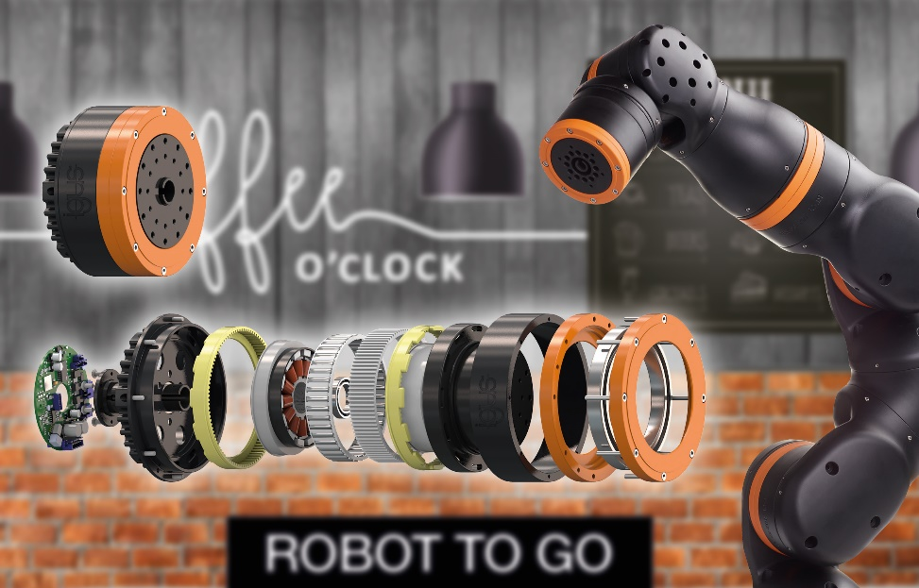
Picture PM0520-1
"One robot to go, please!" – With the lightweight modular gearbox system from igus, new ideas in the field of service robotics can be implemented easily and cost-effectively. (Source: igus GmbH)

