Breakthrough in linear technology: New igus sliding material provides more design freedom
40 percent less friction and optimised 3:1 design rule: drylin T miniature guide with new iglidur E3 material

Whether in an industrial environment or in a coffee machine, in order to maximize the service life of a linear guide and to keep the required drive energy low, it is important to reduce friction and wear as much as possible. igus, a motion plastics specialist, has now achieved a breakthrough in tribological plastics: With iglidur E3, igus has developed a new sliding material that has a friction coefficient that is up to 40 percent better and thus opens up design flexibility in linear technology for users for the first time from the classic 2:1 Rule expanded to 3:1.

The drylin T miniature linear slide offers extremely smooth running and new design freedom thanks to the newly developed iglidur E3 sliding material. Depending on the operating point, this has a friction coefficient of around 0.16 and thus achieves up to 40 percent less friction compared to the igus standard materials, measured on hard-anodised aluminium, and even less compared to commercially available sliding materials. This also means that manual adjustment require 40 percent lower displacement forces. "This is an important step towards greater design freedom, as it enables us to expand design leeway for the first time," says Stefan Niermann, head of igus' Linear and Drive Technology business unit. The traditional 2:1 rule, which generally applies to linear plain bearings, states that the distance between the driving force and the fixed bearing should not be more than twice the bearing clearance. Otherwise, an uneven movement sequence could jam the system. The greater the distance between the drive and the guide bearing, the higher the wear and required drive force. igus has now extended this design rule to 3:1, so that the drive can be 50 percent further away without impairing linear guide movement. At the same time, the required drive forces are reduced by 40 percent, which means 40 percent energy savings in electrically driven applications. The drylin T miniature guide is available in three sizes (09, 12, and 15) and can be used in such applications as laboratory and medical technology and tool building.

Proven to slide better – without harmful lubricants
The miniature linear carriage with the new iglidur E3 sliders offers the well-known advantages of igus motion plastics. The solid lubricants incorporated into the material of the high-performance plastics ensure low-noise operation, high resistance to dirt and no need for maintenance. Eliminating lubrication is good for saving costs but also the environment. With new material mixing and processing as well as countless tests in the igus test laboratory,igus has further pushed the application limits of motion plastics and created new design freedom in linear technology.

Caption:
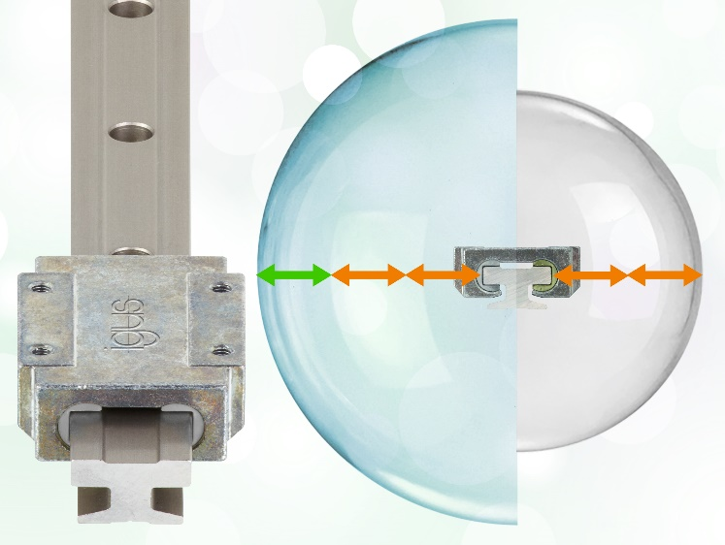
Picture PM2522-1
The newly developed iglidur E3 ensures 40 percent less friction and new design freedom in linear technology – without lubricant pollution. (Source: igus GmbH)

PRESS CONTACT:

Alexa Heinzelmann
Head of International Marketing

igus® GmbH
Spicher Str. 1a
51147 Cologne
Tel. 0 22 03 / 96 49-7272
aheinzelmann@igus.net
www.igus.eu/press

ABOUT IGUS:

igus GmbH develops and produces motion plastics. These lubrication-free, high-performance polymers improve technology and reduce costs wherever things move. In energy supplies, highly flexible cables, plain and linear bearings as well as lead screw technology made of tribo-polymers, igus is the worldwide market leader. The family-run company based in Cologne, Germany, is represented in 35 countries and employs 4,900 people across the globe. In 2021, igus generated a turnover of €961 million. Research in the industry's largest test laboratories constantly yields innovations and more security for users. 234,000 articles are available from stock and the service life can be calculated online. In recent years, the company has expanded by creating internal startups, e.g. for ball bearings, robot drives, 3D printing, the RBTX platform for Lean Robotics and intelligent "smart plastics" for Industry 4.0. Among the most important environmental investments are the "chainge" programme – recycling of used e-chains - and the participation in an enterprise that produces oil from plastic waste.

The terms "igus", “Apiro”, "chainflex", "CFRIP", "conprotect", "CTD", “drygear”, "drylin", "dry-tech", "dryspin", "easy chain", "e-chain", "e-chain systems", "e-ketten", "e-kettensysteme", "e-skin", "e-spool”, "flizz", “ibow”, “igear”, "iglidur", "igubal", “kineKIT”, "manus", "motion plastics", "pikchain", "plastics for longer life", "readychain", "readycable", “ReBeL”, "speedigus", "tribofilament“, "triflex", "robolink", “xirodur”, and "xiros" are protected by trademark laws in the Federal Republic of Germany and internationally, where applicable.

