Compact rotation: igus adds to its 16mm slewing ring range
The space-saving PRT-04 slewing ring bearings are now available in other sizes with inner and outer tooth drive and a locking function

They are compact and lightweight and show how things are done. They have been developed specifically for movement in tight spaces and give igus an entire PRT-04 modular system. The lubrication-free slewing ring bearing system comes in eight sizes. They feature outer tooth drive and angle stop (optional), and now also inner drive teeth and a locking function. This allows the design engineer to find the product needed for applications with very little installation space.

igus slewing ring bearings rotate assembly units, control panels and indexing tables, even at high speeds. In order for them to turn whilst remaining maintenance-free, igus uses sliding elements that work radially and axially between the bearing's inner and outer races. The slides made of the high-performance polymer iglidur J ensure that friction and wear are minimised, without lubrication. Introduced as a new product in 2019, igus is now launching an entire modular system for its PRT-04 compact slewing ring bearing range. The corrosion-resistant slewing rings have been developed specifically for use in tight installation spaces and loads of up to 48,000N. This range has the advantage of requiring only half the space the PRT-01 needs, being 60% lighter and costing 20% less. Arguments that convince customers include the following: "The PRT-04 slewing ring bearings allowed us to implement several applications in automation technology, the packaging industry and furniture technology", says Stefan Loockmann-Rittich, Head of igus GmbH iglidur® bearings Business Unit. "The series has now been expanded so that design engineers can have even greater design freedom."

Compact drive with inner drive teeth and new locking function
The compact, lightweight slewing rings are available in a total of eight sizes from 20 to 300 millimetres. In addition to accessories such as drive pins, variable mounting plates and clamping levers, igus offers three outer drive ring systems and one inner drive ring for very limited installation spaces, such as in driverless transport systems. The slewing ring bearings are driven with drive belts or gears that igus manufactures with injection moulding from highly wear-resistant tribo-polymers. igus has also developed a slewing ring bearing with a locking function specifically for applications such as assembly tables. The locking points are either fixed at 90° or can be defined according to customer requirements. For special areas of use, igus supplies a slewing ring bearing version with dissipative sliding elements to prevent electric charge in an ESD-compliant manner. As with all igus products, the service life of the slewing ring bearings can also be calculated online for the respective application.

Learn more about igus slewing ring bearings: https://www.igus.eu/info/information-slewing-ring-bearings?L=en

Caption:

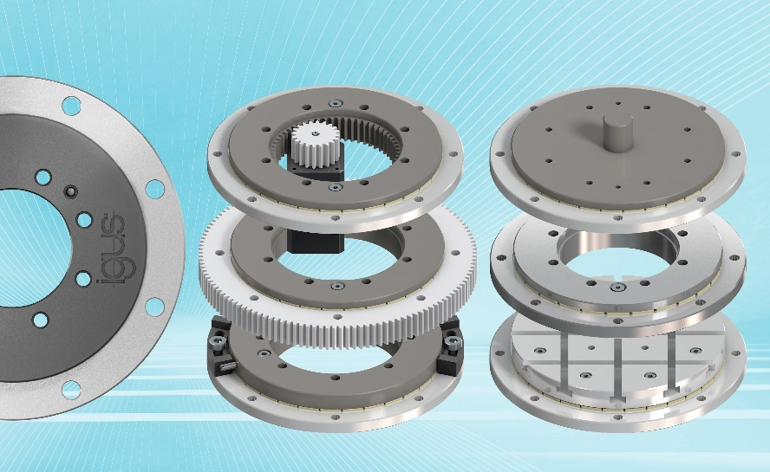
Picture PM0221-1
The space-saving PRT-04 slewing ring bearing modular system allows design engineers to freely design rotating applications. (Source: igus GmbH)

PRESS CONTACT:  Oliver Cyrus  Head of PR and Advertising  Anja Görtz-Olscher  PR and Advertising  igus® GmbH  Spicher Str. 1a  51147 Cologne  Tel. 0 22 03 / 96 49-459 or -7153  Fax 0 22 03 / 96 49-631  ocyrus@igus.net  agoertz@igus.net  www.igus.eu/press | ABOUT IGUS:  igus GmbH develops and produces motion plastics. These lubrication-free, high-performance polymers improve technology and reduce costs wherever things move. In energy supplies, highly flexible cables, plain and linear bearings as well as lead screw technology made of tribo-polymers, igus is the worldwide market leader. The family-run company based in Cologne, Germany, is represented in 35 countries and employs 3,800 people across the globe. In 2019, igus generated a turnover of €764 million. Research in the industry's largest test laboratories constantly yields innovations and more security for users. 234,000 articles are available from stock and the service life can be calculated online. In recent years, the company has expanded by creating internal startups, e.g. for ball bearings, robot drives, 3D printing, the RBTX platform for Lean Robotics and intelligent "smart plastics" for Industry 4.0. Among the most important environmental investments are the "chainge" programme – recycling of used e-chains - and the participation in an enterprise that produces oil from plastic waste. (Plastic2Oil).

The terms "igus", “Apiro”, "chainflex", "CFRIP", "conprotect", "CTD", “drygear”, "drylin", "dry-tech", "dryspin", "easy chain", "e-chain", "e-chain systems", "e-ketten", "e-kettensysteme", "e-skin", "e-spool”, "flizz", “ibow”, “igear”, "iglidur", "igubal", “kineKIT”, "manus", "motion plastics", "pikchain", "plastics for longer life", "readychain", "readycable", “ReBeL”, "speedigus", "tribofilament“, "triflex", "robolink", “xirodur”, and "xiros" are protected by trademark laws in the Federal Republic of Germany and internationally, where applicable.

