4K for 3D: igus offers multi-material printing for multifunctional components
The motion plastics specialist continues to expand its 3D printing capacities for durable, wear-resistant and complex components

If a component is to have several properties, it usually has to be manufactured in several steps. But such production can quickly become cost-intensive for small quantities. It is precisely for this reason that igus now offers multi-material printing with up to four materials. This allows multifunctional and wear-resistant special parts to be manufactured quickly and cost-effectively in just one step. To this end, igus has further expanded its 3D printing capacities and its range of materials for the FDM process.

3D printing of individual wear-resistant parts with different materials offers the user great design possibilities. At the same time, multifunctional components significantly reduce the manufacturing process. Therefore, igus has been offering the production of durable special parts in multi-material printing with two materials since last year. In this way, wear-resistant but at the same time resilient components, as well as intelligent special parts, can be produced. This service has now been expanded by motion plastics. igus can now use up to four materials in a single process to manufacture multifunctional components. "For this purpose, we have expanded our 3D printing production and now also offer new materials that can be processed specifically in multi-material printing", explains Tom Krause, Head of Additive Manufacturing at igus GmbH. "For example, we can produce parts for equipment, tool or special machine construction cost-effectively with no minimum order quantity in just a few days."

Multi-material printing for bearings with the best specifications
The igus materials for multi-material printing have different specifications. The iglidur tribo-filament makes components low-friction, maintenance-free and up to 50 times more abrasion-resistant than regular 3D printing materials. With iglidur I160-EL, igus is now offering a new elastic material that can be printed in the individual bearing, as a seal, for example. igumid P150, on the other hand, is the new 3D printing filament for multi-material printing, which ensures high strength (87 MPa flexural strength) of the component. Especially for the additive manufacturing of intelligent components with integrated sensors, igus offers two further smart materials: sigumid P and sigumid F. The latter is printed onto the bearing and sends a signal via a normally closed contact when the wear limit is reached. By contrast, sigumid P is used to alert of an overload in the bearing. This is because when pressure is applied to the bearing, the shape changes and so does the resistance. "4K printing now makes it possible to combine all the specifications of the different materials - wear-resistant, strong, elastic and intelligent - in one complex component", Tom Krause sums up.

More information on multi-material printing can be found at:
https://www.igus.eu/info/multiple-component-3d-printing?L=en

Caption:

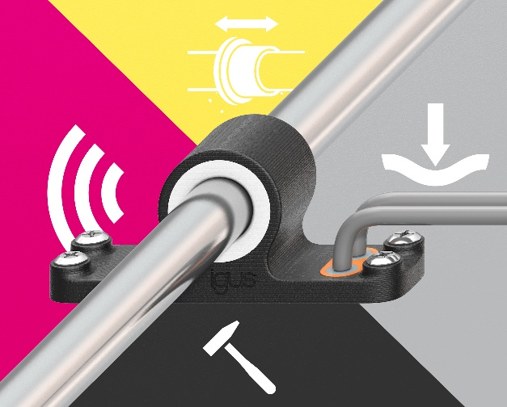
Picture PM1721-1
With 4K 3D printing, multifunctional components can be produced cost-effectively and quickly in just one manufacturing step. (Source: igus GmbH)

PRESS CONTACT:  Oliver Cyrus  Head of PR and Advertising  Anja Görtz-Olscher  PR and Advertising  igus® GmbH  Spicher Str. 1a  51147 Cologne  Tel. 0 22 03 / 96 49-459 or -7153  Fax 0 22 03 / 96 49-631  ocyrus@igus.net  agoertz@igus.net  www.igus.eu/press | ABOUT IGUS:  igus GmbH develops and produces motion plastics. These lubrication-free, high-performance polymers improve technology and reduce costs wherever things move. In energy supplies, highly flexible cables, plain and linear bearings as well as lead screw technology made of tribo-polymers, igus is the worldwide market leader. The family-run company based in Cologne, Germany, is represented in 35 countries and employs 3,800 people across the globe. In 2019, igus generated a turnover of €764 million. Research in the industry's largest test laboratories constantly yields innovations and more security for users. 234,000 articles are available from stock and the service life can be calculated online. In recent years, the company has expanded by creating internal startups, e.g. for ball bearings, robot drives, 3D printing, the RBTX platform for Lean Robotics and intelligent "smart plastics" for Industry 4.0. Among the most important environmental investments are the "chainge" programme – recycling of used e-chains - and the participation in an enterprise that produces oil from plastic waste. (Plastic2Oil).

The terms "igus", “Apiro”, "chainflex", "CFRIP", "conprotect", "CTD", “drygear”, "drylin", "dry-tech", "dryspin", "easy chain", "e-chain", "e-chain systems", "e-ketten", "e-kettensysteme", "e-skin", "e-spool”, "flizz", “ibow”, “igear”, "iglidur", "igubal", “kineKIT”, "manus", "motion plastics", "pikchain", "plastics for longer life", "readychain", "readycable", “ReBeL”, "speedigus", "tribofilament“, "triflex", "robolink", “xirodur”, and "xiros" are protected by trademark laws in the Federal Republic of Germany and internationally, where applicable.

