Maintenance-free knife edge rollers expand the igus online shop range
iglidur rollers with predictable service life ensure product transport in food technology

So that users can get their wear-resistant knife edge roller even faster, igus has expanded its online shop to include the range of iglidur rollers made from high-performance polymers. Included in the new range are knife edge rollers made of the blue material iglidur A250. The new tribo-polymer is particularly characterised by its wear resistance at high belt speeds and fulfils the requirements of FDA and EU conformity at the same time.
10 years ago, a long service life, low wear and chemical resistance under cleaning conditions were the decisive factors for the development of the igus knife edge rollers in the beverage industry. Today, they are not only used in beverage technology, but also in food and packaging systems. The rollers ensure that conveyor belts are guided even at high speed over knife edge transitions that are limited in installation space. In this way, the products are transferred safely from one conveyor to the other. However, it is not only the safety of increasingly automated production that is in demand; all machine and systems components must also meet the requirements for hygiene and cleanliness. Therefore, igus has developed a total of five materials for knife edge rollers for different application scenarios. All products help the user to save costs, reduce maintenance and increase the service life of their system. The comprehensive range of lubrication-free knife edge rollers is now also offered by igus in its online shop. For special dimensions, the user can make use of the Tribo-Cut CNC service from igus, resort to the product range of bar stock or even special dimensions in injection moulding.

iglidur A250: FDA-compliant knife edge roller for food contact
One of the five iglidur materials for knife edge rollers is iglidur A250. It meets the strict hygiene requirements of the FDA and EU10/2011 regulations and is also suitable for high speeds. The rollers made of iglidur A250 only require a low drive power, due to a minimisation of the coefficient of friction. Thanks to its blue colour it is also optically detectable. All iglidur knife edge rollers from igus are free from external lubrication, so they are insensitive to dust and dirt and easy to clean. igus examines the long service life and wear resistance of the rollers in its in-house test laboratory, covering 3,800 square metres. The plastics specialist can therefore make a statement about durability of all rollers.

Go to the iglidur knife edge rollers shop:
https://www.igus.eu/iglidur/knife-edge-rollers?L=en

Caption:

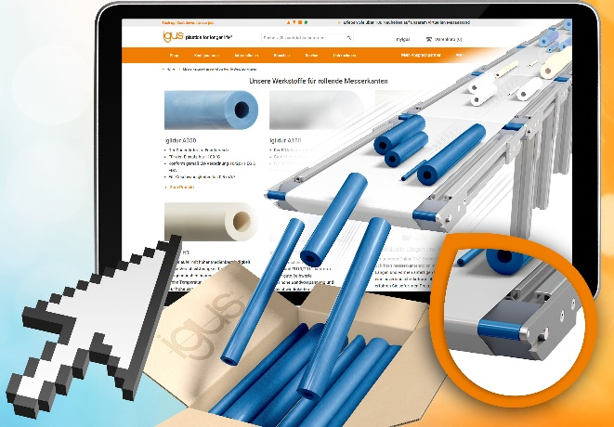
Picture PM1121-1
In the expanded knife edge shop from igus, users can obtain lubrication-free polymer rollers for the packaging and food industry. (Source: igus GmbH)

PRESS CONTACT:  Oliver Cyrus  Head of PR and Advertising  Anja Görtz-Olscher  PR and Advertising  igus® GmbH  Spicher Str. 1a  51147 Cologne  Tel. 0 22 03 / 96 49-459 or -7153  Fax 0 22 03 / 96 49-631  ocyrus@igus.net  agoertz@igus.net  www.igus.eu/press | ABOUT IGUS:  igus GmbH develops and produces motion plastics. These lubrication-free, high-performance polymers improve technology and reduce costs wherever things move. In energy supplies, highly flexible cables, plain and linear bearings as well as lead screw technology made of tribo-polymers, igus is the worldwide market leader. The family-run company based in Cologne, Germany, is represented in 35 countries and employs 3,800 people across the globe. In 2019, igus generated a turnover of €764 million. Research in the industry's largest test laboratories constantly yields innovations and more security for users. 234,000 articles are available from stock and the service life can be calculated online. In recent years, the company has expanded by creating internal startups, e.g. for ball bearings, robot drives, 3D printing, the RBTX platform for Lean Robotics and intelligent "smart plastics" for Industry 4.0. Among the most important environmental investments are the "chainge" programme – recycling of used e-chains - and the participation in an enterprise that produces oil from plastic waste. (Plastic2Oil).

The terms "igus", “Apiro”, "chainflex", "CFRIP", "conprotect", "CTD", “drygear”, "drylin", "dry-tech", "dryspin", "easy chain", "e-chain", "e-chain systems", "e-ketten", "e-kettensysteme", "e-skin", "e-spool”, "flizz", “ibow”, “igear”, "iglidur", "igubal", “kineKIT”, "manus", "motion plastics", "pikchain", "plastics for longer life", "readychain", "readycable", “ReBeL”, "speedigus", "tribofilament“, "triflex", "robolink", “xirodur”, and "xiros" are protected by trademark laws in the Federal Republic of Germany and internationally, where applicable.

