Certified safety: new biocompatible igus ball bearing material for medical technology
xirodur MT180 complies with the world's most stringent safety standards and reduces certification costs for medical technology products

igus, the motion plastics specialist, is expanding its range of high-performance plastics for medical technology. New to the product range: xirodur MT180, a material for light, hygienic, lubrication-free xiros deep groove ball bearings - certified according to the strictest standards, such as USP Class VI and DIN EN ISO 10993. The material's certified biocompatibility puts manufacturers of medical technology, such as bio-reactors, on the safe side and saves time and money for product approval.
In medical and pharmaceutical technology, too, machine and plant engineers are increasingly replacing metal components such as deep groove ball bearings with counterparts made of high-performance plastic. The advantage is that igus xiros-series ball bearings operate without lubrication and are maintenance-free while remaining low-friction and hygienic. A common difficulty is that not all plastics are suitable for all medical-technology applications. So far, manufacturers have often had to plan time and costs for new assembly certification. "We invest lots of energy in research and development. That way, we bring materials to the market that are certified according to the strictest standards in the world - materials that medical-technology manufacturers can use without hesitation," says Marcus Semsroth, Head of Business Unit xiros Polymer Ball Bearings at igus. "One of our latest developments is xirodur MT180, a biocompatible material from which light, hygienic, non-magnetic xiros deep groove ball bearings can be manufactured."

xirodur MT180: approved even for contact with the bloodstream
The new ball bearings made of xirodur MT180 are suitable for such applications as bio-reactors, which cultivate microorganisms in a nutrient medium. These reactors played a crucial role in producing RNA vaccines during the COVID-19 pandemic. The ball bearings can be used, e.g. in the agitator. They are classified according to USP 88 Class VI. USP stands for United States Pharmacopeia, a US compendium of drug information that defines quality standards for medicines – some of the strictest worldwide. This classification proves that the igus ball bearings do not pose a risk of contamination here. "xirodur MT180, our new material, has thus reached the highest biocompatibility class," says Semsroth. In this class, the high-performance plastic is approved even for contact with the bloodstream and is therefore just as biocompatible as the materials used in implants. The material also complies with DIN EN ISO 10993 for medical products.

Suitable for prostheses, laboratory equipment and hospital beds
The single-row xiros deep groove ball bearings made of high-performance plastic belong to the rolling bearings family. They consist of four components: an inner and outer race, a cage and the load balls. Cage and races are injection-moulded from xirodur MT180. The balls can be made of stainless steel or glass as desired. When glass balls are used, the bearings are completely non-magnetic and electrically insulating. This makes them suitable for magnetic resonance imaging (MRI), a method that uses a pulsating magnetic field in accordance with USP 88 to make the inside of the body visible layer by layer. Since the magnetic field is many thousands of times stronger than the earth's magnetic field, conventional metal rolling bearings cannot be used. "Ball bearings made of xirodur MT180 are suitable not only for bio-reactors and MRI, but also for prostheses and orthoses, X-ray robots, laboratory equipment and hospital beds," says Ulf Hottung, Medical Technology Industry Manager at igus. Semsroth adds: "The ball bearings are made of high-performance plastic, so they are not only resistant to corrosion and dirt, but also up to 50% lighter and very durable. To ensure quality and safety, we put each of our ball bearings through their paces in our in-house test laboratory."

Caption:

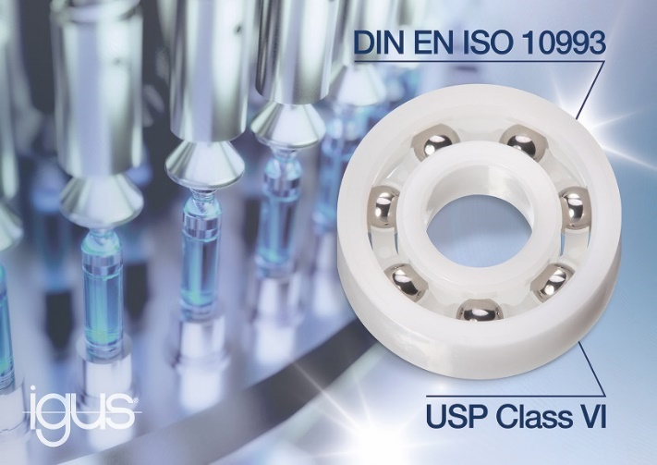
Picture PM0623-1
With their certified biocompatibility, ball bearings made from xirodur MT180 are suitable for applications such as laboratory equipment, X-ray robots, bio-reactors and magnetic resonance imaging. (Source: igus GmbH)

PRESS CONTACT:

Alexa Heinzelmann
Head of International Marketing

igus® GmbH
Spicher Str. 1a
51147 Cologne
Tel. 0 22 03 / 96 49-7272
aheinzelmann@igus.net
www.igus.eu/press

ABOUT IGUS:

igus GmbH develops and produces motion plastics. These lubrication-free, high-performance polymers improve technology and reduce costs wherever things move. In energy supplies, highly flexible cables, plain and linear bearings as well as lead screw technology made of tribo-polymers, igus is the worldwide market leader. The family-run company based in Cologne, Germany, is represented in 31 countries and employs 4,900 people across the globe. In 2021, igus generated a turnover of €961 million. Research in the industry's largest test laboratories constantly yields innovations and more security for users. 234,000 articles are available from stock and the service life can be calculated online. In recent years, the company has expanded by creating internal startups, e.g. for ball bearings, robot drives, 3D printing, the RBTX platform for Lean Robotics and intelligent "smart plastics" for Industry 4.0. Among the most important environmental investments are the "chainge" programme – recycling of used e-chains - and the participation in an enterprise that produces oil from plastic waste.

The terms "igus", “Apiro”, "chainflex", "CFRIP", "conprotect", "CTD", “drygear”, "drylin", "dry-tech", "dryspin", "easy chain", "e-chain", "e-chain systems", "e-ketten", "e-kettensysteme", "e-skin", "e-spool”, "flizz", “ibow”, “igear”, "iglidur", "igubal", “kineKIT”, "manus", "motion plastics", "pikchain", "plastics for longer life", "readychain", "readycable", “ReBeL”, "speedigus", "tribofilament“, "triflex", "robolink", “xirodur”, and "xiros" are protected by trademark laws in the Federal Republic of Germany and internationally, where applicable.

