Linear carriage-to-go: assemble and disassemble igus linear unit in just one step
The new drylin concept is very easy to handle and saves a lot of time

The motion plastics specialist igus demonstrates an exciting new approach for linear carriages. A clip mechanism enables easy installation and removal from the linear guide in a matter of seconds.

Whether building technology, mechanical engineering, industrial handling systems, measuring and testing technology or camera technology: linear systems are an integral part of everyday life. The principle is always the same: a component, such as a control panel, is installed on a carriage and moves over a linear profile with the aid of a guide system or a rolling guide. Previously, it has only been possible to remove the carriage with some effort. Often only using tools and usually only via the profile ends, provided the installation space permits it. A design limitation where tractor manufacturers wanted an alternative solution. For example, the demand is for a carriage enabling operators to keep their touch displays in the optimal view position. There is also a requirement for it to be removed easily and safely in one step after finishing work. They can be stored safely, protected from theft, moisture and cold. "Inspired by this need, we developed the linear “carriage-to-go” as part of a design study - a carriage that can be removed from the linear rail without tools and from any position in just one step," explains Michael Hornung, Product Manager drylin Linear and Drive Technology at igus. "In the field of linear technology, this idea is a novelty that saves time and opens up new areas of application."

Intuitive operability ensures fast installation and removal
The operation of the clip carriage is simple: the carriage moves on a double profile rail via four lubrication and maintenance-free high-performance plastic slide bearings. If the user pulls a lever on the underside of the carriage, two bearings open via a spring mechanism. The carriage can now be pivoted off the rail and removed. The installation is just as quick. The user places the carriage on the upper rail and clips it onto the lower rail. "Operation is so intuitive that installation is reliable and quick." says Hornung. The first pilot customers are enthusiastic about the new technology. Among these customers are users of camera systems and measuring and testing technology. You can install cameras and evaluation units on linear guides faster than ever. The design study is therefore becoming a product. The market launch is planned for spring 2022.

Clip carriage expands the drylin W product range
With the new clip carriage, igus is expanding the drylin W product range. There are currently more than 50 different versions of linear guide carriages, which, in combination with other design elements, allow an almost unlimited number of variants. The essential feature of all models is that they enable high accuracy and smooth operation due to the high-performance plastic used in the plain bearings and that they can be cleaned quickly and thoroughly due to the absence of lubricants.

Caption:

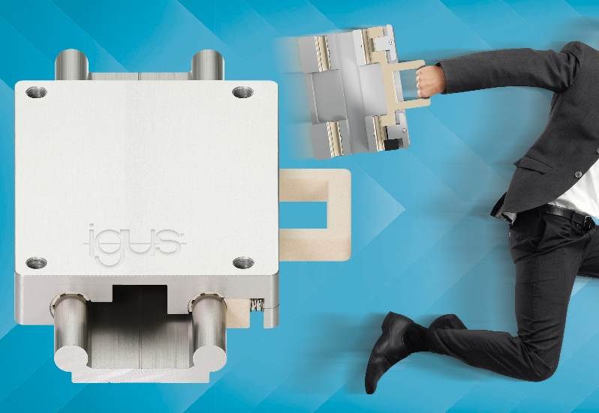
Picture PM0322-1
The drylin clip carriage can be removed from the guide rail in just one step. This is not only very easy, but also saves time. (Source: igus GmbH)

PRESS CONTACT:

Alexa Heinzelmann
Head of International Marketing

igus® GmbH
Spicher Str. 1a
51147 Cologne
Tel. 0 22 03 / 96 49-7272
aheinzelmann@igus.net
www.igus.eu/press

ABOUT IGUS:

igus GmbH develops and produces motion plastics. These lubrication-free, high-performance polymers improve technology and reduce costs wherever things move. In energy supplies, highly flexible cables, plain and linear bearings as well as lead screw technology made of tribo-polymers, igus is the worldwide market leader. The family-run company based in Cologne, Germany, is represented in 35 countries and employs 4,150 people across the globe. In 2020, igus generated a turnover of €727 million. Research in the industry's largest test laboratories constantly yields innovations and more security for users. 234,000 articles are available from stock and the service life can be calculated online. In recent years, the company has expanded by creating internal startups, e.g. for ball bearings, robot drives, 3D printing, the RBTX platform for Lean Robotics and intelligent "smart plastics" for Industry 4.0. Among the most important environmental investments are the "chainge" programme – recycling of used e-chains - and the participation in an enterprise that produces oil from plastic waste.

The terms "igus", “Apiro”, "chainflex", "CFRIP", "conprotect", "CTD", “drygear”, "drylin", "dry-tech", "dryspin", "easy chain", "e-chain", "e-chain systems", "e-ketten", "e-kettensysteme", "e-skin", "e-spool”, "flizz", “ibow”, “igear”, "iglidur", "igubal", “kineKIT”, "manus", "motion plastics", "pikchain", "plastics for longer life", "readychain", "readycable", “ReBeL”, "speedigus", "tribofilament“, "triflex", "robolink", “xirodur”, and "xiros" are protected by trademark laws in the Federal Republic of Germany and internationally, where applicable.

