Switch-off protection on long travels: new EC.PR system monitors energy chains
igus position-based push/pull force monitoring ensures safety on crane systems

A forgotten screwdriver in an energy chain, a bent trough as well as ice, snow and bulk material can quickly lead to a total failure of cranes with high costs. This prompted igus to develop a new push/pull force monitoring system. The EC.PR precisely records the force values of the floating moving end and adjusts the force limits. This prevents high repair costs and damage to the system.

A system failure is the worst case scenario for crane operators. Often high costs are incurred not only for repair and maintenance, but above all for downtime and non-produced goods. igus has developed the EC.PR system especially for long travel energy chains from 150 metres upwards, which uses sensors to determine the push/pull force of the energy chain and automatically switches off when a defined force is exceeded. This can prevent a crash of the system. If, for example, a foreign object enters the energy chain or if the trough bends, the push/pull force increases at that position. The system detects the changed value and switches off the system. By means of the new EC.PR system, the force for switching off the trolley is automatically adjusted to the position. The system receives the position information from additional modules of the Siemens PLC, an OPC-UA server, and analogue or digital position measuring systems. The EC.PR system can be easily integrated into existing control concepts and switch cabinets.

Tested under real conditions at outdoor test facility
The EC.PR system consists of two sensors that communicate with each other. A sensor measures the push/pull force of the e-chain while, for example, a digital distance measuring system determines the exact position of the trolley or the moving end of the e-chain. For this purpose, so-called "beacons" are attached to the outside of the guide trough at a distance of 500 millimetres. Each position and thus each beacon is assigned a specific push/pull force. If the assigned maximum push/pull force of a position is exceeded, the system switches off automatically via the EC.PR. The user can remove the foreign object from the energy chain, reset the system and then put the system back into operation. The new system has already been successfully tested at the 200 metre long outdoor test rig at igus in Cologne.

The EC.PR and other innovations for predictive maintenance were presented by igus at the digital trade show IN.STAND on 21st and 22nd October 2020.

The EC.PR system explained in 60 seconds:
https://youtu.be/9ykh0uKhdEo

Videos from the outdoor test rig:
https://www.igus.de/contentData/wpck/mp4/global/isense-EC.PR-%20Teststand-1.mp4
https://www.igus.de/contentData/wpck/mp4/global/isense-EC-PR-Teststand-2.mp4

PRESS CONTACT:  Oliver Cyrus  Head of PR and Advertising  Anja Görtz-Olscher  PR and Advertising  igus® GmbH  Spicher Str. 1a  51147 Cologne  Tel. 0 22 03 / 96 49-459 or -7153  Fax 0 22 03 / 96 49-631  ocyrus@igus.net  agoertz@igus.net  www.igus.eu/press | ABOUT IGUS:  igus GmbH is a global leading manufacturer of energy chain systems and polymer plain bearings. The Cologne-based family business has offices in 35 countries and employs 4,150 people around the world. In 2019, igus generated a turnover of 764 million euros from motion plastics, plastic components for moving applications. igus operates the largest test laboratories and factories in its sector to offer customers quick turnaround times on innovative products and solutions tailored to their needs.

The terms "igus", “Apiro”, "chainflex", "CFRIP", "conprotect", "CTD", “drygear”, "drylin", "dry-tech", "dryspin", "easy chain", "e-chain", "e-chain systems", "e-ketten", "e-kettensysteme", "e-skin", "e-spool”, "flizz", “ibow”, “igear”, "iglidur", "igubal", “kineKIT”, "manus", "motion plastics", "pikchain", "plastics for longer life", "readychain", "readycable", “ReBeL”, "speedigus", "triflex", "robolink", “xirodur”, and "xiros" are protected by trademark laws in the Federal Republic of Germany and internationally, where applicable.

Caption:

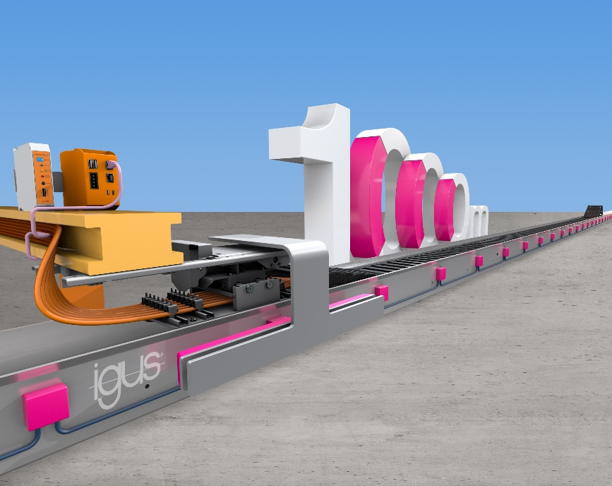
Picture PM5720-1
The EC.PR system monitors the push/pull force along travels up to 1,000 metres based on the position and switches off automatically when the measured values change. (Source: igus GmbH)

