igus goes gamification: the igumania online game makes motion plastics even more tangible
Anyone can be production manager of their own Mars Rover factory, playfully immersing themselves in the world of igus motion plastics

Unplanned maintenance and production downtimes are amongst the biggest challenges industrial companies face. motion plastics specialist igus now offers everyone the opportunity to become a production manager themselves and take on this challenge - with the igumania online browser game. The idle game was developed with the help of the Unity game platform and immerses players in the world of motion plastics. Installing igus products reduces maintenance times in production so that machine downtimes are eliminated, even in the game. The igus corporate goal is also the goal of the game: improve what moves.

As a freshly minted Mars Rover factory production manager, you can fight against the many unplanned maintenance times and plant downtimes in production. This is the scenario players face in the igumania online game. Support is provided by Rusty, the loyal robot assistant, and Dave, the igus technical sales employee, whose visit marks the start of the joint success story with motion plastics. Throughout the course of the game, the player can install various igus products: iglidur plain bearings, energy chains, flexible chainflex cables, drylin linear and drive technology and even complete Low Cost Automation solutions, such as the ReBeL service robot. At the beginning of the game, not all motion plastics solutions are available. They can be unlocked over the course of the game with the igus laboratory technology tree. Players can also experience the real/virtual igus motion plastics show (IMPS) as an in-game trade show, and learn even more about motion plastics products. Completing various tasks unlocks more perks, advantages and products - e-chain recycling, assembly line expansion, conveyor belt acceleration or smart plastics for automatic robot maintenance.

Gamification approach for more user-friendliness
But why does igus want its own game? "The idea arose as we were thinking about how to make our products made of high-performance plastics and their unique selling points even more tangible - in a very simple and playful way," says igus Managing Director Frank Blase. igus follows the principle of "serious gaming": the online game is not only meant to be entertaining, but also close gaps in knowledge in a playful way while communicating the advantages of igus high-performance plastics. "We have good expertise in the software sector and already offer a number of online tools - from product service life calculators to 3D printing services and configurators for linear robots. We are already pursuing the gamification approach here in such ways as using the Unity platform for our linear robot configurator, which makes it extremely intuitive. We want to further develop this approach and make our entire online experience even more playful and user-friendly in the future. Having our own online game is the ideal opportunity to gain valuable experience in the field of gamification."

Game development: from student project to company foundation
To develop its own online game, igus has engaged the services of Cologne Game Lab, an institute at the Cologne University of Applied Sciences, whose student projects have won prizes that include the German Computer Game Prize. As part of the igus student project, ten student teams took up the challenge. The task: develop a concept for an igus game within a week. The concept for "igumania" won, and the winning team was awarded the contract to develop the game. What makes it special: the student project became an idea for a company, and Arkadijs Gribacovs, Ethem Kurt and Leonard Liebler founded elads GbR for game development. "There are still relatively few entrepreneurs in Germany. We are all the more pleased that our idea has awakened the entrepreneurial spirit of young talent and provided the impetus for founding a company," says Frank Blase. And the development of igumania will continue: after gaining initial experience and carrying out optimisations, developers are planning to launch an Android and iOS app version.
Interested? Sign up here for the link to the game and for news on game updates: igumania game registration.

Caption:
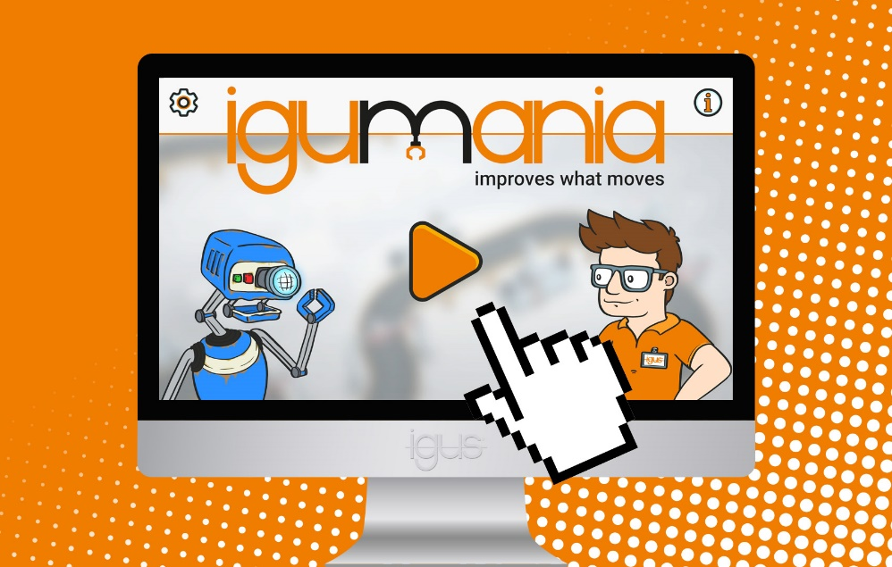
Picture PM3922-1
The igumania online browser game allows anyone to become a production manager and explore the world of lubrication-free, maintenance-free motion plastics and lead their company to success. (Source: igus GmbH)

PRESS CONTACT:

Alexa Heinzelmann
Head of International Marketing

igus® GmbH
Spicher Str. 1a
51147 Cologne
Tel. 0 22 03 / 96 49-7272
aheinzelmann@igus.net
www.igus.eu/press

ABOUT IGUS:

igus GmbH develops and produces motion plastics. These lubrication-free, high-performance polymers improve technology and reduce costs wherever things move. In energy supplies, highly flexible cables, plain and linear bearings as well as lead screw technology made of tribo-polymers, igus is the worldwide market leader. The family-run company based in Cologne, Germany, is represented in 35 countries and employs 4,900 people across the globe. In 2021, igus generated a turnover of €961 million. Research in the industry's largest test laboratories constantly yields innovations and more security for users. 234,000 articles are available from stock and the service life can be calculated online. In recent years, the company has expanded by creating internal startups, e.g. for ball bearings, robot drives, 3D printing, the RBTX platform for Lean Robotics and intelligent "smart plastics" for Industry 4.0. Among the most important environmental investments are the "chainge" programme – recycling of used e-chains - and the participation in an enterprise that produces oil from plastic waste.

The terms "igus", “Apiro”, "chainflex", "CFRIP", "conprotect", "CTD", “drygear”, "drylin", "dry-tech", "dryspin", "easy chain", "e-chain", "e-chain systems", "e-ketten", "e-kettensysteme", "e-skin", "e-spool”, "flizz", “ibow”, “igear”, "iglidur", "igubal", “kineKIT”, "manus", "motion plastics", "pikchain", "plastics for longer life", "readychain", "readycable", “ReBeL”, "speedigus", "tribofilament“, "triflex", "robolink", “xirodur”, and "xiros" are protected by trademark laws in the Federal Republic of Germany and internationally, where applicable.

