"It's a win-win situation, for the environment and for us as a company"
igus programme for recycling energy chains picks up speed

Machine components made of plastic have long since become indispensable in industry. So it is natural to ask what the recycling situation will be at the end of their service life. One possible answer is provided by the motion plastics specialist igus. In the chainge recycling programme, customers can send discarded energy and energy chains to igus for recycling in exchange for a value voucher, regardless of the manufacturer. One of the companies that has tried this out is the machine manufacturer Busch Microsystems.

"It's a win-win situation, for the environment and for us as a company," Dominik Benz of Busch Microsystems Consult GmbH is certain. The design manager of the machine manufacturer from Langenlonsheim was faced with the situation that a customer could not accept a newly developed and already built 3-axis linear robot system. In the end, it had to be dismantled. And the energy chains weighing a total of 400 kilograms were suddenly no longer needed. So where to dispose of the e-chains? "Our igus consultant introduced the igus chainge recycling programme, which recycles the installed e-chains," Dominik Benz recalls. "My colleagues and I took an immediate interest in the programme."

Sustainably recycled instead of simply incinerated
The aim of the chainge recycling programme is to recycle the plastic of the energy chains, to reuse it and therefore to feed it into a recyclable material cycle. For this purpose, users can send their discarded, cleaned plastic chains to igus, irrespective of the manufacturer and receive a voucher in return. The plastics are then sorted by material type, shredded and prepared in order to maintain quality standards in the production process. Plastics from outside companies are offered for sale as ground material. A sustainable alternative, because normally the chain is simply disposed of along with other plastic waste. Recycling hardly takes place. In most factories, the usual procedure is therefore to remove energy chains from their machines and throw them into industrial waste bins. The plastics are then mostly incinerated. A process that was no longer an option for Dominik Benz. "We could not and would not close our minds to the subject of recycling, quite the contrary." Helmut Rath, head of control engineering at IBG Automation, agrees: "Everything we do for our environment is ultimately capital well spent. The return process was simple and straightforward." Busch Microsystems and IBG Automation are among a growing number of companies for which plastics recycling is playing an increasingly important role. With the recent return of 3.4 tons in Singapore, the heaviest single return to date, almost 17 tons have already been collected worldwide in the igus chainge recycling programme and reprocessed locally. "This is a very first step," Angelina Donner, Lean Engineer at igus clarifies. "We work every day to convince more and more customers to send their energy chains for the recycling process." The Rhineland-Palatinate designers see it the same way, because they want to continue participating in the chainge recycling programme in the future, as Dominik Benz emphasises. "We try a lot of new things in day-to-day development. There are always some leftovers from e-chains. From now on, we collect these centrally and send them back to igus once a year for recycling."

Caption:

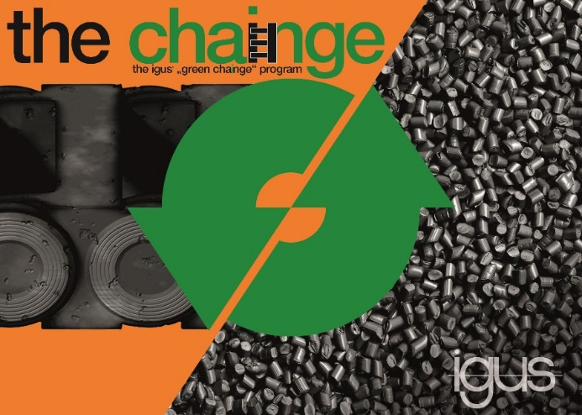
Picture PM5021-1
Time for chainge: In the recycling programme from igus, energy and drag chains are taken back and recycled irrespective of the manufacturer.
(Source: igus GmbH)
ABOUT IGUS:

igus GmbH develops and produces motion plastics. These lubrication-free, high-performance polymers improve technology and reduce costs wherever things move. In energy supplies, highly flexible cables, plain and linear bearings as well as lead screw technology made of tribo-polymers, igus is the worldwide market leader. The family-run company based in Cologne, Germany, is represented in 35 countries and employs 4,150 people across the globe. In 2020, igus generated a turnover of €727 million. Research in the industry's largest test laboratories constantly yields innovations and more security for users. 234,000 articles are available from stock and the service life can be calculated online. In recent years, the company has expanded by creating internal startups, e.g. for ball bearings, robot drives, 3D printing, the RBTX platform for Lean Robotics and intelligent "smart plastics" for Industry 4.0. Among the most important environmental investments are the "chainge" programme – recycling of used e-chains - and the participation in an enterprise that produces oil from plastic waste (Plastic2Oil).

PRESS CONTACT:

Oliver Cyrus Anja Görtz-Olscher
Head of PR and Advertising Manager PR and Advertising

igus® GmbH igus® GmbH
Spicher Str. 1a Spicher Str. 1a
51147 Cologne 51147 Cologne
Tel. 0 22 03 / 96 49-459 Tel. 0 22 03 / 96 49-7153
ocyrus@igus.net agoertz@igus.net
www.igus.de/presse www.igus.de/presse

The terms "igus", “Apiro”, "chainflex", "CFRIP", "conprotect", "CTD", “drygear”, "drylin", "dry-tech", "dryspin", "easy chain", "e-chain", "e-chain systems", "e-ketten", "e-kettensysteme", "e-skin", "e-spool”, "flizz", “ibow”, “igear”, "iglidur", "igubal", “kineKIT”, "manus", "motion plastics", "pikchain", "plastics for longer life", "readychain", "readycable", “ReBeL”, "speedigus", "tribofilament“, "triflex", "robolink", “xirodur”, and "xiros" are protected by trademark laws in the Federal Republic of Germany and internationally, where applicable.

