Shaking hands with a robot: igus launches bionic hand for ReBeL cobot on the market
igus adds a humanoid hand made of lubrication-free high-performance plastics to its ReBeL product range

Robots have become an integral part of industry and are increasingly finding their way into small and medium-sized companies in the form of cobots, such as the ReBeL. They sort, pick and move with the help of cameras, suction devices and gripper systems. igus has now developed a finger gripper for the ReBeL cobot so that it can also perform humanoid tasks. It is made entirely of lubrication-free plastics, and is therefore very cost-effective and easy to integrate.

With the ReBeL, igus has brought a compact and lightweight cobot onto the market, which allows for a cost-effective way to start working with robotics. It is ideal for assembly tasks, quality inspections and jobs in the service sector. So that the robot can actually perform tasks, it requires grippers and suction devices. For this purpose, igus offers a wide selection of suitable end effectors from various manufacturers on the RBTX.com marketplace. "As the ReBeL is very light and inexpensive with a weight of around 8 kilogrammes and a price starting at €3,970, it is often used in humanoid applications. For this reason, we have received several customer requests for a robot hand that can be easily connected to the ReBeL via plug and play," explains Alexander Mühlens, Head of the Low Cost Automation Business Unit at igus GmbH. This is why igus has now developed a particularly cost-effective ReBeL finger gripper, which is available for as little as €1,840. The humanoid hand is compatible with all ReBeL models. It is controlled via DIO at the tool centre point, making it easy to integrate and suitable for various applications. The special feature of the finger gripper is that it can imitate a person's hand movements. "The ReBeL can take on a wide range of simple humanoid tasks and applications with the new low-cost hand. We are thinking of such fields as research and development at universities as well as tasks in the catering or entertainment industries," says Mühlens.

Precise movements thanks to high-performance plastics
All components, including the flange, cables and control unit, are provided directly from igus in Cologne. This gives the customer a solution that is 100% compatible. Lubrication-free high-performance plastics keep the price low. The plain bearings in the joints made of iglidur polymers are not only cost-effective and lubrication-free, but also ensure smooth and precise movements of the individual fingers. Extensive tests in the company's own 3,800-square-metre laboratory guarantee the longevity of the humanoid hand. They are extremely flexible and can be controlled via various interfaces, including USB, TTL (5V) serial and internal scripting. In addition to the finger gripper, igus offers other products for the ReBeL environment. These include, for example, fire-resistant smoke hoods, a 7th axis, gripper sets, adapter plate sets, energy supply systems, a finished workstation and connection cables.

Caption:

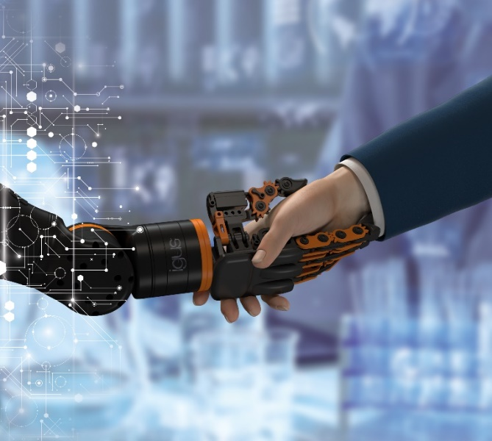
Picture PM6123-1
igus has developed a finger gripper for the ReBeL cobot. The ReBeL can perform a variety of simple humanoid tasks with the new low-cost robotic hand. (Source: igus GmbH)

PRESS CONTACT:

Alexa Heinzelmann
Head of International Marketing

igus® GmbH
Spicher Str. 1a
51147 Cologne
Tel. 0 22 03 / 96 49-7272
aheinzelmann@igus.net
www.igus.eu/press

ABOUT IGUS:

igus GmbH develops and produces motion plastics. These lubrication-free, high-performance polymers improve technology and reduce costs wherever things move. In energy supplies, highly flexible cables, plain and linear bearings as well as lead screw technology made of tribo-polymers, igus is the worldwide market leader. The family-run company based in Cologne, Germany, is represented in 31 countries and employs 4,600 people across the globe. In 2022, igus generated a turnover of €1,15 billion. Research in the industry's largest test laboratories constantly yields innovations and more security for users. 234,000 articles are available from stock and the service life can be calculated online. In recent years, the company has expanded by creating internal startups, e.g. for ball bearings, robot drives, 3D printing, the RBTX platform for Lean Robotics and intelligent "smart plastics" for Industry 4.0. Among the most important environmental investments are the "chainge" programme – recycling of used e-chains - and the participation in an enterprise that produces oil from plastic waste.

The terms "igus", “Apiro”, "chainflex", "CFRIP", "conprotect", "CTD", “drygear”, "drylin", "dry-tech", "dryspin", "easy chain", "e-chain", "e-chain systems", "e-ketten", "e-kettensysteme", "e-skin", "e-spool”, "flizz", “ibow”, “igear”, "iglidur", "igubal", “kineKIT”, "manus", "motion plastics", "pikchain", "plastics for longer life", "readychain", "readycable", “ReBeL”, "speedigus", "tribofilament“, "triflex", "robolink", “xirodur”, and "xiros" are protected by trademark laws in the Federal Republic of Germany and internationally, where applicable.

