A smart box! New igus module for predictive maintenance
i.Cee:local module predicts the service life of machinery and equipment, making maintenance efficient and predictable

With the i.Cee:local module, igus has now developed a new home for its smart plastics software. The module calculates the remaining service life of the energy chain, cable, linear guide and plain bearing during operation. This allows the service life of the system to be optimised, faults to be detected and rectified at an early stage, and maintenance to be planned in advance. With its multi-connectivity, i.Cee:local can be integrated via the Internet or without IoT connectivity via the local network, depending on customer requirements.

smart plastics sensors from igus: they monitor abrasion, measure the pull/push force and provide information about an imminent overload. But how does the maintenance manager get concrete information about the condition of the system? The new solution from igus is the i.Cee:local. The intelligent module bundles the data of all smart plastics systems used and prepares it for the maintenance engineer. i.Cee:local has two functions: it is the home of the open source i.Cee software, the brain of smart plastics. For the first installation, the software is first parametrised and thus optimally adapted to the specific application with the help of the service life algorithms from igus. "The service life forecast, which we determine on the basis of millions of test data in our in-house 3,800 square metre laboratory, is compared and adjusted during operation with the values actually determined, so that a real-time service life statement can be made about the durability of the machine and system", explains Richard Habering, Head of the smart plastics Business Unit at igus GmbH. With i.Cee:local, maintenance can be planned in advance, malfunctions can be detected in time and plant downtime can be avoided. The costs of an early retrofit can be reduced through the maximum use of igus components, and spare parts can also be ordered automatically at an early stage. The use of i.Cee:local is suitable for all igus smart plastics products, from plain bearings up to chains.

Multi-connectivity for easy overview
The second important specification of i.Cee:local is its multi-connectivity. The possibility of seamless integration into the designated network environments allows the implementation of various Industry 4.0 use cases. The data of the i.Cee:local module can be accessed either via a display on the system, via a cloud solution or an IoT dashboard, as JSON/MQTT protocol, on the intranet, via the REST API interface or directly via SMS or email. "No matter whether online or offline, depending on the customer's requirements, the data can be accessed quickly and easily by the maintenance staff, thanks to the i.Cee:local module", says Richard Habering.

Find out more about the i.Cee:local at:
https://www.igus.eu/info/i-cee-plus-2

Captions:

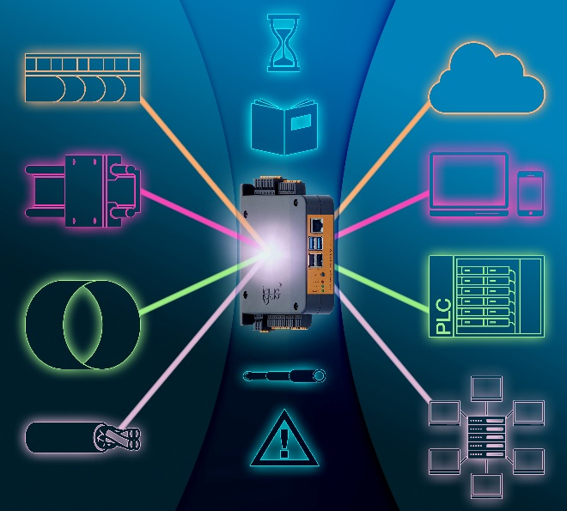
Picture PM2621-1
The igus smart plastics i.Cee module ensures predictive maintenance on
e-chain systems, chainflex cables, linear guides and plain bearings.
(Source: igus GmbH)

PRESS CONTACT:  Oliver Cyrus  Head of PR and Advertising  Anja Görtz-Olscher  PR and Advertising  igus® GmbH  Spicher Str. 1a  51147 Cologne  Tel. 0 22 03 / 96 49-459 or -7153  Fax 0 22 03 / 96 49-631  ocyrus@igus.net  agoertz@igus.net  www.igus.eu/press | ABOUT IGUS:  igus GmbH develops and produces motion plastics. These lubrication-free, high-performance polymers improve technology and reduce costs wherever things move. In energy supplies, highly flexible cables, plain and linear bearings as well as lead screw technology made of tribo-polymers, igus is the worldwide market leader. The family-run company based in Cologne, Germany, is represented in 35 countries and employs 3,800 people across the globe. In 2019, igus generated a turnover of €764 million. Research in the industry's largest test laboratories constantly yields innovations and more security for users. 234,000 articles are available from stock and the service life can be calculated online. In recent years, the company has expanded by creating internal startups, e.g. for ball bearings, robot drives, 3D printing, the RBTX platform for Lean Robotics and intelligent "smart plastics" for Industry 4.0. Among the most important environmental investments are the "chainge" programme – recycling of used e-chains - and the participation in an enterprise that produces oil from plastic waste. (Plastic2Oil).

The terms "igus", “Apiro”, "chainflex", "CFRIP", "conprotect", "CTD", “drygear”, "drylin", "dry-tech", "dryspin", "easy chain", "e-chain", "e-chain systems", "e-ketten", "e-kettensysteme", "e-skin", "e-spool”, "flizz", “ibow”, “igear”, "iglidur", "igubal", “kineKIT”, "manus", "motion plastics", "pikchain", "plastics for longer life", "readychain", "readycable", “ReBeL”, "speedigus", "tribofilament“, "triflex", "robolink", “xirodur”, and "xiros" are protected by trademark laws in the Federal Republic of Germany and internationally, where applicable.

