New compact igus cables guarantee 100 million double strokes – more than any other cable in the world
chainflex CF98.PLUS and CF99.PLUS cables allow a sustainable machine concept with the smallest bend radii

igus is continuously improving in order to optimise our customers' moving applications. The specialist for moving cables has now refined its successful chainflex control cable series. CF98.PLUS and CF99.PLUS are the only cables on the market that are guaranteed to handle over 100 million double strokes or that can be used in energy chains with the tiny radii of 3xd.

In the blink of an eye, the machine moves and applies the chip to the new smartphone with high precision. This process is repeated thousands of times a day and requires multiple cables. Smaller and smaller installation spaces, shorter and shorter cycles and 99 percent availability for machines and systems are requirements that are not limited to the semiconductor industry. Demand for fast, compact automation systems is also increasing in many other sectors, such as medical technology, the automotive industry and sorting systems. So, igus has now refined its proven CF98 control cables to produce an unshielded variant and CF99 to produce a shielded one. "With great success," says a delighted Rainer Rössel, chainflex cable Business Unit Manager at igus. "The new CF98.PLUS and CF99.PLUS cables are the first and only cables available on the market that are approved for use in energy chains and for which igus guarantees 100 million double strokes." This means an increase in service life of 250 percent over the original series. The new cables are also designed for very small bend radii, just three times the diameter of the cable (3xd). Users where space is critical can now use a reliable high-end TPE cable and give their end customers a sustainable machine concept.

Long service life guaranteed
For more than ten years, igus have worked on the new cables, testing them in its own 3,800 square metre laboratory and improving them. The cable specialist has set up two extra-large test rigs for this purpose. The essential improvements are primarily in a special conductor material alloy and a new manufacturing process for the insulation material. The extensive testing allows igus to promise a guaranteed service life of 36 months for all its cables. Cable service life can also be determined online with an online service life calculator. "Users who choose CF98.PLUS or CF99.PLUS make a significant contribution to their company's sustainability concept because they are investing in their machine's durability," says Rössel.

Caption:
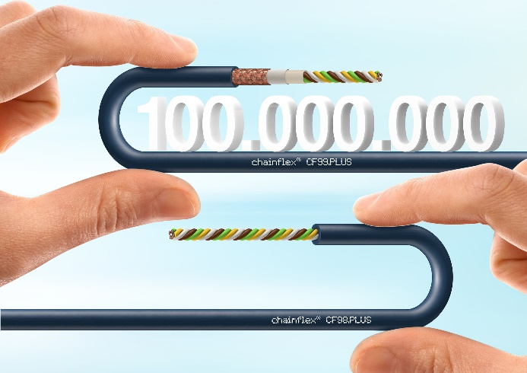
Picture PM6522-1
The two new chainflex cable series, CF98.PLUS and CF99.PLUS, can withstand up to 100 million double strokes with the smallest bend radii. (Source: igus GmbH)

PRESS CONTACT:

Alexa Heinzelmann
Head of International Marketing

igus® GmbH
Spicher Str. 1a
51147 Cologne
Tel. 0 22 03 / 96 49-7272
aheinzelmann@igus.net
www.igus.eu/press

ABOUT IGUS:

igus GmbH develops and produces motion plastics. These lubrication-free, high-performance polymers improve technology and reduce costs wherever things move. In energy supplies, highly flexible cables, plain and linear bearings as well as lead screw technology made of tribo-polymers, igus is the worldwide market leader. The family-run company based in Cologne, Germany, is represented in 31 countries and employs 4,900 people across the globe. In 2021, igus generated a turnover of €961 million. Research in the industry's largest test laboratories constantly yields innovations and more security for users. 234,000 articles are available from stock and the service life can be calculated online. In recent years, the company has expanded by creating internal startups, e.g. for ball bearings, robot drives, 3D printing, the RBTX platform for Lean Robotics and intelligent "smart plastics" for Industry 4.0. Among the most important environmental investments are the "chainge" programme – recycling of used e-chains - and the participation in an enterprise that produces oil from plastic waste.

The terms "igus", “Apiro”, "chainflex", "CFRIP", "conprotect", "CTD", “drygear”, "drylin", "dry-tech", "dryspin", "easy chain", "e-chain", "e-chain systems", "e-ketten", "e-kettensysteme", "e-skin", "e-spool”, "flizz", “ibow”, “igear”, "iglidur", "igubal", “kineKIT”, "manus", "motion plastics", "pikchain", "plastics for longer life", "readychain", "readycable", “ReBeL”, "speedigus", "tribofilament“, "triflex", "robolink", “xirodur”, and "xiros" are protected by trademark laws in the Federal Republic of Germany and internationally, where applicable.

