Clip, stop and go: an igus linear carriage with a new locking mechanism that you can take with you
The drylin W clip-on carriage ensures quick installation (directly on the rail) and easy handling

The new igus linear clip-on carriage is the only one of its kind in the world. It can be mounted directly on the linear rail, removed and locked in place with a clamping lever in a matter of seconds. It is a practical way to transport such items as control panels, camera systems, measuring and testing units and tools.

The new igus clip-on carriage enables you to easily remove the linear carriage from the rail, place it on another guide and fix it in a suitable place. Presented as a study at the end of 2021, the carriage with its new locking mechanism is now going into series production. "The idea to develop the carriage came from our customers providing feedback on the cabin interior. They wanted to be able to move the control panels ergonomically and, if necessary, remove them and take them away," says Michael Hornung, Product Manager International drylin Linear Technology at igus GmbH. And so, the clip-on carriage with its simple installation and removal function was developed for the drylin W linear guide. The assembled equipment can be removed from the guide rail wherever it is with just one movement, taken to another cabin and safely locked away. The first prototype quickly became very popular, and constructive feedback led to its refinement. "The customers wanted to be able to lock the carriage, so we have now integrated the clamp into the clip-on carriage in the series," says Michael Hornung.

Three functions in a single carriage
The carriage series now combines a total of three functions. It is the only linear carriage in the world that can be easily clipped onto a linear rail. The user can mount the rail from wall to wall and does not need to plan any additional installation space for the carriage. Moreover, it is a classic drylin W linear carriage for easy adjustment. Thanks to liners made of tribologically optimised high-performance plastics, the carriage slides smoothly and quietly on the rail without any lubrication. Dirt and dust cannot stick, and moisture and water also pose no problem for the carriage. The new clamping lever fixes the carriage in place and protects it against vibration and inadvertent adjustment. The lever can be varied as the customer requires. In addition to interior-area customers, many other interested parties have become aware of the new linear carriage - from the machine tool sector for variable use of testing and measuring systems and machine-to-machine tools as well as building and camera technology.

Caption:
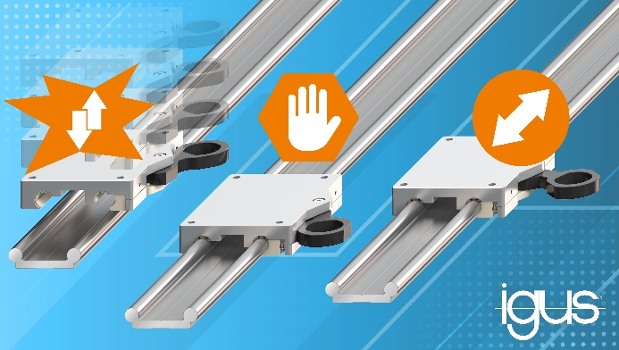
Picture PM0423-1
Three in one: the new igus clip-on carriage can be mounted directly on the linear rail, removed and locked in place with a clamping lever in a matter of seconds. The classic drylin W linear carriage ensures easy adjustment. (Source: igus GmbH)

PRESS CONTACT:

Alexa Heinzelmann
Head of International Marketing

igus® GmbH
Spicher Str. 1a
51147 Cologne
Tel. 0 22 03 / 96 49-7272
aheinzelmann@igus.net
www.igus.eu/press

ABOUT IGUS:

igus GmbH develops and produces motion plastics. These lubrication-free, high-performance polymers improve technology and reduce costs wherever things move. In energy supplies, highly flexible cables, plain and linear bearings as well as lead screw technology made of tribo-polymers, igus is the worldwide market leader. The family-run company based in Cologne, Germany, is represented in 31 countries and employs 4,900 people across the globe. In 2021, igus generated a turnover of €961 million. Research in the industry's largest test laboratories constantly yields innovations and more security for users. 234,000 articles are available from stock and the service life can be calculated online. In recent years, the company has expanded by creating internal startups, e.g. for ball bearings, robot drives, 3D printing, the RBTX platform for Lean Robotics and intelligent "smart plastics" for Industry 4.0. Among the most important environmental investments are the "chainge" programme – recycling of used e-chains - and the participation in an enterprise that produces oil from plastic waste.

The terms "igus", “Apiro”, "chainflex", "CFRIP", "conprotect", "CTD", “drygear”, "drylin", "dry-tech", "dryspin", "easy chain", "e-chain", "e-chain systems", "e-ketten", "e-kettensysteme", "e-skin", "e-spool”, "flizz", “ibow”, “igear”, "iglidur", "igubal", “kineKIT”, "manus", "motion plastics", "pikchain", "plastics for longer life", "readychain", "readycable", “ReBeL”, "speedigus", "tribofilament“, "triflex", "robolink", “xirodur”, and "xiros" are protected by trademark laws in the Federal Republic of Germany and internationally, where applicable.

