Remote Scouts at the Hannover Messe: igus brings innovations live to the screen
Experience 190 motion plastics innovations comfortably at your desk with individually guided online tours

No time to visit the Hannover Messe 2023? No problem. The motion plastics specialist is offering the so-called Remote Scout Service for the first time this year. The igus experts equipped with data glasses show visitors live the new products that are of interest to them in individual online tours.

For the first time, igus will take people to the trade show stand in Hannover who are somewhere else - in Hamburg, Dresden or Munich. Interested parties can simply book a so-called Remote Scout online. The igus experts are equipped with data glasses and transfer the latest motion plastics products and solutions to the web browser on a PC, smart phone or tablet in 30 minutes. Interested parties see 1:1 what the igus scouts see. They have both hands free and can demonstrate everything in the same way as it would be possible with an appointment on site.

The Remote Scouts present 190 real innovations
The Hannover Messe 2023 is not only one of the trade show highlights of the year for igus. Here, the motion plastics specialist will be presenting a fireworks display of innovations from 17 to 21 April. With "enjoyneering" igus shows 190 real innovations and digital revolutions at two trade show stands. At the trade show stand for product innovations in Hall 6, extremely wear-resistant polymer plain bearings for the highest loads can be seen, as well as highly dynamic energy supply systems that can be quickly opened by hand. Visitors will also see innovations from low-cost robotics, such as the extended ReBeL cobot family. This also enables small and medium-sized companies to get started with automation intuitively and at low risk. At the trade show stand in Hall 17, everything revolves around exciting digital possibilities such as igusGO or the iguverse, a virtual space in which users can experience products as digital twins and design new machines, systems and vehicles together.
Corona provided the impetus for the Remote Scouts
The idea for the Remote Scouts came about during the corona pandemic. Because of the contact restrictions, trade shows were on hold. An unusual situation to which igus responded quickly. A real, 400 square metre trade show stand was created at the company headquarters in Cologne, the award-winning igus motion plastics show (IMPS). In addition to a virtual visit, sales experts use the cameras of their smart phones or tablets to show interested parties the innovations from the world of motion plastics. A successful concept that is now starting the next round at the Hannover Messe with the Remote Scout Service.

Caption:

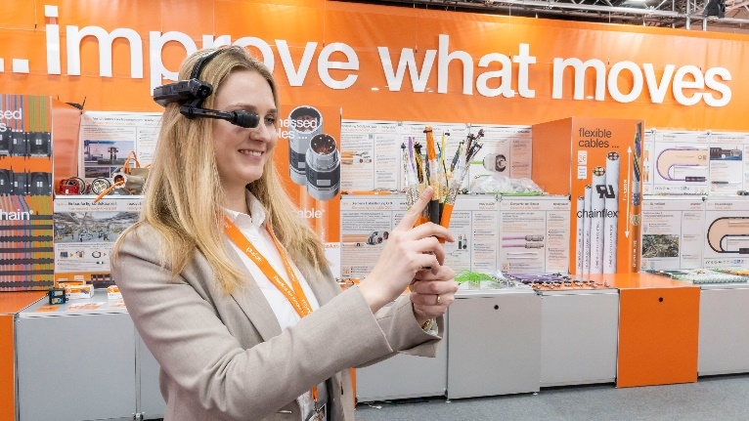
Picture PM2023-1
Live from the Hannover Messe on the screen: The Remote Scout Service shows interested parties the latest products and industry-specific solutions, tailored to their personal interests. (Source: igus GmbH)

PRESS CONTACT:

Alexa Heinzelmann
Head of International Marketing

igus® GmbH
Spicher Str. 1a
51147 Cologne
Tel. 0 22 03 / 96 49-7272
aheinzelmann@igus.net
www.igus.eu/press

ABOUT IGUS:

igus GmbH develops and produces motion plastics. These lubrication-free, high-performance polymers improve technology and reduce costs wherever things move. In energy supplies, highly flexible cables, plain and linear bearings as well as lead screw technology made of tribo-polymers, igus is the worldwide market leader. The family-run company based in Cologne, Germany, is represented in 31 countries and employs 4,900 people across the globe. In 2021, igus generated a turnover of €961 million. Research in the industry's largest test laboratories constantly yields innovations and more security for users. 234,000 articles are available from stock and the service life can be calculated online. In recent years, the company has expanded by creating internal startups, e.g. for ball bearings, robot drives, 3D printing, the RBTX platform for Lean Robotics and intelligent "smart plastics" for Industry 4.0. Among the most important environmental investments are the "chainge" programme – recycling of used e-chains - and the participation in an enterprise that produces oil from plastic waste.

The terms "igus", “Apiro”, "chainflex", "CFRIP", "conprotect", "CTD", “drygear”, "drylin", "dry-tech", "dryspin", "easy chain", "e-chain", "e-chain systems", "e-ketten", "e-kettensysteme", "e-skin", "e-spool”, "flizz", “ibow”, “igear”, "iglidur", "igubal", “kineKIT”, "manus", "motion plastics", "pikchain", "plastics for longer life", "readychain", "readycable", “ReBeL”, "speedigus", "tribofilament“, "triflex", "robolink", “xirodur”, and "xiros" are protected by trademark laws in the Federal Republic of Germany and internationally, where applicable.

