For a neatly sliding bag: new igus coating powder for food technology
FDA-compliant polymer powder IC-05 with four times longer service life than IC-01 ensures wear-resistant sheet metal

Whether in dosing systems, on conveyor belts of filling systems or in labelling technology: you will find sheet metal and parts that are exposed to friction and wear in all these places. To increase the service life of the metallic components, igus has now developed a new coating material. The sprayed-on IC-05 tribo-polymer protects sensitive and small bearing points as well as sliding surfaces. It is optically detectable due to its blue colour and is approved for use in food technology. In the test, the material was able to convince with a four times longer service life than the coating powder IC-01.

Nowadays, it is impossible to imagine the food industry without automated systems. But what happens if a bottle falls over in the filling line or a packet soup gets wedged in the parts chute and tears open? Scenarios that lead to unplanned plant shutdown, cost time and money. Moving machine components with low coefficient of friction are in demand here. In order to give guide plates, metallic slides or even parts with complex geometries a high wear resistance, igus has now developed a new coating material especially for use in food technology. The high-performance IC-05 polymer complies with FDA requirements and EU10/2011 regulations and is therefore ideally suited for contact with food. Its blue colour makes it optically detectable. The material significantly reduces the coefficient of friction of the coated parts and increases the service life and availability of the equipment. It also improves product safety and reduces costs. Lubricants can be dispensed with completely. The powder material can either be sprayed onto the desired components by the user or by igus. Layer thicknesses of 60 to 120 µm are possible. "Especially for places where there is no space for a plain bearing, a coating of the moving parts that are exposed to wear is a good idea", explains Stefan Loockmann-Rittich, head of the iglidur plain bearing technology business division at igus GmbH.

Laboratory test reveals four times longer service life
igus tested the durability of the coated parts in its own 3,800 square metre laboratory in Cologne. Here, a part coated with IC-05 was compared with an identical part coated with the standard material IC-01 in various test set-ups. The FDA-compliant component impressed with a four times longer service life. In addition to IC-05, igus offers five other coating materials, for example, for applications in the high-temperature range or with high chemical resistance.

Learn more about the igus coating materials at:
https://www.igus.eu/info/plain-bearings-coating-iglidur?L=en

Caption:

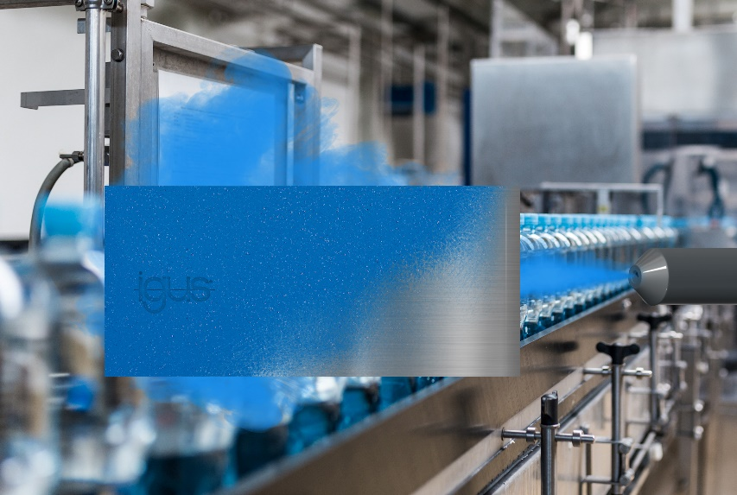
Picture PM0321-1
Parts coated with IC-05 provide users in the food industry with FDA-compliant machine components that slide well. (Source: igus GmbH)

PRESS CONTACT:  Oliver Cyrus  Head of PR and Advertising  Anja Görtz-Olscher  PR and Advertising  igus® GmbH  Spicher Str. 1a  51147 Cologne  Tel. 0 22 03 / 96 49-459 or -7153  Fax 0 22 03 / 96 49-631  ocyrus@igus.net  agoertz@igus.net  www.igus.eu/press | ABOUT IGUS:  igus GmbH develops and produces motion plastics. These lubrication-free, high-performance polymers improve technology and reduce costs wherever things move. In energy supplies, highly flexible cables, plain and linear bearings as well as lead screw technology made of tribo-polymers, igus is the worldwide market leader. The family-run company based in Cologne, Germany, is represented in 35 countries and employs 3,800 people across the globe. In 2019, igus generated a turnover of €764 million. Research in the industry's largest test laboratories constantly yields innovations and more security for users. 234,000 articles are available from stock and the service life can be calculated online. In recent years, the company has expanded by creating internal startups, e.g. for ball bearings, robot drives, 3D printing, the RBTX platform for Lean Robotics and intelligent "smart plastics" for Industry 4.0. Among the most important environmental investments are the "chainge" programme – recycling of used e-chains - and the participation in an enterprise that produces oil from plastic waste. (Plastic2Oil).

The terms "igus", “Apiro”, "chainflex", "CFRIP", "conprotect", "CTD", “drygear”, "drylin", "dry-tech", "dryspin", "easy chain", "e-chain", "e-chain systems", "e-ketten", "e-kettensysteme", "e-skin", "e-spool”, "flizz", “ibow”, “igear”, "iglidur", "igubal", “kineKIT”, "manus", "motion plastics", "pikchain", "plastics for longer life", "readychain", "readycable", “ReBeL”, "speedigus", "tribofilament“, "triflex", "robolink", “xirodur”, and "xiros" are protected by trademark laws in the Federal Republic of Germany and internationally, where applicable.

