Compact for small installation spaces: igus presents new miniature linear guides
Lubrication-free drylin W series extended by Installation Size 06

Laboratory equipment, espresso machines, tiny houses: wherever installation space is scarce and components are difficult to reach, designers are looking for space-saving and maintenance-free linear guides for adjustment and positioning tasks. igus is therefore adding new miniature linear guides in Installation Size 06 to its drylin W series. They are not only compact but also lubrication-free.

The new miniature linear guide of the drylin W series consists of a modular system, including ready-to-install systems or individual components. New additions are the drylin WW-06-20-T415-AL miniature linear carriages with a corrosion-resistant housing made of anodised aluminium. They fit on a double shaft rail, also made of anodised aluminium. "Together, the carriages and rail require an installation height of only 20 millimetres and a width of just 32 millimetres", says Michael Hornung, Product Manager drylin Linear and Drive Technology at igus. Compared to the most compact solution from igus to date, designers thus save 28% in width, 12% in height and 70% in weight. "The linear guide fits into almost any niche - whether installed horizontally, vertically or overhead. It is ideal for adjustment mechanisms in the most confined installation spaces, including pipetting systems or furniture for caravans." All components in Installation Size 06 are available in silver and in black. "The black look, which is often in demand, does not reflect light and can be inconspicuously integrated into any design."

Also new: a mini linear actuator with electric motor
Another new product is the SLW-06-20 electric linear actuator. It contains a lead screw in the centre of the new drylin W miniature guide WS-06-20. "Here, too, we have succeeded in saving installation space by making design-related adjustments. The system also has an installation height of 20 millimetres and a width of 32 millimetres", says Hornung. "Among other things, the solution is suitable for automatic adjustment tasks in small installation spaces, such as in medical and laboratory technology or household appliances - for example, positioning the portafilter in an espresso machine." Such applications also benefit from dryspin lead screw technology. For example, thread geometry of the lead screw are not angular, but rounded. This reduces the contact area between the lead screw nut and the lead screw and results in less vibration, which could be noticeable as rattling or squeaking. Thanks to the rounded thread geometry, the threads travel smoothly and almost noiselessly. The mini linear actuator can be adjusted manually or electrically and is available in silver and in black, just like the drylin W miniature guide.

Sliding instead of rolling: thanks to freedom from lubrication, the miniature linear guides operate without maintenance for many years
The new miniature linear guides in Installation Size 06 follow the igus principle "sliding instead of rolling". The carriages slide on the rails via liners made of high-performance plastic - without lubricating oil or grease. This is due to the microscopic solid lubricants in the plastic that are released over time and enable low-friction dry operation. "In many systems, grease becomes a dirt magnet. This quickly creates a lubricating film that can affect the smooth running of the linear guide and requires a lot of cleaning," says Hornung. "Furthermore, a high degree of cleaning is not ideal, particularly in applications with small installation spaces because the components are usually difficult to reach", he adds. "Thanks to the absence of lubrication, our miniature linear guides operate without maintenance for many years."

Caption:

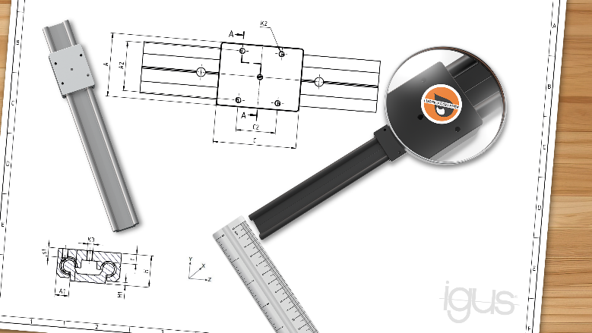
Image PM5723-1
For particularly small and compact installation spaces, igus has added the Installation Size 06 to its lubrication-free drylin W linear guide series. (Source: igus GmbH)

PRESS CONTACT:

Alexa Heinzelmann
Head of International Marketing

igus® GmbH
Spicher Str. 1a
51147 Cologne
Tel. 0 22 03 / 96 49-7272
aheinzelmann@igus.net
www.igus.eu/press

ABOUT IGUS:

igus GmbH develops and produces motion plastics. These lubrication-free, high-performance polymers improve technology and reduce costs wherever things move. In energy supplies, highly flexible cables, plain and linear bearings as well as lead screw technology made of tribo-polymers, igus is the worldwide market leader. The family-run company based in Cologne, Germany, is represented in 31 countries and employs 4,600 people across the globe. In 2022, igus generated a turnover of €1,15 billion. Research in the industry's largest test laboratories constantly yields innovations and more security for users. 234,000 articles are available from stock and the service life can be calculated online. In recent years, the company has expanded by creating internal startups, e.g. for ball bearings, robot drives, 3D printing, the RBTX platform for Lean Robotics and intelligent "smart plastics" for Industry 4.0. Among the most important environmental investments are the "chainge" programme – recycling of used e-chains - and the participation in an enterprise that produces oil from plastic waste.

The terms "igus", “Apiro”, "chainflex", "CFRIP", "conprotect", "CTD", “drygear”, "drylin", "dry-tech", "dryspin", "easy chain", "e-chain", "e-chain systems", "e-ketten", "e-kettensysteme", "e-skin", "e-spool”, "flizz", “ibow”, “igear”, "iglidur", "igubal", “kineKIT”, "manus", "motion plastics", "pikchain", "plastics for longer life", "readychain", "readycable", “ReBeL”, "speedigus", "tribofilament“, "triflex", "robolink", “xirodur”, and "xiros" are protected by trademark laws in the Federal Republic of Germany and internationally, where applicable.

