igus opens digital innovations trade show 2020

More than 100 motion plastics innovations show how customers can save costs and improve their technology

In its virtual trade show, igus is now presenting more than 100 plastic innovations and product range additions from all areas of motion plastics. Around 400 square metres in size, the real stand is now open to visitors on the Internet and, using multimedia, provides information on the topic of "Cost down, Life up. It’s our job." The trade show is part of the digital support given to customers, whereby personal guided tours, person-to-person meetings and group meetings on the stand can be arranged.

In its virtual trade show, igus is now showing visitors how high-performance polymers can be used to sustainably increase the service life of moving applications and also reduce costs. "When one trade show after the other was cancelled, it quickly became clear to us: we should create our own trade show and share it with the world from Cologne", explains Frank Blase, CEO of igus GmbH. At its headquarters in Cologne, igus built a 400 square-metre trade show stand and placed it on the Internet at www.igus.eu/virtualexhibition. The stand is open to visitors. At the individual stations, visitors can make use of displays, films and texts to immerse themselves into the world of motion plastics - from SPE cables designed specially for e-chains to lightweight drylin polymer telescopes and intelligent smart plastics solutions. Links take the user to more detailed technical information and videos on the website.

Real stand, virtual visit
The virtual trade show is part of the extensive digital consultation service provided by igus. Anyone wishing to obtain specific, detailed information can make an appointment and, together with a customer consultant, can take a tour of the stations on the virtual trade show stand in the Internet. A personal meeting with an igus product expert or industry expert is also possible on the real trade show stand, without the visitor having to leave her/his workplace/home office. With the help of a tablet, the expert guides the visitor over the trade show stand and can directly access the exhibited products and demonstrate their use on trade show machines. In addition, the stand can be used as a basis for a series of tutorials and webinars, which customers can use to expand their knowledge relating to all aspects of motion plastics from igus. You can find more information on the igus Academy at https://www.igus.eu/info/igus-academy.

Caption:

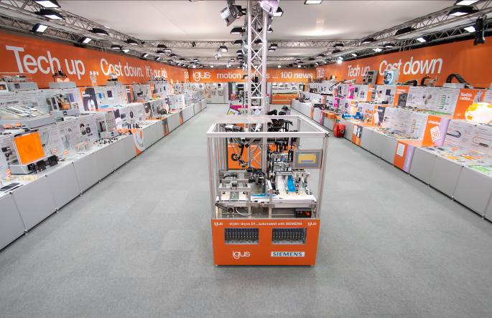
Picture PM2420-1
A virtual tour of the igus trade show stand: 150 displays and 40 videos provide information to visitors about the more than 100 motion plastics innovations, which are clearly set out and can be found very quickly. (Source: igus GmbH)

