Plastic recycling pioneer Mura Technology celebrates pre-opening of world’s first HydroPRS™ plant

Mura Technology is starting the commissioning phase of the world’s first HydroPRS™ plant in the UK. First partner, igus, congratulates to this recycling milestone.

Cologne, Teesside, October 2023 – Plastic waste is not incinerated, but turned back into oil in 30 minutes – using only pressure, heat and water: this revolutionary HydroPRS™ recycling is now being launched on a commercial scale for the first time. The British company Mura Technology is now starting to commission the world's first plant – with the support of investor igus. A significant step towards an environmentally friendly and resource-saving recycling economy for plastics.

Mura Technology's first HydroPRS™ plastics recycling plant opened its doors to investors, partners and advocates on 26 October at the Wilton International industrial site in Teesside, UK, just before the site will be going into operation in 2024. The plant uses supercritical water (water at high temperature and high pressure) to turn products such as films, pots or tubs made from multi-layer mixed plastics, previously considered inseparable, into virgin-equivalent, recycled hydrocarbon feedstocks. This can then be used in the manufacture of new plastics and other products. The capacity of the plant is 20,000 tonnes per year – with plans to increase this to over three times this initial size. Until now, mixed plastics could only be separated by type in mechanical recycling with great effort and therefore usually ended up in incineration.

HydroPRS™ – New type of reconversion saves 80 percent CO₂ emissions
The advantages of the new recycling process are obvious: Through the reconversion of waste plastic to virgin-replacement feedstocks, crude oil is not lost as a valuable fossil raw material. At the same time, independent life-cycle analyses by WMG at the University of Warwick have shown that CO₂ emissions are 80 percent lower than with combustion. Compared to fossil oil-based raw materials, HydroPRS™ produces products with equivalent or lower global warming potential and saves up to around 5 barrels of oil for every tonne of plastic waste processed. This pioneering technology means that the same material can be recycled an unlimited number of times. This means that HydroPRS™ has the potential to significantly reduce single-use plastics and permanently increase the recyclability of materials in the plastics industry. “This technology is a real game changer in plastics recycling. We are proud to be accompanying Mura on this journey as the first partner”, says igus CEO Frank Blase. He had read about HydroPRS™ in 2019 and was convinced of its future viability. Igus has invested 5 Mio. Euros so far to support Mura from the start-up phase into commercializing the technology.

igus's declared goal: transforming plastics into a circular economy
As a plastics-producing company, igus also feels responsible for continuously optimising the environmental balance of its materials. Supporting HydroPRS™ technology is just one of many building blocks in this process. igus uses 99 percent of the plastic waste from production for new granulate for the injection moulding machines. In 2019, igus also launched "chainge" - a digital recycling platform for discarded energy chains and other components made of engineering plastics. In 2022, the first energy chain made from 100 percent recyclate was created. In the igus:bike project, the company is also realising a plastic bicycle for sustainable urban mobility, whose frame and wheels can be made from plastic waste such as old fishing nets. Plastic waste in landfills and in the world's oceans is thus transformed into a valuable resource.

Caption:

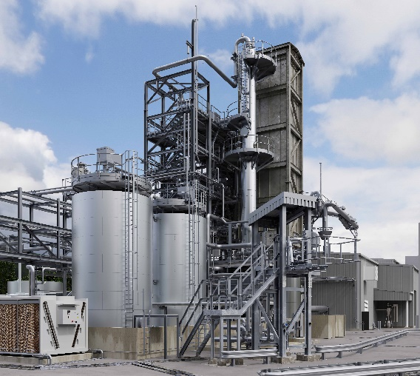
Image PM5823-1
Mura Technology MPS (Main Process Structure)
The first HydroPRS™ plant by Mura Technology in Teesside, UK, will be going into operation in 2024. It will have the capacity to recycle 20.000 tonnes of plastic waste per year.

PRESS CONTACT:
Alexa Heinzelmann
Head of International Marketing

igus® GmbH
Spicher Str. 1a
51147 Cologne
Tel. 0 22 03 / 96 49-7272
aheinzelmann@igus.net
www.igus.eu/press

ABOUT IGUS:

igus GmbH develops and produces motion plastics. These lubrication-free, high-performance polymers improve technology and reduce costs wherever things move. In energy supplies, highly flexible cables, plain and linear bearings as well as lead screw technology made of tribo-polymers, igus is the worldwide market leader. The family-run company based in Cologne, Germany, is represented in 31 countries and employs 4,600 people across the globe. In 2022, igus generated a turnover of €1,15 billion. Research in the industry's largest test laboratories constantly yields innovations and more security for users. 234,000 articles are available from stock and the service life can be calculated online. In recent years, the company has expanded by creating internal startups, e.g. for ball bearings, robot drives, 3D printing, the RBTX platform for Lean Robotics and intelligent "smart plastics" for Industry 4.0. Among the most important environmental investments are the "chainge" programme – recycling of used e-chains - and the participation in an enterprise that produces oil from plastic waste.

The terms "igus", “Apiro”, "chainflex", "CFRIP", "conprotect", "CTD", “drygear”, "drylin", "dry-tech", "dryspin", "easy chain", "e-chain", "e-chain systems", "e-ketten", "e-kettensysteme", "e-skin", "e-spool”, "flizz", “ibow”, “igear”, "iglidur", "igubal", “kineKIT”, "manus", "motion plastics", "pikchain", "plastics for longer life", "readychain", "readycable", “ReBeL”, "speedigus", "tribofilament“, "triflex", "robolink", “xirodur”, and "xiros" are protected by trademark laws in the Federal Republic of Germany and internationally, where applicable.

