Position ready-to-install energy chains easily, quickly and accurately
Save installation time and improve handling: with the fast positioner, igus adds a new "assembly helper" to the readychain service

If machines or systems are at a standstill, this costs production companies valuable time and money. To make it easier for customers to install energy supply systems and reduce installation time, igus offers the readychain service with pre-assembled systems consisting of chain, cables, connector and many other components. What makes it special: igus offers customers everything from a single source igus. The energy chain is filled, fully harnessed with connectors, quality-checked and delivered ready for connection - on request in the exact installation position. igus is now supplementing this service with a new "assembly helper": the fast positioner. This simple tool makes handling ready-to-install e-chains even easier.

In today's fast-paced world, time is invaluable, especially when it comes to operating machines and systems. Efficient workflows and innovative solutions that save time and resources are therefore essential. "This is precisely why we offer our readychain service," says Markus Hüffel, Product Manager readychain and readycable at igus. Customers don't only benefit when it comes to professional work, such as cutting to length, assembling and testing the cables. Assembly time is also reduced, which increases productivity. Hüffel: "It is important to us to deliver not just a product, but a complete solution. We also think about the customer's upstream and downstream processes and want to actively improve them. For this reason, we have now added a simple tool to our service that offers great added value: the fast positioner. It makes handling and precise positioning of the ready-to-connect energy chain systems even easier, safer and faster." igus supplies the readychains including fast positioner in a preset installation position. For the customer, this simply means: unpack, position, detach the fast positioner - and the e-chain is ready for connection. There is no need for any other tools or double handling by several people. This makes it easier and faster to install.

Customised and sustainable solution
"We manufacture the individual parts of the fast positioner using 3D printing. They are tailored precisely to customer requirements - including individual colour selection and imprints as an identification aid," emphasises Hüffel. They can be easily placed between the upper and lower part of an energy chain and fixed in place with cable tiewraps. Removal after placement is just as simple. In addition, the material can be regranulated and recycled. It is also possible to make the fast positioner from sustainable materials, such as corn starch. The material is both very robust and lightweight. It cannot rust and is compostable, depending on the source material.

Complete solution from a single source
The advantage with igus: customers get everything from a single source. igus carries out design, production and harnessing on site. Hence, throughput times are short and delivery fast. The fast positioner, the latest addition to the readychain service, is not only a carrying handle, but also serves as a fixing device so that the chain is always in the ideal installation position. "With this tool, we show our customers that we have thought out our solution carefully from start to finish," concludes Hüffel.

Caption:
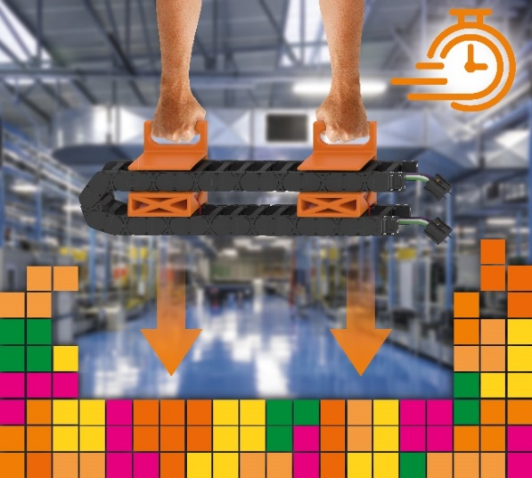
Picture PM6023-1
Precise positioning like Tetris: with the fast positioner, customers receive their readychain in the ideal installation position and can move the entire e-chain system to the right place in just a few simple steps. (Source: igus GmbH)

.

PRESS CONTACT:

Alexa Heinzelmann
Head of International Marketing

igus® GmbH
Spicher Str. 1a
51147 Cologne
Tel. 0 22 03 / 96 49-7272
aheinzelmann@igus.net
www.igus.eu/press

ABOUT IGUS:

igus GmbH develops and produces motion plastics. These lubrication-free, high-performance polymers improve technology and reduce costs wherever things move. In energy supplies, highly flexible cables, plain and linear bearings as well as lead screw technology made of tribo-polymers, igus is the worldwide market leader. The family-run company based in Cologne, Germany, is represented in 31 countries and employs 4,600 people across the globe. In 2022, igus generated a turnover of €1,15 billion. Research in the industry's largest test laboratories constantly yields innovations and more security for users. 234,000 articles are available from stock and the service life can be calculated online. In recent years, the company has expanded by creating internal startups, e.g. for ball bearings, robot drives, 3D printing, the RBTX platform for Lean Robotics and intelligent "smart plastics" for Industry 4.0. Among the most important environmental investments are the "chainge" programme – recycling of used e-chains - and the participation in an enterprise that produces oil from plastic waste.

The terms "igus", “Apiro”, "chainflex", "CFRIP", "conprotect", "CTD", “drygear”, "drylin", "dry-tech", "dryspin", "easy chain", "e-chain", "e-chain systems", "e-ketten", "e-kettensysteme", "e-skin", "e-spool”, "flizz", “ibow”, “igear”, "iglidur", "igubal", “kineKIT”, "manus", "motion plastics", "pikchain", "plastics for longer life", "readychain", "readycable", “ReBeL”, "speedigus", "tribofilament“, "triflex", "robolink", “xirodur”, and "xiros" are protected by trademark laws in the Federal Republic of Germany and internationally, where applicable.

