Find the right plain bearing even faster
igus presents the new iglidur online shop for making the purchase of plastic plain bearings easier

Enter dimensions, determine application parameters, find plain bearings - simple! This is how the new igus online shop for polymer plain bearings now works. Whether catalogue part or special bearing, customers receive a transparent overview of all plain bearings that are suitable for their application. Convenient filters such as price, delivery time and service life help with the selection. Technical drawings and CAD data are available as a free download.

With the iglidur bearing hub, igus presents its web shop for plain bearings with a new, easy-to-use interface and unique functions. Similar to online retailers for tools or fashion, customers can now quickly find the right plain bearings for their application on a modern user interface. However, in addition to the revised operation, the new web shop also has completely new functions. igus has been offering several online tools for several years. They include one for calculating the service life of components to facilitate material selection, another for determining the most favourable or fastest manufacturing option for custom-made products, including price and delivery time. The new shop now combines catalogue, web shop and calculation program in one. This means that customers will soon find the most favourable plain bearing for their application that works. Instead of clicking through more than 50 different iglidur materials, users can now simply enter the dimensions and operating conditions of their desired plain bearing. In a matter of seconds, the shop displays all suitable products including service life, price and delivery time. The more requirements the plain bearing has to fulfil, such as FDA conformity, operating temperatures or loads, the more selective the choice becomes. If the entries do not match the existing dimensions program, prices and delivery times for custom-made products in the desired material are calculated in real time. "With the new igus web shop for iglidur plain bearings, we are setting another milestone in the digitalisation of our services," says Lars Butenschön, Product Marketing Manager iglidur at igus GmbH. "It is our aim to make the procurement process as simple and efficient as possible for our customers."
Development together with customers: success for both sides
Over the course of a year, a four-person IT team developed the web shop with interdisciplinary employees from other teams. The motion plastics specialist's customers were involved right from the start. "Workshops with customers and our experience have shown that designers and application developers are primarily looking for existing standards. The core requirements are different for each case. Sometimes a single dimension, such as the inner diameter, is fixed and the rest is optional, in other cases the list of requirements is so specific that no standard plain bearing will fit, but a custom-made product is required," explains Butenschön. Special shapes can therefore now also be ordered directly via the new web shop. These can be special parts from the FastLine injection-moulding service, machined parts from bar stock or special parts from 3D printing. The online shop has been live since the end of last year and is also used by the technical igus sales consultants in the field. "The feedback from our customers and colleagues shows us that the user interface is convincing and that the selection and ordering process is significantly faster," says Butenschön. As an additional service, the web shop provides technical drawings and CAD data for every iglidur plain bearing. This makes it easier for engineers and purchasers to select the perfect bearing for their individual requirements.

igus GmbH invites customers, engineers and interested parties to discover the new igus web shop for iglidur plain bearings. Visit it at https://www.igus.eu/info/iglidur-bearing-hub.

Caption:
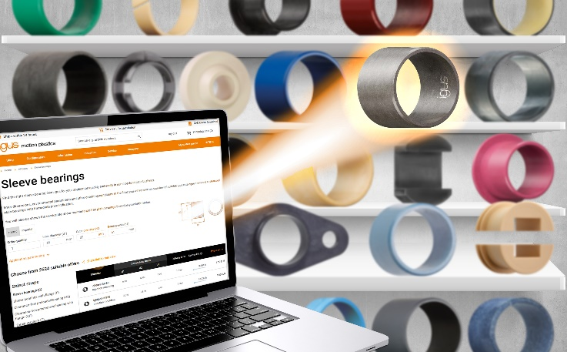
Picture PM0824-1
With the new iglidur web shop, customers can now find the right plain bearing within seconds and order it immediately. (Source: igus GmbH)

PRESS CONTACT:

Alexa Heinzelmann
Head of International Marketing

igus® GmbH
Spicher Str. 1a
51147 Cologne
Tel. 0 22 03 / 96 49-7272
aheinzelmann@igus.net
www.igus.eu/press

ABOUT IGUS:

igus GmbH develops and produces motion plastics. These lubrication-free, high-performance polymers improve technology and reduce costs wherever things move. In energy supplies, highly flexible cables, plain and linear bearings as well as lead screw technology made of tribo-polymers, igus is the worldwide market leader. The family-run company based in Cologne, Germany, is represented in 31 countries and employs 4,600 people across the globe. In 2022, igus generated a turnover of €1,15 billion. Research in the industry's largest test laboratories constantly yields innovations and more security for users. 234,000 articles are available from stock and the service life can be calculated online. In recent years, the company has expanded by creating internal startups, e.g. for ball bearings, robot drives, 3D printing, the RBTX platform for Lean Robotics and intelligent "smart plastics" for Industry 4.0. Among the most important environmental investments are the "chainge" programme – recycling of used e-chains - and the participation in an enterprise that produces oil from plastic waste.

The terms "igus", “Apiro”, "chainflex", "CFRIP", "conprotect", "CTD", “drygear”, "drylin", "dry-tech", "dryspin", "easy chain", "e-chain", "e-chain systems", "e-ketten", "e-kettensysteme", "e-skin", "e-spool”, "flizz", “ibow”, “igear”, "iglidur", "igubal", “kineKIT”, "manus", "motion plastics", "pikchain", "plastics for longer life", "readychain", "readycable", “ReBeL”, "speedigus", "tribofilament“, "triflex", "robolink", “xirodur”, and "xiros" are protected by trademark laws in the Federal Republic of Germany and internationally, where applicable.

