The new robolink IP44 from igus: a robot that defies wet elements!
igus has developed a Low Cost Automation solution made of polymer and stainless steel for environments with splashing water

Damp and wet environments can quickly degrade the mechanics of a robot. This prompted igus to launch a Low Cost Automation innovation on the market, which can easily and cost-effectively implement simple tasks and at the same time be allowed to come into contact with splash water. "From discussions with customers, we learned that many users are looking for an economically affordable solution that can also be used in splash water environments, for example, when emulsions have to be removed", explains Alexander Mühlens, Head of Automation Technology at igus GmbH. "We then developed a robot that is suitable for this purpose." The new robolink makes use of the advantages of two materials: stainless steel and high-performance polymers. For the first time in an igus robot, the joining links are made of V2 or V4 stainless steel and the joints of the proven lubrication-free tribo-polymers. The user does not need an expensive additional covering, because the absence of lubrication in the joints means that no grease can be washed out and escape into the environment. The new robolink meets protection class IP44 at least, and is therefore resistant to splash water. It can carry up to three kilograms, has a range of 790 millimetres with five axes and can make 7 picks a minute. Thanks to the use of motors with encoders of protection class IP65, the robot can also be easily used for outdoor inspection. Further application scenarios are possible, for example, in the food and beverage industry, in the chemical and pharmaceutical sector, or even for tank and container cleaning operations.

See the splash-proof robolink with Alexander Mühlens in the video: https://youtu.be/WXm8gO6QxWQ

Captions:

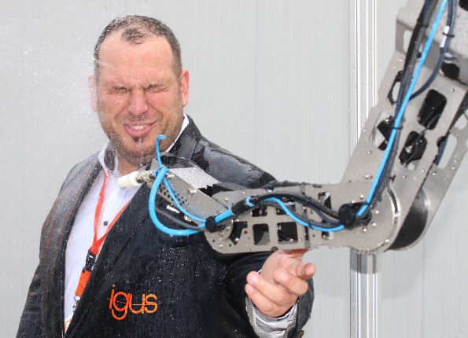
Picture PM6320-1
Splash water is no problem, at least for the new robolink IP44. (Source: igus GmbH)

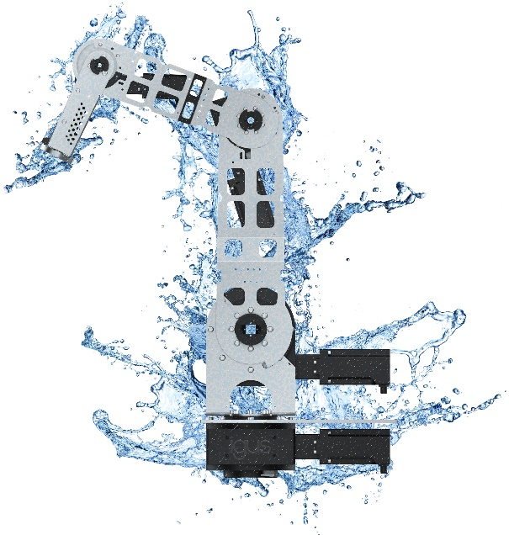
Picture PM6320-2
Due to the lubrication-free and corrosion-free combination of polymer and stainless steel, the new robolink has an IP44 protection class. (Source: igus GmbH)

PRESS CONTACT:  Oliver Cyrus  Head of PR and Advertising  Anja Görtz-Olscher  PR and Advertising  igus® GmbH  Spicher Str. 1a  51147 Cologne  Tel. 0 22 03 / 96 49-459 or -7153  Fax 0 22 03 / 96 49-631  ocyrus@igus.net  agoertz@igus.net  www.igus.eu/press | ABOUT IGUS:  igus GmbH is a global leading manufacturer of energy chain systems and polymer plain bearings. The Cologne-based family business has offices in 35 countries and employs 4,150 people around the world. In 2019, igus generated a turnover of 764 million euros from motion plastics, plastic components for moving applications. igus operates the largest test laboratories and factories in its sector to offer customers quick turnaround times on innovative products and solutions tailored to their needs.

The terms "igus", “Apiro”, "chainflex", "CFRIP", "conprotect", "CTD", “drygear”, "drylin", "dry-tech", "dryspin", "easy chain", "e-chain", "e-chain systems", "e-ketten", "e-kettensysteme", "e-skin", "e-spool”, "flizz", “ibow”, “igear”, "iglidur", "igubal", “kineKIT”, "manus", "motion plastics", "pikchain", "plastics for longer life", "readychain", "readycable", “ReBeL”, "speedigus", "tribofilament“, "triflex", "robolink", “xirodur”, and "xiros" are protected by trademark laws in the Federal Republic of Germany and internationally, where applicable.

