Small investment with a big effect: new contactless monitoring of igus cables in e-chains
i.Sense CF.D sensors use high-frequency technology to detect defects in bus and data cables, preventing expensive system downtimes.
Smart monitoring of igus bus and data cables goes into the next round: the latest generation of i.Sense CF.D monitoring sensors checks the electrical condition of chainflex cables in e-chain systems - without contact and without intervention in the existing harnessing. This allows real-time monitoring without any extra cores and, in combination with the new i.Cee: plus II evaluation module, allows even more efficient predictive maintenance for protection against expensive system failures.
The latest CF.D generation facilitates the entry into predictive maintenance of chainflex bus and data cables in igus e-chain systems. The smart system consists of two sensor units clipped onto the cable before and after the chainflex cable to be monitored. They are small enough to fit into the distribution box on the moving end side and into the control cabinet on the fixed end side. During operation, the sensors continuously check the cables' transmission properties.
High-frequency technology detects the smallest changes in state without contact
The new generation of igus monitoring sensor uses high-frequency technology that works without additional sacrificial cores and without contacting existing cores. "This technology allows the sensors to reliably measure even the smallest transmission deteriorations in cables and connectors," says Richard Habering, head of the igus smart plastics business unit. This allows effective predictive maintenance in moving industrial applications in which cables and connectors are subjected to continuous mechanical stress. The new generation of CF.D sensors is compatible with most bus and data cables in the igus chainflex cable range. "Condition monitoring enables machinery and equipment users to detect and replace cables approaching their wear limit at an early stage, significantly enhancing plant safety." It is a small investment with a big effect. In some industries, downtime costs of 5,000 euros per minute and more are not uncommon.
i.Cee: plus II: detect impending faults with smartphones and tablets
When data and bus cables approach their wear limit, another innovation comes into play: i.Cee: plus II - a module that connects to the CF.D sensors. A CF.D sensor makes a USB connection to the predictive i.Cee maintenance module. Incipient deterioration of the transmission properties signals necessary maintenance work and adjusts the component service life calculation accordingly. It outputs the measurement results for each individual sensor to a dashboard that users can access through the local network or on the move on the internet with a PC, smartphone, or tablet. This means that those responsible can keep up to date at all times and from anywhere in the world and can react quickly to alarm messages received via SMS or e-mail. The dashboard also provides an overview of the system's history, including the total number of energy chain strokes, temperature in production, and time remaining until the next scheduled maintenance. Says Habering, "i.Cee: plus II and the new generation of CF.D sensors put predictive maintenance on a secure footing thanks to intuitive operability and flexible integration into user IT so that malfunctions and unexpected operational downtime can be prevented more reliably than ever." The new generation of CF.D monitoring modules and i.Cee: plus II represent further igus expansion of the i.Sense environment for predictive maintenance. igus has been developing a family of products since 2016 under this heading, with various sensors and monitoring modules adding intelligence to motion plastics products such as energy chains, cables, linear guides, and slewing ring bearings. These smart plastics are already predicting the service life for numerous customer applications in such sectors as the automotive industry.

Caption:

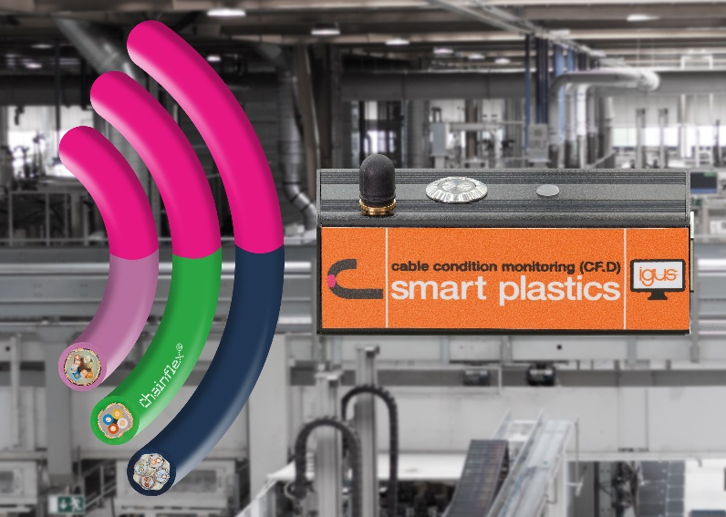
Picture PM6321-1
igus CF.D delivers reliable condition monitoring for bus cables without additional measuring cores. (Source: igus GmbH)

PRESS CONTACT:

Alexa Heinzelmann
Head of International Marketing

igus® GmbH
Spicher Str. 1a
51147 Cologne
Tel. 0 22 03 / 96 49-7272
aheinzelmann@igus.net
www.igus.eu/press

ABOUT IGUS:

igus GmbH develops and produces motion plastics. These lubrication-free, high-performance polymers improve technology and reduce costs wherever things move. In energy supplies, highly flexible cables, plain and linear bearings as well as lead screw technology made of tribo-polymers, igus is the worldwide market leader. The family-run company based in Cologne, Germany, is represented in 35 countries and employs 4,150 people across the globe. In 2020, igus generated a turnover of €727 million. Research in the industry's largest test laboratories constantly yields innovations and more security for users. 234,000 articles are available from stock and the service life can be calculated online. In recent years, the company has expanded by creating internal startups, e.g. for ball bearings, robot drives, 3D printing, the RBTX platform for Lean Robotics and intelligent "smart plastics" for Industry 4.0. Among the most important environmental investments are the "chainge" programme – recycling of used e-chains - and the participation in an enterprise that produces oil from plastic waste (Plastic2Oil).

The terms "igus", “Apiro”, "chainflex", "CFRIP", "conprotect", "CTD", “drygear”, "drylin", "dry-tech", "dryspin", "easy chain", "e-chain", "e-chain systems", "e-ketten", "e-kettensysteme", "e-skin", "e-spool”, "flizz", “ibow”, “igear”, "iglidur", "igubal", “kineKIT”, "manus", "motion plastics", "pikchain", "plastics for longer life", "readychain", "readycable", “ReBeL”, "speedigus", "tribofilament“, "triflex", "robolink", “xirodur”, and "xiros" are protected by trademark laws in the Federal Republic of Germany and internationally, where applicable.

