3D printing in outer space: igus linear axes produce spare parts in zero gravity
Students use drylin linear units to develop a 3D printer for the cost-effective production of structural elements in outer space

When booms for solar panels or satellite antennas are transported into space in a launch vehicle, they are exposed to high loads. To simplify the complex transport and speed up the production of the elements, the AIMIS-FYT student team is working on a 3D printing process. In the future, it should be possible to produce structural parts in outer space. To conduct experimental tests in zero gravity, the students built a 3D printer. For the drive technology supported by igus, they relied on the maintenance-free and lightweight drylin SAW linear axes.

The current process for transporting equipment into outer space is quite inefficient and expensive. This is because the structural parts are primarily designed to withstand the high loads during the launch phase of a spacecraft. However, these structures are oversized for the subsequent operating period. Due to the high costs and limited space on a launch vehicle, alternative solutions are required. The Munich-based student team AIMIS-FYT took on the problem, and is working on a 3D printing process for cost-effective manufacturing in outer space, as part of their aerospace engineering degree programme. To do this, the students rely on photoreactive resin and UV light, which hardens the resin. A 3D printer had to be designed and built for experimental tests of the process in zero gravity. In their search for the right drive technology, the engineers turned to motion plastics specialist igus and found what they were looking for in the drylin SAW linear axes. The linear modules are used in the two z-axes and in the x-axis of the printer and thus form the central drive unit. The linear axes are particularly impressive due to their low weight, as they are made of aluminium and maintenance-free sliding elements made of high-performance polymer. To reduce the clearance of the lubrication-free and dirt-resistant polymer linear slides, the budding engineers resorted to adjustable bearings. To ensure that the print filament can also be rotated, a compact robolink D rotary axis with worm gear was installed in the printer.

Successful test series under real conditions
To test the printer and the process, the team applied for the FlyYourThesis! programme of the European Space Agency (ESA) and was accepted. The parabolic flights took place in November and December 2020. When the aircraft reaches the peak of the climb and tilts into descent, micro-gravity occurs, very similar to weightlessness in space. Ideal conditions for a real test of the printer. "The linear axes always ran without problems in all experiments, so that we were able to print a small rod and also small framework structures for each parabola", Torben Schäfer from the AIMIS-FYT team is pleased to report.

The young engineers support from igus promotes innovative projects
Projects such as AIMIS-FYT are supported by igus as part of the "young engineers support" (yes) programme. With the university initiative, igus wants to support pupils, students and lecturers with free samples, university discounts and sponsorships and the development of innovative projects. For more information about the university support, visit www.igus.eu/yes.

PRESS CONTACT:  Oliver Cyrus  Head of PR and Advertising  Anja Görtz-Olscher  PR and Advertising  igus® GmbH  Spicher Str. 1a  51147 Cologne  Tel. 0 22 03 / 96 49-459 or -7153  Fax 0 22 03 / 96 49-631  ocyrus@igus.net  agoertz@igus.net  www.igus.eu/press | ABOUT IGUS:  igus GmbH develops and produces motion plastics. These lubrication-free, high-performance polymers improve technology and reduce costs wherever things move. In energy supplies, highly flexible cables, plain and linear bearings as well as lead screw technology made of tribo-polymers, igus is the worldwide market leader. The family-run company based in Cologne, Germany, is represented in 35 countries and employs 3,800 people across the globe. In 2019, igus generated a turnover of €764 million. Research in the industry's largest test laboratories constantly yields innovations and more security for users. 234,000 articles are available from stock and the service life can be calculated online. In recent years, the company has expanded by creating internal startups, e.g. for ball bearings, robot drives, 3D printing, the RBTX platform for Lean Robotics and intelligent "smart plastics" for Industry 4.0. Among the most important environmental investments are the "chainge" programme – recycling of used e-chains - and the participation in an enterprise that produces oil from plastic waste. (Plastic2Oil).

The terms "igus", “Apiro”, "chainflex", "CFRIP", "conprotect", "CTD", “drygear”, "drylin", "dry-tech", "dryspin", "easy chain", "e-chain", "e-chain systems", "e-ketten", "e-kettensysteme", "e-skin", "e-spool”, "flizz", “ibow”, “igear”, "iglidur", "igubal", “kineKIT”, "manus", "motion plastics", "pikchain", "plastics for longer life", "readychain", "readycable", “ReBeL”, "speedigus", "tribofilament“, "triflex", "robolink", “xirodur”, and "xiros" are protected by trademark laws in the Federal Republic of Germany and internationally, where applicable.
Captions:

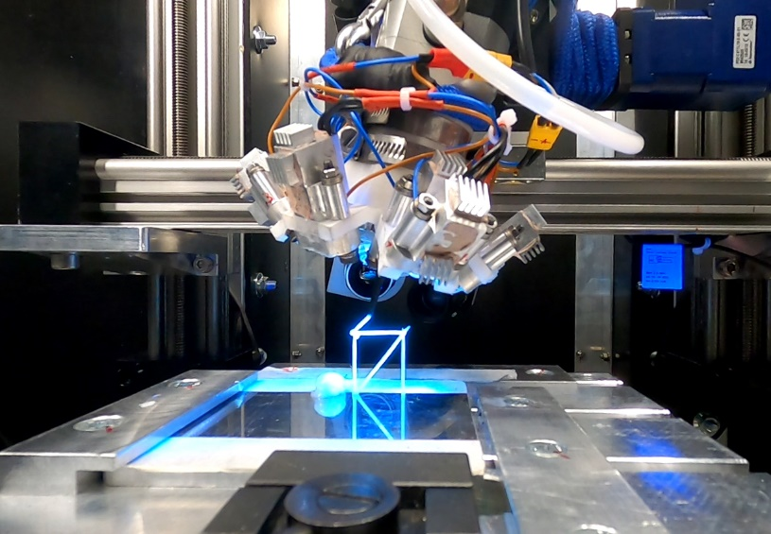
Picture PM0721-1
The maintenance-free drylin SAW linear axes are the central element of the 3D printer. They ensure precise printing results with adjustable bearings. (Source: AIMIS-FYT)

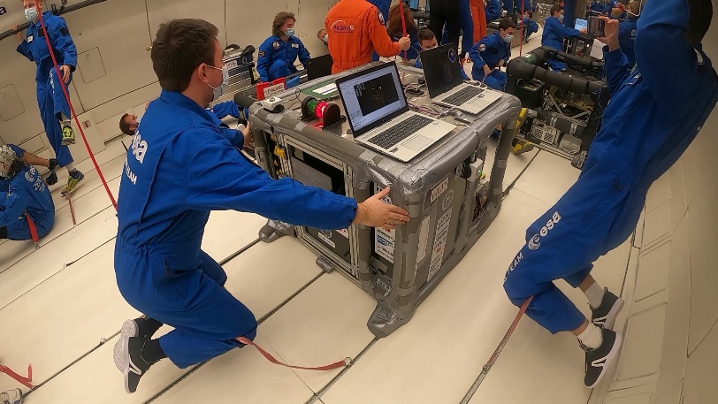
Picture PM0721-2
During a parabolic flight, microgravity occurs, very similar to weightlessness in space. Ideal conditions to test the 3D printer. (Source: AIMIS-FYT)

