Gliding, rolling, saving: igus expands E4.1 energy chain modular system for long travels
New rollers and glide pads for upgrading reduce costs and increase the service life of E4.1 e-chains

On long travels, the energy supply systems from igus are favourites for safely guiding cables and hoses. In most applications, customers rely on the strong E4.1 universal energy chain modular system. igus has now expanded the successful system with glide pads and roller chain links for quick retrofitting. This allows users in abrasive environments as well as in applications with very high speeds or extreme travel lengths to increase the service life of their systems quickly and cost-effectively.

More than 25,000 igus energy chains move over long distances every year, whether in STS cranes, storage and retrieval units or linear robots. In all these areas of application, customers worldwide rely on the tough and modular E4.1 energy chain system from igus. The energy supply system has an undercut design and thus a high torsional rigidity. It is quiet and variable in heights and widths. In 90 per cent of gliding applications, the E4.1 is the universal solution. To extend the service life of the energy chain, especially in abrasive environments, igus has now introduced glide pads with which the chain can be easily upgraded. The wear-optimised sliding elements can be easily placed on the chain links in the inner radius. They are made of a highly abrasion-resistant igumid polymer, which can double the service life of the energy supply system at travel speeds of 1-3m/s.

Safely rolled at high speeds
igus has had energy chain links with rollers in its product range for over 20 years. They reduce the pull/push forces on long travels and ensure a significantly longer service life of the energy supply system. Therefore, igus has now developed new optimised roller chain links in two sizes especially for its E4.1 modular system. Their use is particularly worthwhile at high speeds of up to 10m/s or very long travels. The rollers reduce the drive power by up to 37 per cent, which significantly saves energy. The new roller chain links and glide pads provide a customised energy supply system for every special application from 12m to 500m travel. "In order to find the best technical and economical solution for the customer, we advise them individually", says Jörg Ottersbach, Head of the e-chains Business Unit at igus. "In future, users will also be able to obtain a proposal for their optimum energy chain solution for long travels online in the e-chains expert. Depending on the application site and parameters, the suitable E4.1 energy chain is offered classically in the trough or in special cases with glide pad or roller elements." Optionally, all igus energy chains can be equipped with smart plastics systems for condition monitoring and predictive maintenance.

Image captions:

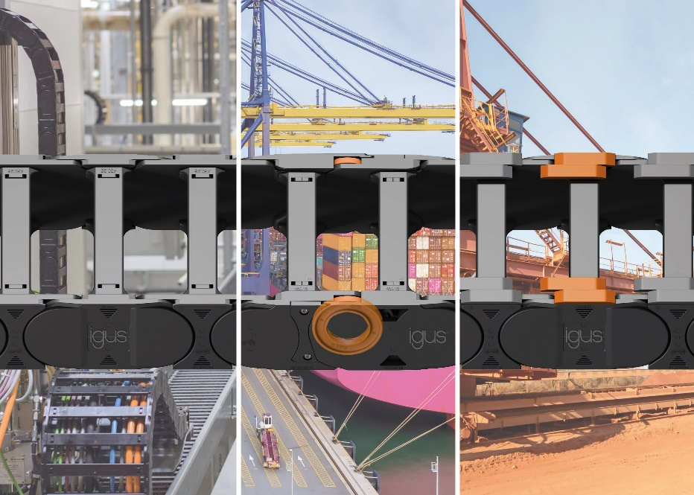
Picture PM2921-1
New rollers and glide pads for upgrading reduce costs and increase the service life of the E4.1 e-chains. (Source: igus GmbH)

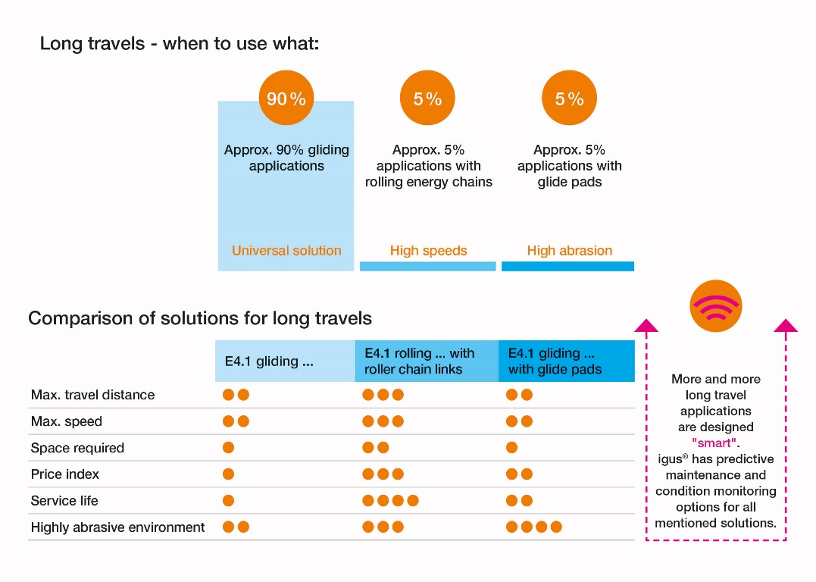
Picture PM2921-2
Depending on the type of application, the use of glide pads or rollers is recommended for long travels. (Source: igus GmbH)
ABOUT IGUS:

igus GmbH develops and produces motion plastics. These lubrication-free, high-performance polymers improve technology and reduce costs wherever things move. In energy supplies, highly flexible cables, plain and linear bearings as well as lead screw technology made of tribo-polymers, igus is the worldwide market leader. The family-run company based in Cologne, Germany, is represented in 35 countries and employs 4,150 people across the globe. In 2020, igus generated a turnover of €727 million. Research in the industry's largest test laboratories constantly yields innovations and more security for users. 234,000 articles are available from stock and the service life can be calculated online. In recent years, the company has expanded by creating internal startups, e.g. for ball bearings, robot drives, 3D printing, the RBTX platform for Lean Robotics and intelligent "smart plastics" for Industry 4.0. Among the most important environmental investments are the "chainge" programme – recycling of used e-chains - and the participation in an enterprise that produces oil from plastic waste (Plastic2Oil).

PRESS CONTACT:

Oliver Cyrus Anja Görtz-Olscher
Head of PR and Advertising Manager PR and Advertising

igus® GmbH igus® GmbH
Spicher Str. 1a Spicher Str. 1a
51147 Cologne 51147 Cologne
Tel. 0 22 03 / 96 49-459 Tel. 0 22 03 / 96 49-7153
ocyrus@igus.net agoertz@igus.net
www.igus.de/presse www.igus.de/presse

The terms "igus", “Apiro”, "chainflex", "CFRIP", "conprotect", "CTD", “drygear”, "drylin", "dry-tech", "dryspin", "easy chain", "e-chain", "e-chain systems", "e-ketten", "e-kettensysteme", "e-skin", "e-spool”, "flizz", “ibow”, “igear”, "iglidur", "igubal", “kineKIT”, "manus", "motion plastics", "pikchain", "plastics for longer life", "readychain", "readycable", “ReBeL”, "speedigus", "tribofilament“, "triflex", "robolink", “xirodur”, and "xiros" are protected by trademark laws in the Federal Republic of Germany and internationally, where applicable.

