Smart and lubrication-free: solar rubbish bin with igus plain bearings revolutionises waste management
Finbin develops waste bins with maintenance-free igus plain bearings - the application deadline for the 11th manus award expires on 10th February 2023

A clean cityscape is what many large cities around the world long for. To bring that dream a little closer, Finbin, a Finnish company, has developed an intelligent rubbish bin. It features a solar-powered press that increases the amount of rubbish it can absorb by a factor of six. The lubrication-free igus plain bearings in use ensure a long service life of the bin. This project won the green manus award in 2021.

Pizza boxes, coffee mugs and beverage tins. For years, cities all over Europe have been fighting against this deluge of waste. Conventional waste bins are increasingly reaching their limits. The Finnish company's answer is the CitySolar waste bin, which compresses waste, increasing the bin's capacity by a factor of six. The waste bin is connected to the internet and requests emptying before it reaches its maximum capacity. To increase the new waste bin type's sustainability, the engineers use components that require no maintenance. Therefore, lubrication-free and maintenance-free igus iglidur G and iglidur M250 plastic plain bearings are used for the mechanics of the press and foot lever. Conventional metal bearings were out of the question because high humidity and lubrication pose a problem in everyday operation. iglidur plain bearings, however, are not sensitive to moisture, dust or dirt. A test in igus's 3,800-square-metre in-house laboratory proves how wear-resistant the bearings are. In the test, the plain bearings were pivoted on a gas-nitrified St52 steel shaft with a load of 30Mpa at a speed of 0.01 metres per second. The iglidur G plain bearings showed virtually no signs of wear even after 200,000 cycles. This makes them ideal for reliable, maintenance-free use in all weathers over many years.

In 2023, the manus award will once again honour sustainable projects
Finbin's CitySolar waste bin was honoured with the 2021 green manus as a forward-looking, sustainable project. Every two years, the international competition awards innovative plastic-bearing projects the gold, silver, bronze and green manus. This year, igus is looking for unique applications once again. Four participants can win up to €5,000. The application deadline is 10th February 2023, and entries can be submitted online in just a few minutes at www.igus.eu/manus.

Caption:
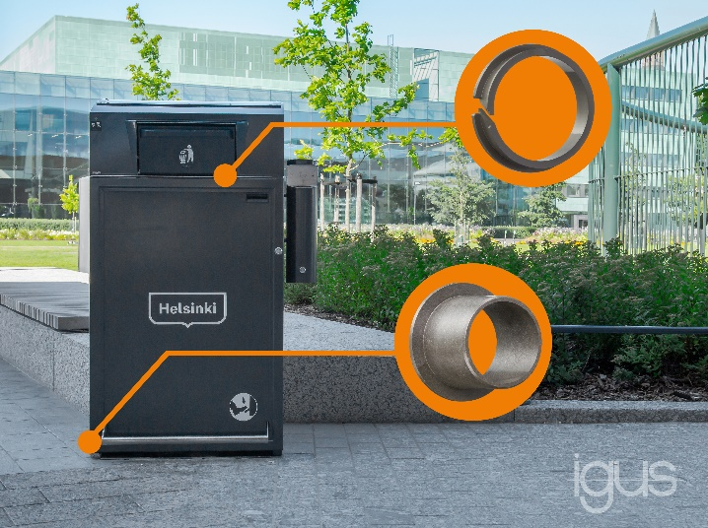
Picture PM0723-1
Lubrication-free igus plain bearings made of high-performance plastics ensure durable mechanics in the smart CitySolar rubbish bin. (Source: Finbin)

PRESS CONTACT:

Alexa Heinzelmann
Head of International Marketing

igus® GmbH
Spicher Str. 1a
51147 Cologne
Tel. 0 22 03 / 96 49-7272
aheinzelmann@igus.net
www.igus.eu/press

ABOUT IGUS:

igus GmbH develops and produces motion plastics. These lubrication-free, high-performance polymers improve technology and reduce costs wherever things move. In energy supplies, highly flexible cables, plain and linear bearings as well as lead screw technology made of tribo-polymers, igus is the worldwide market leader. The family-run company based in Cologne, Germany, is represented in 31 countries and employs 4,900 people across the globe. In 2021, igus generated a turnover of €961 million. Research in the industry's largest test laboratories constantly yields innovations and more security for users. 234,000 articles are available from stock and the service life can be calculated online. In recent years, the company has expanded by creating internal startups, e.g. for ball bearings, robot drives, 3D printing, the RBTX platform for Lean Robotics and intelligent "smart plastics" for Industry 4.0. Among the most important environmental investments are the "chainge" programme – recycling of used e-chains - and the participation in an enterprise that produces oil from plastic waste.

The terms "igus", “Apiro”, "chainflex", "CFRIP", "conprotect", "CTD", “drygear”, "drylin", "dry-tech", "dryspin", "easy chain", "e-chain", "e-chain systems", "e-ketten", "e-kettensysteme", "e-skin", "e-spool”, "flizz", “ibow”, “igear”, "iglidur", "igubal", “kineKIT”, "manus", "motion plastics", "pikchain", "plastics for longer life", "readychain", "readycable", “ReBeL”, "speedigus", "tribofilament“, "triflex", "robolink", “xirodur”, and "xiros" are protected by trademark laws in the Federal Republic of Germany and internationally, where applicable.

